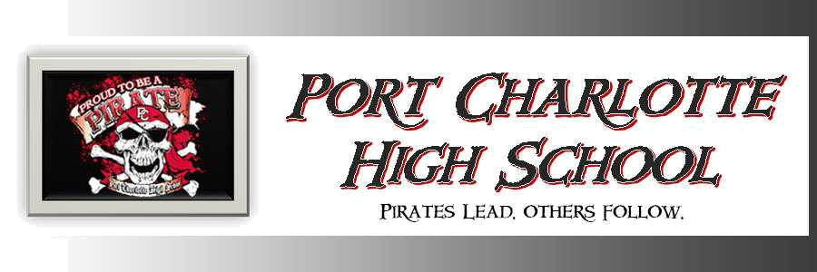

PRIDE OF PC BANDS

Instructor: Mr. Corey Hoeben

Room: F4

Email: Corey.hoeben@yourcharlotteschools.net

Visit the Pride of Port Charlotte Bands website for more information:

http://www.prideofpc.com/

