HTML – Day 2
This website:
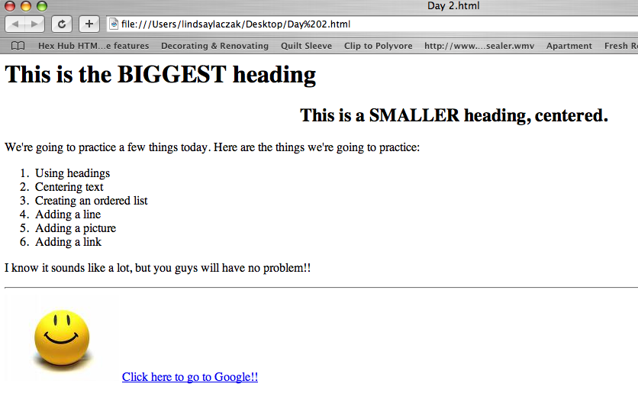

Requires this HTML coding to display properly:
<html>
<body>

<h1> This is the <b> BIGGEST</b> heading </h1>

<h2 align="center"> This is a SMALLER heading, centered. </h2>

<p> We're going to practice a few things today. Here are the things we're going to practice: </p>
<OL>
<LI> Using headings
<LI> Centering text
<LI> Creating an ordered list
<LI> Adding a line
<LI> Adding a picture
<LI> Adding a link
</OL>

<p> I know it sounds like a lot, but you guys will have no problem!! </p>

<HR>

<IMG SRC="smile.jpg">

<a href="http//www.google.com"> Click here to go to Google!! </a>

</body>

</html>
1
2

3

4

5
6
7
8
9
10
11
12
13

14

15

16

17

18

19

New Tags:
<h1> </h1>
<h2> </h2>
<OL> </OL>
<LI> NO END TAG
<IMG> NO END TAG
<HR> NO END TAG
<A> </A>

<h2 align=“center”> This is a SMALLER heading </h2>

New Attributes:
SRC=
Href=
Align=

New Values:
“filename.jpg”
“http://www.websiteurl.com”
“center”

