Glogster Directions

- Go to: http://edu.glogster.com/#
- In the upper right hand corner, click on “Register”



- Fill out the registration as directed:
Enter your school computer ID
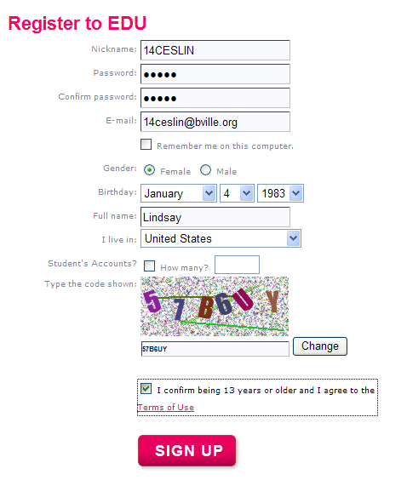
Enter your school computer password
Type your school username, then add “@bville.org” to the end of it
Select your birthday
Enter your FIRST name
Select US
Type the code shown above
Check this box
Click on “Sign Up”

