Cacoo: Creating an Account
- Go to: http://cacoo.com/

- Click on the big pink button towards the bottom that says “Sign Up”

- Fill out the account information like this:

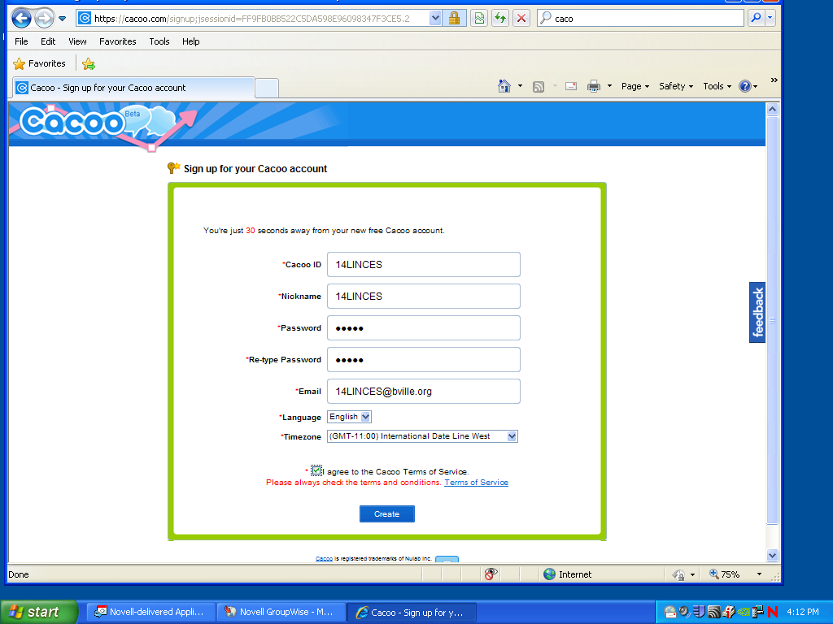
Your school computer ID
Your school computer password
Your school computer ID with “@bville.org” added to the end
Check this box

- Elect a group leader. Our group leader’s is: _________________________

- Group leader (and GROUP LEADER ONLY) will do the following:
  - Click on the pink button that says “Create New Diagram”
  - Add 1 thing to the diagram
  - Click on “Save” and list your period and group names in the title, and then click on “OK
  - Click on the green button that says “Share”
  - Input Nicknames of people in your group, then click “Invite”. ** You must also invite jauclair **
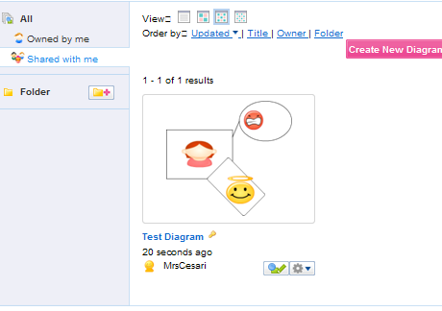
Click “Shared with me”

Click the edit button for the diagram you want to edit

- After step 5, everyone else:

