Adding your Glog to Delicious

- Copy the URL for your Glog
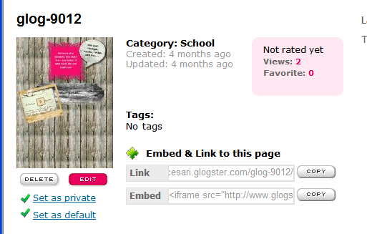
When you first log in to Glogster, scroll down. Click the “copy” button next to where it says “link”

- Go to: http://delicious.com/
#5: Click on “Save a new bookmark”
- In the upper right hand corner click “Sign In”
- The Username is: SpencerFACs The Password is: career1
- Click on “Save a new bookmark” (see picture below)
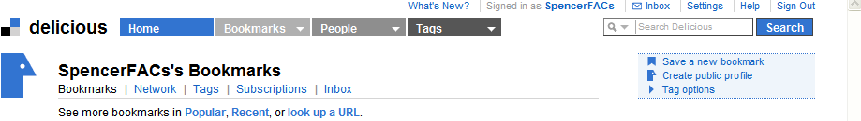

- Fill in bookmark info as shown below:
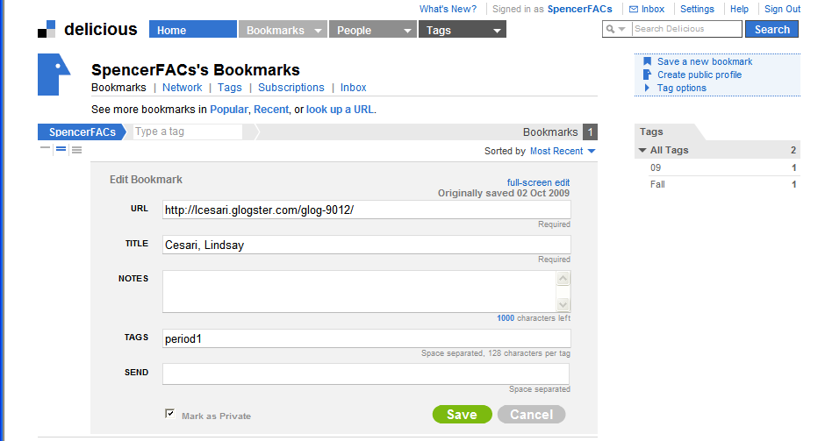
Paste your glog URL here
Enter your name here. Last name, First name.
Put your period in this field. NO SPACES. Exactly as done in the example.
Check the box to mark as private
Click save when you’re all done.

