- Log into www.FamilyID.com . If you don’t remember your password, just click “Forgot Password” and reset it.
- Switch to your personal account. It will be your last name plus “Family Account”. For example, Nguyen Family Account.

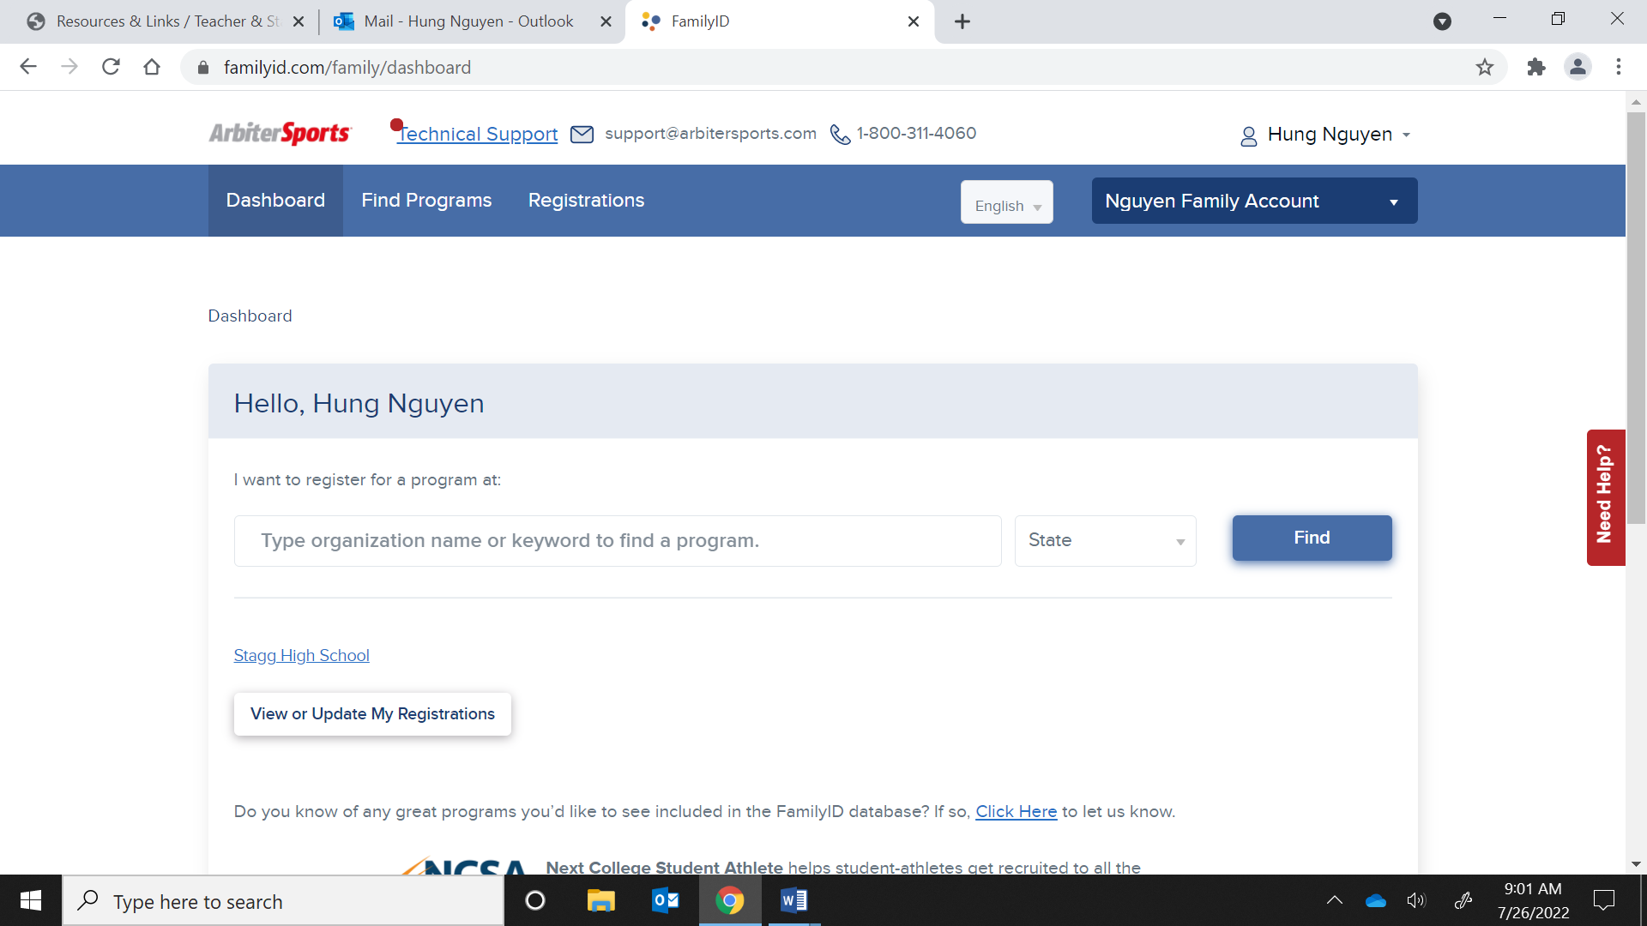

- Click “Stagg High School.”

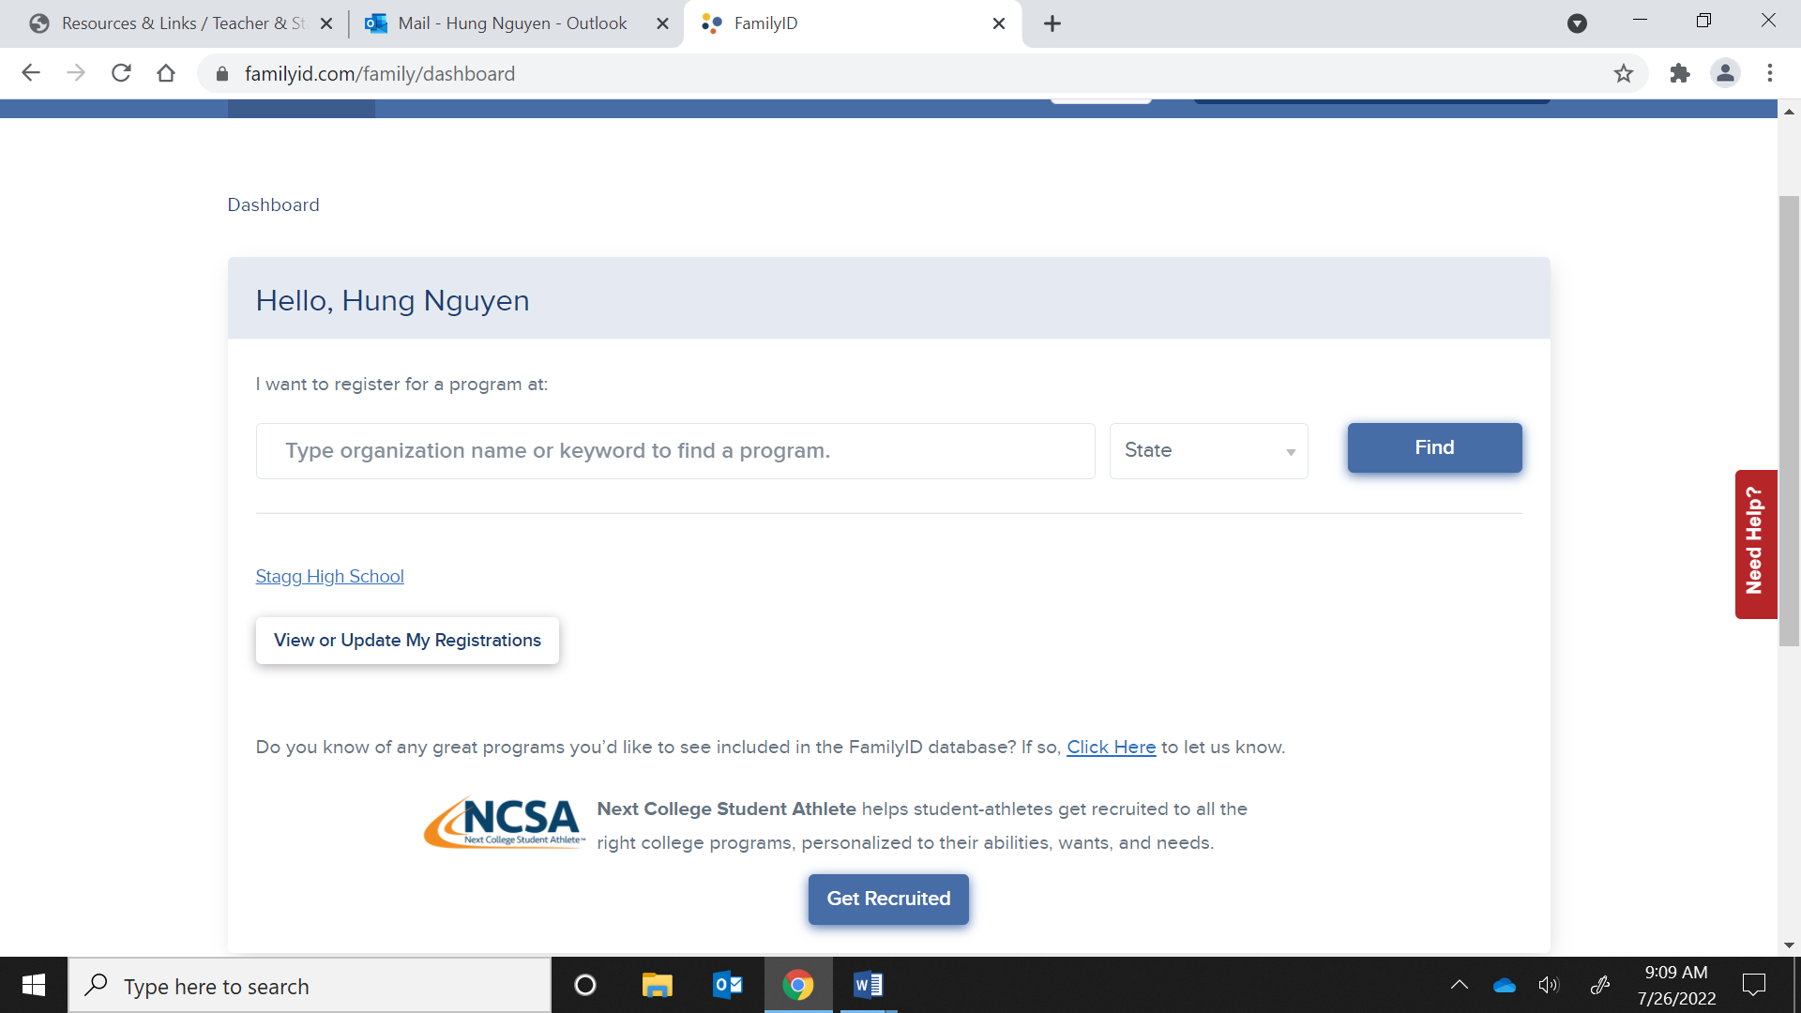

- Click “2022/2023 Stagg High School Athletic Registration”.
- Click “Register Now”.
- Check all the sports you want to play. Make sure to include the level (Varsity, JV, Frosh).
- Click “Click here to Select or Create Participant” and select your name.

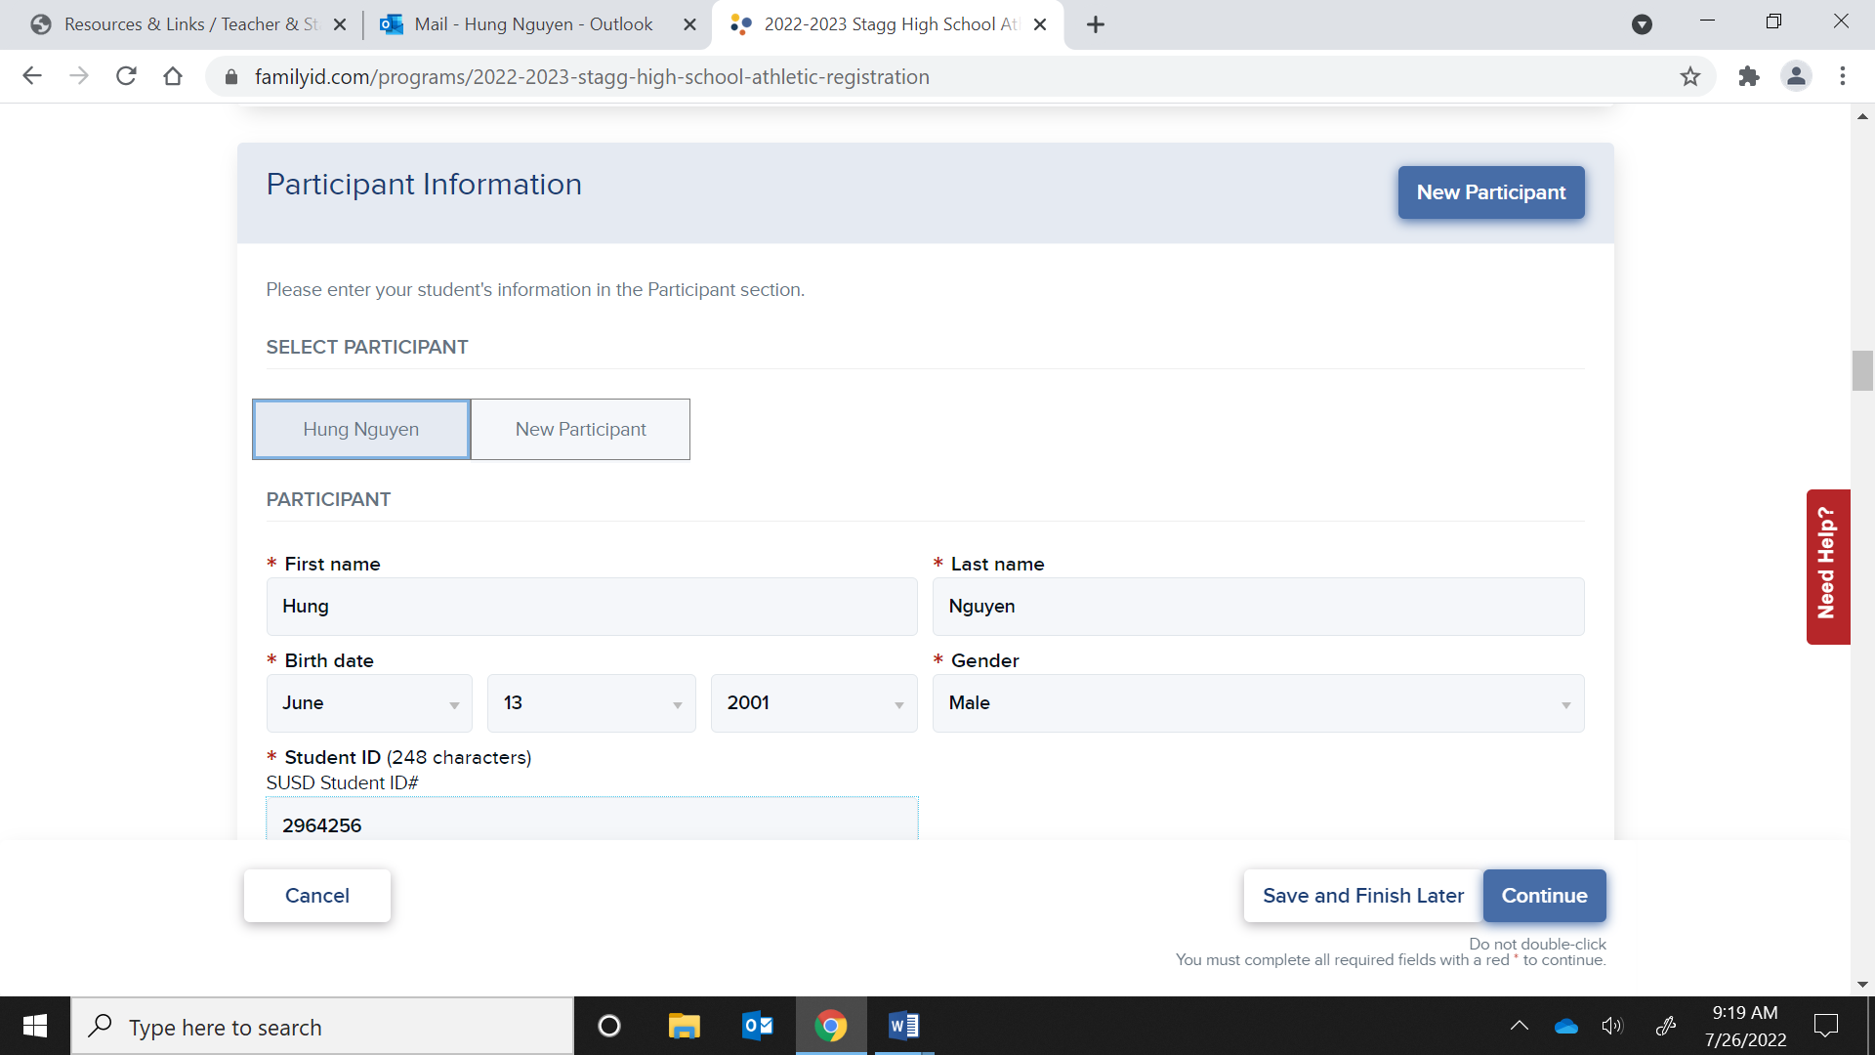

- In the “Additional” section, make sure you add your most recent physical. You can take a picture of it on your phone.
- Check the boxes and sign for the following agreements in the “Agreements” section:
  - Stockton Unified School District Signature Form
  - Consent for Medical Treatment
  - Informed Consent COVID-19
- Make sure you fill out everything with a red asterisk.
- Click “Continue”.
- Click “Submit”

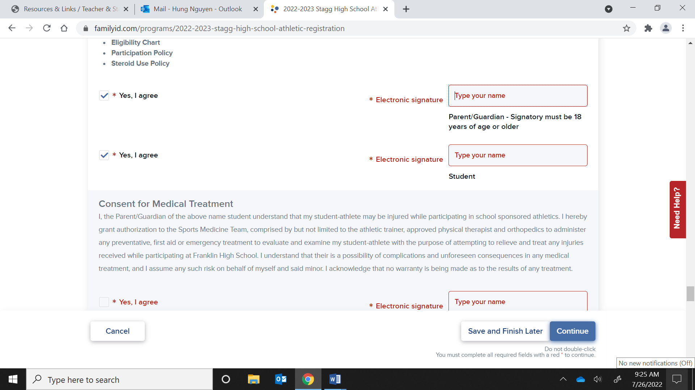

- Scroll down to the “Agreements” Section and click “Yes, I agree” for both, and type in your name for both. Then click “Continue”.

- Click “Submit”.

