San Joaquin Pride Center presents:
YOUTH EMPOWERMENT SUMMIT
LGBT+ YOUTH AND ALLIES –
BUILDING CONNECTIONS
Saturday, October 22, 2022
12:00 Noon – 4:30
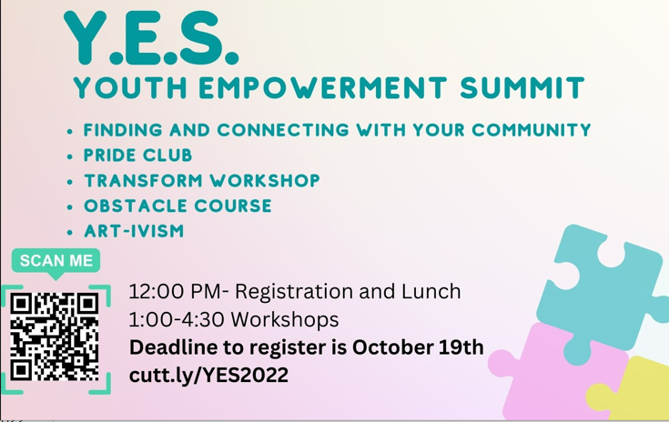
Central United Methodist Church
3700 Pacific Avenue
Lunch, Workshops, Social Connections
This event is FREE!

