AFTER SCHOOL EDUCATION AND SAFETY PROGRAM PLAN
2016-19

Stockton Unified School District



Board of Education
Ms. Gloria Allen
Ms. Andrea Burrise
Ms. Kathy Garcia
Ms. Colleen Keenan
Ms. Maria Mendez
Ms. Angela Phillips
Mr. Steve Smith

Superintendent
Dr. Eliseo Dàvalos

Stockton Unified School District
AFTER SCHOOL PROGRAM PLAN
After School Education and Safety Grant

Grant ID # 39-23939-6867-EZ District CDE Code # 39686760

Janet Yarbrough,  Program Administrator  Student Support Services  (209) 933-7130 X 2618  jyarbrough@stockton.k12.ca.us | Susanne Montoya,  Executive Director  Business Services  (209) 933-7010 X 2015  smontoya@stockton.k12.ca.us
Community Based Organizations
Center for Community Involvement  Erin Rausch, Director  University of the Pacific  3601 Pacific Avenue  Stockton, CA 95211  Jacoby Center for Public Service and Civic Leadership  Roy Childs, Research Director  University of the Pacific  3601 Pacific Avenue  Stockton, CA 95211  (209) 946-7444 | The Table Community Foundation  Tyronne Gross Jr., Director  P.O. Box 690094  Stockton, CA 95263-0094  YMCA of San Joaquin County  April Lewellen, President/CEO  March Lane  Stockton, CA 95210
39 After School Program Sites

School Site Name | Attendance Target
Adams Elementary | 111
August Elementary | 111
Bush Elementary | 111
Cleveland Elementary | 111
El Dorado Elementary | 111
Elmwood Elementary | 111
Fillmore Elementary | 111
Fremont Elementary | 111
Grunsky Elementary | 111
Hamilton Elementary | 111
Harrison Elementary | 111
Hazelton Elementary | 111
Henry Elementary | 111
Hong-Kingston Elementary | 111
Hoover Elementary | 111
Huerta Elementary | 111
Kennedy Elementary | 105
King Elementary | 111
Madison Elementary | 111
Marshall Elementary | 111
McKinley Elementary | 111
Monroe Elementary | 111
Montezuma Elementary | 111
Nightingale Elementary | 111
Peyton Elementary | 111
Pittman Elementary | 107
Primary Years Academy | 83
Pulliam Elementary | 111
Rio Calaveras Elementary | 92
Roosevelt Elementary | 111
San Joaquin Elementary | 111
Spanos Elementary | 111
Taft Elementary | 111
Taylor Elementary | 88
Tyler Elementary | 111
Van Buren Elementary | 111
Victory Elementary | 111
Washington Elementary | 101
Wilson Elementary | 111

Target Populations

The STEP Up After School Program targets students identified as having the greatest academic need in English Language Arts. Using school-wide data, each site analyzes which students need the most support, based on MAP scores, formative and performance data, Student Support Team (SST) meetings and teacher recommendation. The Academic Hour Teacher Coordinator works with the Program Facilitator and site administrator to identify and invite the targeted students into the program. English language arts scores for 1st-3rd grade students are the focus. This target supports the District’s goal that “Every child will read and comprehend at a proficient level by the end of 3rd grade.” In addition, 4-8th grade English Language Learners who are CELDT level 3 and below will be targeted for intervention.

However, after the target population is recruited, remaining slots in the program will be open to all students and grade levels (K-8) on a first-come, first-serve basis. STEP Up is a free after school program.

District-wide Measures of Academic Progress (MAP) summary results are attached (Please see Appendix A). The chart compares student MAP scores to the number of days they participated in the program compared to students who did not attend the after school program. Appendix B shows the percentage of students who met or exceeded state standards on the California Assessment of Student Performance and Progress.

Program Goals and Requirements

The Program Goals developed from the needs assessment are:
- Increase basic math skills
- Increase academic achievement in ELA
- Increase student engagement in school
- Increase student physical fitness
- Provide a safe environment for children during after school hours

To achieve the above academic goals each site will systematically analyze the students in the program using MAP scores and set up interventions based on their needs. Data is collected on student subgroups to address the achievement gap. Each school site reviews achievement data as they collaborate in data teams within their Professional Learning Communities (PLCs). The core curriculum includes summative and performance-based assessments.

Student engagement goals are met by engaging active student leadership in planning activities to better meet the needs and wants of the students. Staff is trained in implementing existing materials and creating activities that are grade level appropriate, exciting and engaging. All sites work at tapping into each staff member’s passion and supporting them in transforming this passion into creative activities to engage students.

To draw in the community and support daily attendance, each year four to five “Family Nights” are planned and implemented to draw in the broader community and celebrate the students. Each event includes performance based presentations that showcase students’ learning in literacy, math, science, arts, and other areas.

In order to maintain attendance goals, each school targets students who will benefit most from the program. Staff calls or personally meets with parents and encourages them to register students. Flyers are sent home to advertise program availability, as well as Parent Link, school-wide phone calls.

Increased physical fitness is encouraged each day. A minimum of 30 minutes is spent in active physical recreation using the curriculum format of SPARK. In addition, a partnership with the Center for Collaborative Solutions provides training and support in transforming after school programs into Healthy Behavior Centers. Five sites are participating currently in the program and more sites will hopefully be added in the following years. Exemplary practices in healthy eating, physical activity and food security are emphasized in these programs.

To address the importance of having a safe environment, emphasis is placed on implementing explicit positive youth development. Each site is encouraged to establish a Youth Council with staff trained in Developmental Assets. Training focuses on identifying and rewarding positive character traits in staff and students and empowering all youth. Tangible and social/emotional rewards are given for regular attendance. Staff is trained in the importance of developing a supportive, asset building relationship with all students, problem solving with difficult students and teaching appropriate social behavior so all students can be successful in the after school program. When necessary, Special Education teachers meet with staff to provide appropriate information for working with students with special needs. Bullying and associated behaviors are not tolerated and staff work with both bully and victim to develop strong personal assets.

To measure whether goals have been met, each year the needs of the community, students, parents, and school are assessed using data from student, staff and parent surveys, California Healthy Kids Survey, and academic scores. Staff meets with teachers and administrators and many attend School Site Council and/or site-based PTO/PTA meetings. District staff hold monthly meetings with partners and site facilitators.

Each site, in collaboration with the site principal, develops a required disaster plan with a yearly schedule of monthly drills. Staff is trained in the tasks for which they will be responsible in the event of a disaster. The planning, tasks and drill schedule reflects the District’s emergency crisis response plan. All staff members are encouraged to obtain CPR/First Aid training.

Program Content and Quality

All programs include a minimum of five hours a week of academic support for all students registered in the program. Certificated teachers provide a district approved academic intervention three hours a week to students identified for Tier 2 and 3 interventions. Literacy is a predominant academic focus throughout the program because without strong reading skills students struggle in all other subject areas
After school line staff are trained and provided with ELA and math guides that connect after school support materials to school day pacing guides. Thus, staff can easily choose appropriate activities to better support students in each grade level.

The educational enrichment element comprises up to at least two hours of each day’s program. Staff is trained in basic tutoring procedures and positive behavior management as well as implementation of purchased materials. All enrichment activities are linked to the program goals. Enrichment activities engage learning in the areas of literacy, math, social studies, science, visual and performing arts, and civics. Each day, students participate in guided physical activities from the SPARK curriculum. In addition, thematic binders have been created to help promote project and performance- based activities to increase student engagement.

A variety of educational supplies and activities were purchased including educational games, Lakeshore learning centers, SRA math kits, activities from Teacher Created Materials, Mind Ware, Nasco Math, Pearson Learning Group, and other resources.

The after school program is aligned with the regular school day. Each site has an Academic Hour teacher coordinator, who is one of the regular school day teachers, providing a link to the regular school day staff and administrators. Academic groups are formed using data from student records and progress in the classroom. SUSD has purchased Imagine Learning (an ELA intervention) site licenses that can be used after school or during school hours as a Tier 2 and 3 interventions. English 3D (an English Learner intervention for 4th -8th grade) will be available for sites as needed. In addition, ASP line staff lead groups using SRA Math Labs K-3, SRA Math Mat Games, KidzLit, Kidzmath, Reader’s Theater, Compass Learning (computer based program), as well as other academic support materials.

Basic mathematic skills are reinforced through drills, games and movement. All K-5 students are recommended to spend at least thirty minutes a week on ST Math (a spatial temporal math program online) to review topics from the school day and/or practice basic skills. To ensure effective assistance with homework the after school staff use homework logs to communicate with classroom teachers (See Appendix C).

Each site has their individual process for scheduling; however all have the same basic components. Every week is planned in advance and includes: a nutritious snack, planned supervised bathroom breaks, a minimum of three hours a week of an academic intervention, a minimum of 30 minutes a day of SPARK planned physical activity, age appropriate enrichment activities and grade level appropriate daily homework time. Throughout the year all sites participate with programs and presentations offered by community based organizations: Center for Community Involvement/University of the Pacific, Water Conservation, Fire Department visits, Safe Moves (bike safety) and others. In addition, throughout the year there are district-wide activities such as Lights On!, letter writing campaigns as a service to a broader community, and coat or food collection projects.

Nutritious snacks are provided for all students who participate in the after school program through SUSD’s Food Services Department and funded by the National School Lunch Program (NSLP). After-school snacks under the NSLP are authorized by the United States Department of Agriculture (USDA) and the California Department of Education, Nutrition Services Division. Examples of snacks served are attached in Appendix D.
A reimbursable snack must contain full servings of any two of the following four food components:
  - Fluid milk;
  - Meat or meat alternate;
  - Fruit, vegetable, or 100% juice; and
  - Grain or bread product.

The Supper Program will be implemented throughout the District beginning in the Fall of 2016. All meals served through this program must include all of the following:
- 1 serving of milk
- 2 servings of fruits and/or vegetables
- 1 serving of grains
- 1 serving of protein

Meals can be hot or cold as simple as a ham sandwich, cucumber slices, apple, and a carton of low-fat milk. An after school snack can also be included with this meal.

Collaboration and Partnerships

Collaboration meetings are held at the District and community level. The Assistant Superintendent of Education Services meets with After School Administration and principals. After School Administration meets with After School Program Facilitators and partner agencies to support and provide training required for new implementations. The STEP Up Advisory Committee also participates in the process as information is shared with committee members regarding the school district needs for student support and academic achievement, and plans are put in place to support these goals. Members contribute staffing, safety information, cultural enrichment activities, and provide training.

Collaborative members of the STEP Up Advisory include the Center for Community Involvement, University of Pacific; Emergency Services/School Safety Program Coordinator; Give Every Child A Chance, Jacoby Center for Public Service and Civic Leadership, University of Pacific; the Table Community Foundation, the YMCA of San Joaquin County and a representative site facilitator. Site collaborative groups include Academic Hour Teacher coordinators, After School Site Facilitators, and partner staff.

Parent representatives would be a valuable partnership to have. Finding a consistent and accessible meeting time has proven to be difficult. To assure parent collaboration each after school facilitator is encouraged to attend Parent/Teacher Organization (PTO) or School Site Council (SSC) meetings. Each site is encouraged to set up formal student leadership groups, a Youth Council, to ensure student groups provide input and assist in planning activities for each program. Engaging the business sector, arts community and other local organizations is an ongoing process.

The STEP Up Advisory meets quarterly. The Academic Hour Teacher Coordinators meet every six weeks, Partner Agencies meet once a month, Agency coordinators and Program Facilitators meet a minimum of once a month (See Appendix E for the projected meeting schedules and Appendix F for the organizational chart).

Staffing

All staff members who supervise students must meet the minimum qualifications of a paraprofessional which include:

- high school diploma or GED and,
- completed at least 2 years of college (minimum 48 semester units)
- obtained an Associates (or higher) degree; or
- met a rigorous standard of quality and can demonstrate, through a formal local academic assessment and proof of certification through the San Joaquin County Office of Education.

In addition, each staff member must be fingerprinted and have a current T.B. clearance.

SUSD After School Program Facilitator positions are advertised on-line through EDJoin.org. ASP staff are trained and encouraged to apply for facilitator jobs. Partner staff agencies run advertisements in the newspaper, recruit at job fairs, college campuses, and on-line job boards. Staff retention is encouraged through on-going training providing skills to enhance their job performance. Regular meetings with program facilitators and partner agencies include teambuilding activities as well as informational items to be shared with staff. Each facilitator is encouraged to celebrate staff successes.

Partners or sub-contractors provide ASP line staff to lead academic support, enrichment, recreation, and homework help activities; other sub-contractors provide specific enrichment activities such as Zumba, or VAPA. All partners and sub-contractors sign a contract guaranteeing all employees have met the minimum requirements of an instructional aide, have recorded evidence of fingerprinting and a current T.B. clearance.

Professional development is determined based on staff survey needs, site observations and programming needs. The following trainings are provided yearly: behavior management, lesson planning and leading groups, policies and procedures, SPARK, KidzLit, safety planning, and connections to the academic school day core materials. Additional areas of professional development are provided based on staff needs, such as new curriculum and technology.

Program Administration

The after school administrator establishes the budget and presents it to the advisory council and district’s business services office. Indirect rates and administrative costs are determined and set not to exceed 15% of the total budget. Partner contracts are determined based on staffing needs. All invoices are reviewed and must be accompanied by appropriate documentation. School site expenditures for supplies, materials, and teacher timesheets are routed through the after school office for approval. Funds are solely used for after school activities and only used to supplement not supplant other funding.

The budget is managed through the after school office and the district’s business office. At the end of each quarter, the after school administrator and the assigned accounting technician confirm the budget before the quarterly expenditure report is uploaded into ASSIST. The District also conducts an annual fiscal audit yearly to maintain compliance.

Each year, an inventory of all equipment at each site is conducted and physically checked by after school staff.

At the beginning of each school year, partners submit an estimate of matching funds they believe they will be able to provide. The amount is included in the contact signed between SUSD and each partner. At the end of the year, each partner submits a memo with the specific match amount for the year. In addition, SUSD uses other funds such as LCAP, SES, Title I, Title III, NSLP snacks, and other funds to guarantee the required 33% match for ASES. The District grant writer actively looks for additional grant opportunities to support after school activities. Each school site facilitator secures match, as well, through volunteers, donations and fundraising (Summary of matching funds Appendix G).

The after school program commences immediately upon the conclusion of the regular school day and operates a minimum of 15 hours per week and at least until 6 p.m. on every regular school day. As students enter the program, each staff person checks in their group. The daily site absence list is used to assure all students are present. Every student must be signed out daily by an authorized person, as recorded in the student’s registration form or by designated staff. The time and reason for early release must be recorded if early release is necessary (See Appendix H – Early Release Forms).

Attendance numbers are determined by the total number of signatures per page in the parent sign-out sheets. All of the pages are totaled together and recorded on the attendance cover sheet. Attendance is taken from the sign-out sheets for each student and absences are entered into Synergy, our District Student Information System. The electronic attendance must match the number of sign-outs counted. The total attendance for each school site is entered in ASSIST for the first and second semester of the school year.

The program plan will be reviewed at the beginning of the year with ASP staff to assure the program is understood, followed and in place. The plan will also be reviewed at the end of each year with the Advisory Committee. The program plan and all records and required documentation are maintained for at least five (5) years and stored at school sites and in storage at the STEP Up Office.

Outcome Measures and Evaluation

To evaluate the program’s effectiveness, surveys will be given to parents, students, staff and principals regarding satisfaction with the program, safety, student academic support, collaboration, professional development and communication with parents.

In addition, the following student data will be examined:
- Grade 5 and 7 Physical Fitness Test results comparing program students vs. non-program students’ performance on the one-mile run and the percentage meeting 4 or more of 6 healthy fitness zones.
- ELA and Math gains and decreases demonstrated by MAP Scores
- Regular school day attendance rates for program students vs. non-program students yearly. Attendance will be calculated as days attended vs. days enrolled. Regular school day attendance for after school students will be submitted as part of the yearly evaluation to the CDE.

Data collected over the last year showed the following results:

- Parents continued to be highly satisfied with the program
- K-8 students in the program had higher attendance rates.
- Nearly 82% of students reported that they liked physical activities more and 74% said they were in better shape due to the physical activity component of the program. Eighty-eight percent of the program staff also agreed that it benefitted students.
- Students who participated in the program showed no gains in ELA and math compared to students not in the program.
- The chart below shows the average progress students made at sites across the district. The largest growth in basic math skills occurred 1st grade through 5th.

 | District Average Math Scores |  | Pre Test | Mid-Year | Post Test | % Increase (Pre/ Post)
 | 1st Grade | 46.70% |  | 71.5% | 80.4% | 72%
 | 2nd Grade | 60.36% |  | 58.8% | 76.8% | 27%
 | 3rd grade | 40.2% |  | 58.8% | 65.8% | 64%
 | 4th Grade | 42.6% |  | 56.5% | 62.4% | 46%
 | 5th Grade | 39% |  | 51.4% | 53.4% | 37%
 | 6th Grade | 44.2% |  | 45.8% | 48.9% | 11%
 | 7th Grade | 38.2% |  | 42.3% | 46.6% | 22%
 | 8th Grade | 42.4% |  | 42.7% | 46.2% | 9%

To improve student achievement, the after school program will target English learners at CELDT Level 3 and below, and students two years below grade level in ELA and math. After school support will be aligned with the school day’s pacing guide. Core ancillary materials will be used to reinforce and re-teach skills during the academic hour of the program. Students with serious academic deficiencies will receive intensive support through teacher-led small group instruction. Staff will be provided with materials and guides to further support daily grade level work during academic and enrichment hours.
Students deficient in ELA will be given at least 3 hours of Imagine Learning a week. Students will rotate in small groups from computerized instruction to teacher-led instruction working on specific areas with teaching resources that work hand-in-hand with Imagine Learning digital curriculum.

Students K-5 will be given at least 30 minutes a week on ST Math. In addition, students in all grade levels will continue to practice basic math skills weekly.

In addition, we will utilize MAP testing to measure academic progress throughout the year and especially for grades K-2 students where growth measures over the course of the program are limited.

During the 2015-16 school year, the STEP Up Advisory and school sites began the process of developing an evaluation tool to align with the Quality Standards for Expanded Learning in California. Stakeholders decided to examine two areas: Quality Staff and Safe and Supportive Environments using the continuous quality improvement cycle. After creating the rubrics, advisory members began testing the process at sites with staff. Stakeholders are in the process of refining the tools to make them less cumbersome and user friendly.

The results of evaluations are made available to the public upon request. Our yearly data analysis is posted on the SUSD webpage. In addition, the data will be presented to the STEP Up Advisory Committee, school sites, and District administration.

APPENDIX A - MAP Assessment and ASP Evaluation
Evaluation of STEP Up Program Goals

1. Goal - Increase academic achievement math skills

Measure the number of students who achieved their 2015 fall – spring MAP growth targets
After School Attendance Level | Target  Met Count | Percent | Target Not Met  Count | Percent | Total Count
Less than 30 days | 387 | 58% | 278 | 42% | 665
30-59 days | 347 | 64% | 194 | 36% | 541
60-89 days | 291 | 60% | 190 | 40% | 481
90-119 days | 261 | 60% | 172 | 40% | 433
120-149 days | 474 | 62% | 292 | 38% | 766
150 or more days | 1764 | 66% | 921 | 34% | 2685
Grand Total | 3524 | 63% | 2047 | 37% | 5571

 | Target  Met Count | Percent | Target Not Met  Count | Percent | Total Count
Non-Participant | 11700 | 63% | 6756 | 37% | 18456
Grand Total | 11700 | 63% | 6756 | 37% | 18456

Approximately 63% of the roughly 5571 K-8 students who participated in the after school program and MAP assessment program achieved their personalized learning targets in 2014-15. Approximately 63% of their nearly 18,456 counterparts who did not participate in the After School Program achieved their personalized learning targets during the same time period.

2. Goal - Increase academic achievement in ELA

Measure the number of students who achieved their 2015 Fall – Spring MAP growth targets
After School Attendance Level | Target  Met Count | Percent | Target Not Met  Count | Percent | Total Count
Less than 30 days | 337 | 50% | 336 | 50% | 673
30-59 days | 286 | 52% | 260 | 48% | 546
60-89 days | 257 | 53% | 225 | 47% | 482
90-119 days | 222 | 51% | 213 | 49% | 435
120-149 days | 402 | 52% | 367 | 48% | 769
150 or more days | 1475 | 55% | 1212 | 45% | 2687
Grand Total | 2979 | 53% | 2613 | 47% | 5592

 | Target  Met Count | Percent | Target Not Met  Count | Percent | Total Count
Non-Participant | 10290 | 56% | 8180 | 44% | 18470
Grand Total | 10290 | 56% | 8180 | 44% | 18470

Approximately 53% of the 5,592 K-8 students who participated in the after school program and MAP assessment program achieved their personalized learning targets in 2014-15. Approximately 56% of their nearly 18,470 counterparts who did not participate in the After School Program achieved their personalized learning targets during the same time period. It is important to consider that students who are struggling readers are targeted for the after school program.

3. Goal - Increase student engagement in school

Measure the number of days students were in attendance at school
After School Attendance Level | Count | Average of Attendance Rate
Less than 30 days | 856 | 93%
30-59 days | 690 | 93.6%
60-89 days | 594 | 94.4%
90-119 days | 487 | 95.1%
120-149 days | 812 | 94.8%
150 or more days | 2728 | 97.2%
Grand Total | 6167 | 95.5%

 | Count | Average of Attendance Rate
Non-Participant | 23476 | 94.2%
Grand Total | 23476 | 94.2%

K-8 students who participated in the After School Program were more likely (95.5%) to attend school than those who did not participate (94.2%) in the program, resulting in increased learning time for students and revenue to support the education process.

4. Goal - Increase student physical fitness
Measure number of students achieving the PFT Healthy Fitness Zone
 | Average of 2015 PFT Achieved 5 of 6 HFZ |  | Average of 2015 PFT Achieved 6 of 6 HFZ |  | Count |  | Total Average of 2015 PFT Achieved 5 of 6 HFZ | Total Average of 2015 PFT Achieved 6 of 6 HFZ
ASP Students | 5 | 7 | 5 | 7 | 5 | 7
Grand Total | 28% | 40% | 11% | 18% | 678 | 380 | 33% | 13%

 | Average of 2015 PFT Achieved 5 of 6 HFZ |  | Average of 2015 PFT Achieved 6 of 6 HFZ |  | Count |  | Total Average of 2015 PFT Achieved 5 of 6 HFZ | Total Average of 2015 PFT Achieved 6 of 6 HFZ
Non-Participant | 5 | 7 | 5 | 7 | 5 | 7
Grand Total | 30% | 40% | 12% | 21% | 2021 | 2046 | 36% | 17%
After School participants scored slightly less than non-participants on the fitness test. Additional data needs to be collected to measure actual student movement after school.

Student survey results showed:
Student Survey Results Regarding Physical Activity | Strongly Agree | Agree | Disagree | Strongly Disagree
Participating in SPARKS has helped me to enjoy physical activities more | 40% | 42% | 11% | 6%
I am in better shape since I have been participating in SPARKS | 30% | 44% | 17% | 9%

5. Goal - Provide a safe environment for children during after school hours
Student surveys showed the following:
Student Survey Results Regarding Safety | Strongly Agree | Agree | Disagree | Strongly Disagree
I have participated in disaster preparedness drills | 41% | 42% | 12% | 6%
I feel comfortable going to the after school program staff with my problems | 28% | 44% | 17% | 11%
The students in the program are kind to each other | 18% | 43% | 27% | 13%
I feel safe when I am at the after school program | 39% | 46% | 10% | 5%

APPENDIX B - California Assessment of Student Performance and Progress (2014-15)

Percent of Students Meeting or Exceeding the State Standards (grades 3-8)

 | Met or Exceeded State Standards |  |  | Met or Exceeded State Standards
School Site | ELA | Math | School Site | ELA | Math
Adams | 16% | 11% | McKinley | 22% | 17%
August | 23% | 21% | Monroe | 14% | 11%
Bush | 25% | 21% | Montezuma | 13% | 10%
Cleveland | 24% | 17% | Nightingale | 21% | 16%
El Dorado | 21% | 12% | Peyton | 37% | 28%
Elmwood | 15% | 13% | Primary Years Academy | 43% | 47%
Fillmore | 19% | 15% | Pittman | 17% | 17%
Fremont | 8% | 23% | Pulliam | 23% | 18%
Grunsky | 13% | 18% | Rio Calaveras | 43% | 42%
Hamilton | 12% | 12% | Roosevelt | 16% | 11%
Harrison | 19% | 18% | San Joaquin | 29% | 23%
Hazelton | 14% | 15% | Spanos | 17% | 11%
Henry | 16% | 12% | Taft | 14% | 7%
Hong-Kingston | 18% | 16% | Taylor | 25% | 15%
Hoover | 20% | 16% | Tyler | 19% | 14%
Huerta | 21% | 16% | Van Buren | 11% | 9%
Kennedy | 21% | 21% | Victory | 25% | 18%
King | 24% | 16% | Washington | 17% | 10%
Madison | 13% | 9% | Wilson | 30% | 24%
Marshall | 16% | 16%

APPENDIX C - Homework Communication Log

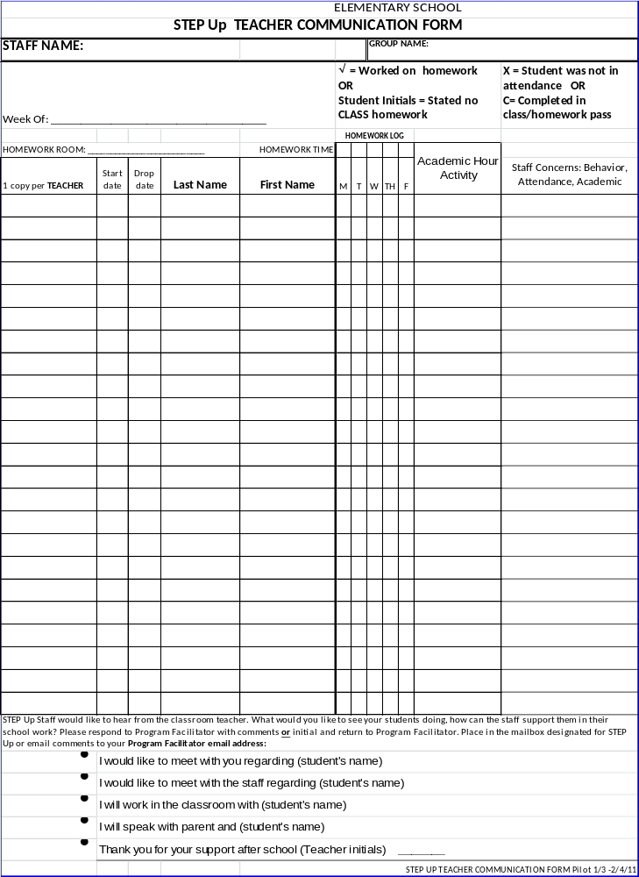

APPENDIX D - Examples of Snacks Served After School

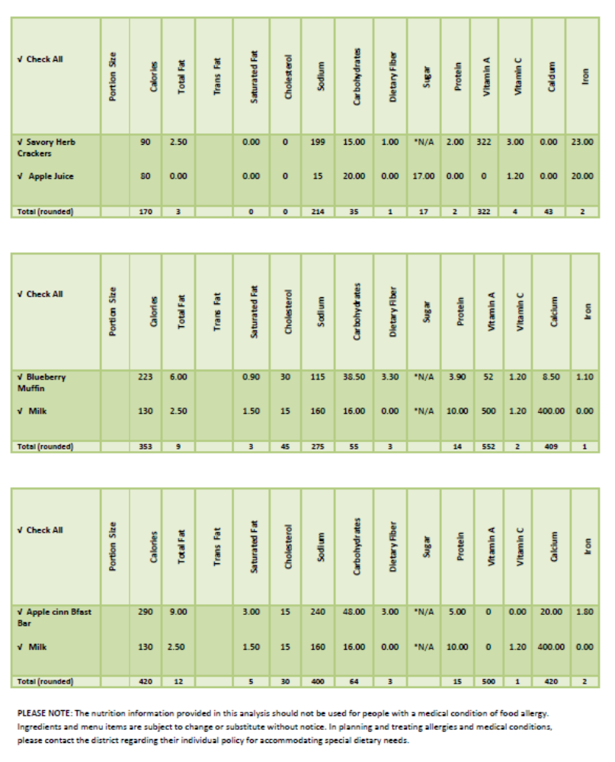
APPENDIX E - Proposed Meeting Schedule for 2016-17

STEP Up Advisory
Date | Time | Room
August 24 | 9:00 am | 210
October 26 | 9:00 am | 210
January 25 | 9:00 am | 210
April 26 | 9:00 am | 210

 | Field Staff Coordinators
Date | Time | Room
August 26 | Noon | 210
September 30 | Noon | 210
October 28 | Noon | 210
December 2 | Noon | 210
January 27 | Noon | 210
February 24 | Noon | 210
March 31 | Noon | 210
April 28 | Noon | 210

 | Program Facilitator Meetings
Date | Time | Room
September 1, 2, 7, 8 &9 | 1:00 pm | 210
October 7 | 1:00 pm | 107
November 3,4, 9, 10 & 11 | 1:00 pm | 210
December 9 | 1:00 pm | 107
January 5, 6, 11, 12, & 13 | 1:00 pm | 210
February 2, 3, 8, 9, &10 | 1:00 pm | 210
March 2, 3, 8, 9 &10 | 1:00 pm | 210
April 6, 7, 12, 13 & 14 | 1:00 pm | 210
May 4, 5, 10, 11 &12 | 1:00 pm | 210

 | Academic Hour Teacher Coordinator Meeting
Date |  | Time | Room
August 27 |  | 3:30 pm | 107
November 19 |  | 3:30 pm | 107
January 21 |  | 3:30 pm | 107
March 15 |  | 3:30 pm | 107
May 17 |  | 3:30 pm | 107

STEP Up Organizational Chart
Students
APPENDIX F – Organizational Chart
STEP Up Advisory
CBO Partner
STEP Up Advisory
CBO Partner
APPENDIX G - Matching Funds
STEP UP Administrator

ASES Matching Funds
The After School Education and Safety Program Legislation states that each program shall provide at least 33 per cent cash or in-kind matching funds from the school district, governmental agencies, community organizations, or the private sector for each dollar received in grant funds. Please provide detailed match amounts and descriptions for the entire amount requested in the grant.
The value of donated facilities or space can be used to fulfill up to 25 per cent of the required match. Only state funds for remedial education are prohibited from being used for the match.
Please enter data in the cells highlighted in blue only
Grant Award: | $5,732,356.00
33% Match Required: | $1,891,677.48
25% Facilities Match | $472,919.37
Match Description | Quantity | Unit | Value per Unit | Days of Use | Total Value
Use of Multipurpose Room | 117 | Hr. | $42.58 | 180.00 | $896,734.80
3 hours a day for 39 sites |  |  |  |  | $0.00
 |  |  | Total |  | $896,734.80
 | Allowable Space Usage Match: |  |  |  | $472,919.37
Other Collaborative Match | $1,418,758.11
Match Description | Quantity | Unit | Value Per Unit | Days of Use | Total Value
Second Harvest Food Bank | 1 |  | $537,959.24 | 1 | $537,959.24
Free/Reduced (Snacks) | 701048 |  | $0.82 | 1 | $574,859.36
LCAP | 1 |  | $239,635.00 | 1 | $239,635.00
EL Tutoring Title III | 1 |  | $261,570.12 | 1 | $261,570.12
City of Stockton | 1 |  | $0.00 | 1 | $0.00
Jacoby Center (UOP) | 1 |  | $98,287.00 | 1 | $98,287.00
Title I/Families In Transition | 1 |  | $35,623.00 | 1 | $35,623.00
TABLE | 1 |  | $51,728.58 | 1 | $51,728.58
YMCA | 1 |  | $60,500.00 | 1 | $60,500.00
USTA | 1 |  | $6,480.00 | 1 | $6,480.00
SES | 1 |  | $375,645.33 | 1 | $375,645.33
Donations | 1 |  | $936.30 | 1 | $936.30
CCI | 1 |  | $5,915.00 | 1 | $5,915.00
Harmony Stockton | 1 |  | $123,198.77 | 1 | $123,198.77
Community Presentations | 1 |  | $2,775.46 | 1 | $2,775.46
Volunteers | 6350.25 |  | $10.00 | 1 | $63,502.50
 |  |  | Total |  | $2,438,615.66
Total Match Required: |  |  | $1,891,677.48
Total Documented Match: |  |  | $2,911,535.03
APPENDIX H -EARLY RELEASE FORMS English/Spanish

STOCKTON UNIFIED SCHOOL DISTRICT STEP UP AFTER SCHOOL PROGRAM

EARLY RELEASE FORM

A child may be released early from the _____________ afterschool program prior to the end of the program time of ___ p.m. based upon the conditions outlined below. This agreement will be in effect as of _____________ through the last day of the program or through _______________.

NAME OF STUDENT:

CHECK APPLICABLE BOX:

1. Attending a parallel program
2. Family Emergencies (such as a death in the family, catastrophic incidents, etc.).
3. Medical Appointments.
4. Safety issues (darkness, weather)
5. Child accidents that occur during program time (program staff should call parent or guardian).

6. Religious obligations/events

7. Family needs
8. Transportation
9. Other conditions as prescribed by the Administration.

Parent, guardian, or program staff should sign the child out; in the case of program staff signing out the child, it is recommended that the child’s signature or initial be recorded as well.

____________________________________ Signature of Parent/Guardian or Date
Authorized Individual

DISTRITO ESCOLAR UNIFICADO DE STOCKTON
PROGRAMA EXTRACURRICULAR “STEP UP”

FORMULARIO DE SALIDA ADELANTADA

Un estudiante puede irse del programa extracurricular de la escuela __________________antes de la salida programada de las _____p.m. bajo las siguientes condiciones. Este acuerdo entrará en efecto desde el día ______________ hasta el último día del programa o hasta el día _____________.

NOMBRE DEL ESTUDIANTE:

MARQUE LA CAJA APROPIADA:
1. Asistiendo a un programa paralelo (programas en la escuela o deportes fuera de la escuela como fútbol soccer, baloncesto, etc.)
2. Emergencias Familiares (como una muerte en la familia, incidentes graves, etc.).
3. Citas Médicas.
4. Problemas de seguridad (oscuridad, clima)
5. Accidentes del niño(a) durante la duración del programa (personal del programa deben llamar al padre o guardián.)
6. Obligaciones/eventos religiosos
7. Necesidades de la Familia
 8. Transportación
9. Otras condiciones, dictadas por la Administración.

Padres, guardianes, o personal del programa deben de firmar por el estudiante a hora de salir, en el caso que el personal del programa firme por el estudiante, es recomendado que el estudiante firme su nombre o sus iniciales también.

____________________________________ ______________________
Firma del Padre o Guardián o Fecha
Persona Autorizada

