2024-2025 SSMS Student Handbook

We are looking forward to a successful and exciting year for all of you. The information contained in this student planner will provide you with important information about school services, procedures, rules, regulations, and activities. You can guarantee your success by giving the maximum effort in the classroom. We also encourage each one of you to participate in at least one school activity.

The entire faculty is willing to offer you help and assistance but remember you are responsible for your own success. You must be an active learner. Do not hesitate to seek advice or assistance from your teachers, aides, counselor, or administrators. We encourage your best efforts and are confident you will have a great year!

Everyone deserves to be treated with respect and dignity. EVERYONE includes: students, teachers, secretaries, aides, custodians, cafeteria staff, and bus drivers. If you want to be treated with respect, you must first show respect to others.

Sumter County Schools Vision Statement
Preparing the Next Generation Today

Sumter County Schools Mission Statement
The Sumter School District is committed to providing a rigorous and relevant standards-based education in a safe environment. Through a partnership of students, parents, staff and community, students are given the opportunity to reach their full potential as lifelong learners and contributing members of society.

SSMS Vision/Mission Statement
Vision: Inspiring everyone to achieve personal excellence.

Mission Statement: The Raider Family will promote life-long learners to attain personal excellence by encouraging resiliency in the face of challenges, being committed to achieving goals, and positively impacting society. As a result, our students will embrace defeat, persevere, and celebrate success as a part of their growth and preparation for high school and beyond.

SSMS Expectations
H – Have Respect
O – Own Your Outcomes
W – Work Your Hardest
L – Lead Positively
Accidents
To ensure a safe environment, accidents in the school buildings, on the school grounds, or at any school function must be reported immediately to the person in charge of the event. An accident report must be filled out in the office.

Alternative Education
The Alternative Education Program at SSMS is designed to help students who are disruptive in school. The program is an isolation-type situation where students will not have contact with fellow students during the school day; however, students will be completing assigned academic work to be graded by the regular classroom teacher. Students are provided with a set of rules and guidelines to read and sign upon assignment to AE. Assignments to the AE program is made on an individual basis. Students are expected to complete all assignments while working quietly and efficiently in a designated seat. Any student that refuses to serve his or her designated AE assignment will be suspended.

Attendance
Attendance in school to age 16 is required by law. Recent legislation has mandated ways in which schools must enforce attendance laws. Criteria for determining excused absences shall be as provided in Florida Statutes, which include absence for religious instruction or a religious holiday, absence due to sickness, injury, or other insurmountable condition, an absence due to participation in an academic class or program. Additionally, a parent may submit a Student Vacation/Leave Form for principal approval however, only the first 9 absences will be eligible for approval per semester. Parents may write a note to excuse a student’s absence up to the first 9 times in a semester. On the 10th absence and thereafter in a semester, a doctor’s note will be required to excuse the absence. Students have 3 days upon their return to school to turn in their letters and/or doctor’s notes to excuse their absence.

The school will notify the parent in writing as a method of early intervention after the student has 4 unexcused absences. When a student has 5 unexcused absences, the school will initiate a Child Study Team meeting with the parent and student to develop an attendance agreement. The school coordinates with Youth and Family Alternatives on truancy issues. The school may utilize the School Resource Officer to serve Child Study Team meeting notices and/or home visits. When a student has 7 unexcused absences, an attendance contract is signed by the student and parent outlining immediate actions to be taken to improve school attendance. Upon the 15th unexcused absence in a 90-calendar day period, the student meets criteria for parental prosecution and/or designation of the child as a “child in Need of Services” as the child is alleged to be a habitual truant. (FS 1003.26.1.e) The student’s name will be reported to the State’s Attorney and the Department of Motor Vehicles and the student’s driver’s license will be suspended.

Absence Procedure: The student should take the written excuse to the cafeteria before first period. Failure to follow this procedure within 3 days of returning to school with result in an automatic unexcused absence. Students with unexcused absences will receive a grade no higher than 59% for the classes missed. In order to participate in after school activities, a student must attend at least ½ of the school day. If a student becomes ill or is injured at school, the parents will be notified by telephone. To help us accommodate your sick child, or in the case of an emergency, parents should have a CURRENT ADDRESS and PHONE NUMBER on file in the school office. Emergency forms are to be completed online through Skyward. Notifying parents or guardians in case of an accident or serious illness is of benefit to all and is expedited by these forms.

Tardy Policy/Early Checkouts
Tardies and Early Checkouts: Parent(s) may write a note to excuse up to 3 tardies, early checkouts, or any combination of the two per semester. Any tardies and/or checkouts beyond that will require a doctor’s note to be excused. All other tardies and checkouts will be considered unexcused. Students with unexcused tardies and checkouts will receive a grade no higher than 59% for the classes missed. **This is not the same process for being tardy in between classes**

Consequences:
- Upon the 3rd Tardy or Early checkout – Attendance Notice
- Upon the 5th Tardy or Early checkout – Long Form

To help ensure your child’s safety, students leaving the school during the day MUST BE CHECKED OUT THROUGH THE OFFICE. The office will page the student while the parent/guardian is signing out the student. All adults who are authorized by a parent to pick up a student must be listed on the emergency information on file in Skyward and will be required to show their ID. All early checkouts must occur prior to the last 20 minutes of the school day.
Custody of children: School personnel are bound by law to release children to either of their natural parents unless we have on file a copy of a court order which grants custody to either parent or a third party.

Before and After School Policies
To provide a safe environment, no student is allowed on the school campus or in the school building(s) after normal school hours unless supervised by a teacher. Students are to go home immediately after school is out. In the event unsupervised students are on campus after hours, they will be warned and we will attempt to notify parents. If this act is repeated, students will be placed on the trespass log at the Sheriff’s Department. (The early room will be open beginning at 8:00 a.m. each morning.) Supervision by school personnel will be limited to 30 minutes before and 30 minutes after school or school activity.

Books, Etc.
Damaged or lost textbooks or library books must be paid for before another book is issued or checked out. Please take good care of your valuable textbooks and return library books on the assigned due date. Library books are checked out for two weeks. Students must have their ID badge to check out a book. The student must record the due date in his or her planner. At the end of each school year, students must meet all responsibilities and obligations to the school. Such obligations include, but are not limited to, book fines, damaged classroom materials, lost or damaged textbooks, and library books. School activities, including but not limited to 8th grade promotion, will be reserved only for those students meeting all school obligations.

Bullying and/or Harassment
Our Code of Student Conduct states that bullying and/or harassment will not be tolerated. All incidents of possible threats, signs or discussions of weapons, signs of gang activity, inappropriate use of technology, or the conditions that might invite or encourage MUST be reported to an adult. This may also include, but not limited to, teasing, name calling, intimidation or spreading of rumors. The following informational link may be found on the district website: http://www.stopbullying.gov/

Care of the School
You should take pride in and care for your school building, both inside and outside. Respect and pride means keeping the building neat and clean. You can show your pride by:
- Throwing all trash, etc. in the wastebaskets
- Helping teachers pick up papers from the floor
- Not writing on the desks and walls
- No gum
You are expected to assume responsibility for the care of all school property. If you damage property, you are responsible for paying for the damage.

Cellular Devices
Students who choose to carry a personal cell phone on campus must turn the phone off and put it in their book bag. Smartwatches with cellular capabilities may not be used and must be in the “Do not Disturb” mode while on campus. Failure to follow these rules will result in the following disciplinary measures:
- 1st Violation: The student must give their phone/smart watch to the staff member to be placed in the front office to be picked up by the parent.
- 2nd Violation: Same as the 1st violation and Short Form
- 3rd Violation: Same as the 1st violation and Long Form (1 day AE)
Any further violations will result in a long form with disciplinary actions.

Drug and Alcohol Policy
The unlawful possession and use of alcohol, illegal drugs, or any substances when used as a hallucinogenic substance is wrong and harmful. At a minimum, the unlawful possession, use, or distribution of such by students on school premises, or, as part of any of the schools' activities, is prohibited. This also includes use, possession and distribution of a drug, tobacco, or nicotine product or paraphernalia. Tobacco and nicotine products shall not be limited to any lighted or unlighted cigarettes, cigars of pipe tobacco, chewing tobacco or snuff and electronic cigarettes (also known as e-cigs, vapes, vaporizers). Responses, as included herein, up to and including expulsion and referral for prosecution, will be imposed on students who are in violation of this infraction.

End of Year Honor’s Ceremony
An Honor’s Ceremony will be held in May. The students who meet the following criteria will be invited:
- Honor Roll A & A/B for the first 3 quarters
- Presidential Award of Excellence - (8th grade only) see requirements below
  - Cumulative GPA of a 3.0 for 6th, 7th and the first semester of 8th grade.
  - Level 4 or 5 on either the FAST Reading or Math.
- Presidential Award of Achievement - (8th graders only)
  - 8th grade teachers will select four (4) students with a high work ethic and who have demonstrated academic excellence in their core classes.

Evacuation Drills
Evacuation drills are considered very important. They are held regularly to develop safety practices that will help you move quickly and in an orderly manner out of the building during an emergency.

The signal is a repeated tone with a message. When the signal is given, you must give your full attention to your teacher and await instruction regarding the evacuation of the building. Then you must respond promptly and leave the building by the prescribed route, in a single file line, staying with your class. You will remain outside until the signal is given to return to the building. No talking or distraction while leaving or reentering the building will be tolerated.

False fire alarms endanger the lives of all students and other school personnel. Any student who sets off a false alarm or tampers with fire extinguishers could be suspended or expelled and possibly turned over to law enforcement officials.
Food Delivery Services
Students are not permitted to have food delivered unless it is delivered by a parent or guardian. Delivery drivers will not be permitted to leave the order with the office staff at any time.

Grade Checks
Grade checks will be completed on a weekly basis and require a parent/guardian signature.

Hazing
The Sumter County School Board will not tolerate hazing. Hazing means any action or situation that endangers the mental or physical health or safety of a student at a school with any school with grades 6 through 12 for purposes of initiation or admission into or affiliation with any school-sanctioned organization. It includes, but is not limited to: (a) pressuring, coercing, or forcing a student to participate in illegal or dangerous behaviors, or (b) any brutality or physical nature, such as whipping, beating, branding, or exposure to the elements.

Health Services
All 6th grade students receive vision, hearing, height, weight, BMI, and scoliosis screening during the year by a qualified nurse as required by the State of Florida.

Immunizations required for 7th Grade: TDAP (Tetatanus, Diptheria, Accelluar Perussis) Your child must have started or completed the immunization requirements pursuant to Florida Statutes to be able to attend school. Please send any updated blue cards (DH680) to the school.

Prescription medications must be in the proper container and must be kept in the administration office. Students are NOT allowed to carry ANY medication, prescription or over-the-counter (aspirin, etc.), on their person during the school day. The only exceptions are inhalers and epi-pens with a doctor’s order on file stating the child may self-carry these medications. A student may possess and use a medication to relieve headaches while on school property or at a school-sponsored event or activity without a physician's note or prescription if the medication is regulated by the United States Food and Drug Administration for over-the-counter use to treat headaches.Students must have a parent permission form on file, the medicine must be in the original container and students cannot share/distribute the medication. There will be disciplinary action for sharing/distributing medication. Health service access forms must be completed annually through Skyward.

Hotline
We have a student HOTLINE (1-800-423-TIPS) to anonymously report unsafe actions. Please use it if you notice any suspicious activity that you fear could lead to violence or illegal activities in our school.

ID Badges
Students are to come to school each day with their school ID badges. These badges are used for bus transportation, the breakfast/lunch program and checking out books from the media center. Each student is given an ID badge at the beginning of the school year. Should a student forget their ID badge at home, they should report to the office before Raider Time to obtain a replacement badge. Replacement badges are $3 (Raider Bucks can also be used to purchase ID badges). Students choosing not to wear an ID badge will face disciplinary actions: warning, short form, long form.

Lunchroom
The lunchroom is a place for students to enjoy their breakfast and/or lunch meal. In order to maintain a pleasant environment appropriate behavior is important. Students should use a “quiet” voice inside of the lunchroom. Students should eat in an orderly manner. Choose a seat and remain seated until you have finished eating. When finished eating, students should take their trash to the appropriate location.

Parent Conferences
Parents are welcome and we encourage you to come to talk with teachers and the counselor. To minimize disruption of instructional time, appointments will be made to coincide with the teachers’ schedules. Parent conferences are usually Tuesdays and Thursdays prior to the beginning of the school day.

Physical Education
All students taking P.E. will be required to wear dress out for PE in appropriate attire. Students must wear t-shirts and shorts in school colors (red, gray, white, or black). The length of shorts must extend beyond the fingertips. Sweatpants and sweatshirts are allowed during cool weather. Sunglasses and/or hats are allowed when classes are outside. Students must wear sneakers to participate in activities in the gym. Students are not allowed in the gym without adult supervision approved by the principal.

Pledge of Allegiance
A student may be excused from instruction and/or reciting the pledge of allegiance, including standing and placing the right hand over his or her heart when his/her parent(s), as defined by Florida Statutes, files a written request with the school principal.

Quarterly Reward Celebrations
An Honor Roll Ceremony will be held for the first, second, and third quarter of the year. Students who meet the following criteria will be invited:
- A Honor Roll: Straight A’s in all classes each quarter.
- A/B Honor Roll: Combination of A’s and B’s each quarter.
A Quarterly Rewards Day will be scheduled at the conclusion of each quarter: Students who meet the following criteria will be invited:
- No more than 3 unexcused absences
- 70% of AR goal
- 65% or higher in all classes
- No long forms
- No more than 5 minor incidents (ex: lunch detentions, tardy, dress code violations, etc.)

Raider Bucks
All staff will reward students with Raider Bucks for following the HOWL expectations. Students may not trade Raider Bucks with other students.

School Expenditures
Per full-time Equivalent Student Direct School Expense 2022-2023: $10,561.

Student Conduct and Discipline
The primary purpose of education in our school is to meet the needs of our students in a safe environment. Self-discipline is vital to this process. To achieve this goal, there are certain expectations and standards that we feel are necessary. SSMS students are expected to behave in a manner that reflects self-disciple, maturity and consideration for others. The following behaviors are examples of conduct that are prohibited at SSMS:
- Possession, use, and/or sale of drugs (licit or illicit), alcoholic beverages and/or tobacco products
- Possession/use of weapons or dangerous instruments
- Fighting
- Theft
- Profane, abusive, or inappropriate language
- Refusal to obey directions
- Engaging in disruptive conduct
- Disrespect to staff
- Harassing behavior-bullying
- Hazing
- Continuous classroom misbehavior as documented by Short Form
- Running
- Bringing dangerous objects of any kind. If an object has no reasonable purpose at school, leave it at home.
- Out of class or leaving class without permission
- The sale of any item on campus without permission of the principal
- Use of video games, cell phones, etc. If any of these items are taken from you, your parent(s) or guardian(s) must personally come to school to claim them. They will not be returned to you.
- Inappropriate dress
- Inappropriate use of technology

While this list of misbehavior is not intended to be all-inclusive, it illustrates the types of behaviors that are inconsistent with an effective educational program – behaviors, which will not be tolerated. The listed behaviors and others are considered Major Disciplinary Infractions and will be dealt with immediately using one or more of the following:
- Parent contact/warning
- Conferences, detention
- Assignment to Alternative Education (ISS)
- Suspension
- Recommendation for Alternative Placement
- Expulsion
In addition, your classroom teacher will establish rules that you are expected to follow while you are in that teacher’s classroom. If you violate these class rules, you will be written up on a Long Form. The teacher will attempt various strategies to help you correct your inappropriate behavior. One of these strategies is a required contact with your parents through phone calls, notes, and conferences or mailed conduct reports. The following items concerning discipline and student conduct in general at SSMS are provided for your information:
Ask before you act – if you are unsure whether an item or act is permissible, ask a teacher. If you are having a problem of any nature, immediately contact the teacher responsible for your supervision: Do not wait until later to report problems.

Student Transfer Process
Thirty (30) days prior to the beginning of each semester, the district will post a list of the out-of-field teachers on the district website. A parent whose student is assigned an out-of-field teacher may request that his or her child be transferred to an in-field classroom within the school and grade in which the student is currently enrolled. Any parent may request his or her child to be transferred to another classroom teacher once during a school year. The request must be made in writing and given to the school principal. The parent does not have the right to select the specific classroom teacher. These requests may not put a classroom over the state-mandated class size. The principal must notify the parent and specify the reasons for the denial.

Sumter County Code of Student Conduct: Summary for Students
The lawmakers of Florida have passed a law, which says that schools must have a Code of Student Conduct. A copy of this publication will be provided for each student in Sumter County. It will be reviewed and discussed with students.

This Code of Student Conduct tells you about your rights as a student in the school and also tells you about the rules you must follow as students. (Students are under the jurisdiction of the school Board Policy from the time they leave home until the time they return home after school.

Sumter County Schools Non-Discrimination Statement
Sumter County Schools does not discriminate on the basis of race, color, national origin, gender, age, disability, pregnancy, or marital status in its educational programs, services, or activities, or in its hiring or employment practices. The district also provides equal access to its facilities to the Boy Scouts and other patriotic youth groups, as required by the Boys Scouts of America Equal Access Act. Questions, complaints, or requests for additional information regarding discrimination or harassment may be sent to:

Helen Christian
Senior Director, Curriculum and Instructional Services
Title IX Coordinator
Phone Number: 352-793-2315 X 50204

Dana Williams
Senior Director of Human Resources,
Civil Rights Protection
Phone Number: 352-793-2315 X 50251

Debbie Moffitt
Assistant Superintendent
Phone Number: 352-793-2315 X 50260

Jennifer Wyatt
504 Coordinator
Phone Number: 352-793-2315 X 51210

Located at: The Sumter County School Board
2680 W CR 476
Bushnell, FL 33513

Tardy Hall
Students who arrive late to class (after the bell rings) during class changes will be sent to Tardy Hall by their classroom teacher. Once sent to Tardy Hall, students will remain there for the duration of that class period. Repeat tardies within a semester will result in the following disciplinary measures:
- 2nd Tardy: Short Form
- 3rd Tardy: 1 day in AE
- 4th Tardy: 2 days in AE
- 5th Tardy: 3 days in AE
- 6th Tardy: 1 day out of school suspension
- 7th Tardy: 2 days out of school suspension
- 8th Tardy: 3 days out of school suspension

Technology
SSMS students have 1:1 devices on campus. It is the expectation of the school that students will come each morning with their device (device should be charged) and a charger. Failure to follow this rule will result in the following disciplinary measures:
- 1st Violation: Parent Phone Call
- 2nd Violation: Lunch Detention
- 3rd Violation: Short Form
- 4th Violation: Long form (1 day AE)
Any violation after the fourth will accumulate days of AE.

Transportation
Once a student arrives at school by bus, car, bicycle, or walking, he/she is not allowed to leave unless he/she checks out through the office. Violations will result in serious consequences due to the dangers involved in being off campus without permission. Students will not be allowed to get off the bus at a different stop unless written permission from parents is granted and approved by the principal or designee. Written permission for a change in bus transportation for a day pass has to be received in the front office before a student can ride another bus. Approval will be determined based on seat availability on the bus. For permanent bus changes, documentation of a change in residency is required and the transportation department may take up to 3 days for determination of approval. Written permission for a change for walkers and/or parent pick-up has to be received in the front office prior to permission being granted. The administration reserves the right to deny any transportation request not meeting this criterion. Students may not ride buses unless they are assigned to a bus or have a bus pass. ALL students are expected to follow the bus regulations when on the bus. Riding the bus is a privilege based on appropriate behavior.

Visitors
ALL visitors must report to the front office before going to a class or contacting a student. Visitors must have a driver’s license or identification. No one will be allowed to visit a student without permission from the administrative office! Students are not allowed to bring guests to school to spend the day.

Volunteers
All volunteers must be approved at the individual school each year before they can volunteer in any capacity at SSMS. This includes a completed volunteer application, a copy of the applicant’s driver’s license, and approval by the Sumter County School Board. Since the process takes several weeks, please apply early. Volunteer applications can be found at https://www.sumter.k12.fl.us/site/Default.aspx?PageID=4213

Water Bottles
Students are allowed to have water bottles with screw-on lids on campus. Bottles should not have anything other than water in them and can be refilled at the water bottle refill stations throughout campus. Caffeinated beverages may be consumed during breakfast or lunch. They may not be carried around and consumed throughout the day.

Student Dress Code
A positive relationship exists between a student’s actions and accomplishments and the way he or she dresses. The following dress code will be strictly enforced:
Shirts and Tops
Any collared polo or button-up shirt. This shirt may be solid-colored or have school appropriate patterns and/or designs. Shirts can be tucked in or worn out but must be long enough that they would cover the belly when arms are raised. Students must have shirt buttoned no more than the student’s hands width from the neck. Turtlenecks can be worn under a collared shirt for extra warmth, but do not meet collared shirt criteria.

- No large wording, inappropriate content or holes
- No low cut or revealing shirts
- No sheer or see-through material

Pants and Capris
Jeans or Dockers-styled pants/capris in solid colors and/or school appropriate prints are permitted. All pants and capris must be worn at the waist (with a belt if necessary). Undergarments should not be visible.
- No holes including unintentional, intentional, manufactured shredding, tearing or patchwork
- No sweatpants, pajama pants, house pants, or athletic pants
- No leggings, jeggings, tights or other form fitting pants are acceptable
- No sheer or see-through material
Shorts and Skirts
Jeans or Dockers-styled shorts/skirts in solid colors and school appropriate prints are permitted. All shorts and skirt lengths must reach to the width of a dollar bill from the back of the knee (this includes slits in skirts).
- No holes including unintentional, intentional, manufactured shredding, tearing or patchwork
- No swim shorts
- No athletic or form-fitting shorts (spandex, etc.) are acceptable
- No sheer or see-through material
Dresses
Collared dresses are allowable but must reach to the width of a dollar bill from the back of the knee. Collared dresses in solid colors and school appropriate prints are permitted. Tights or leggings can be worn under a dress.
- No holes including unintentional, intentional, manufactured shredding, tearing or patchwork
- No sheer or see-through material
Jackets, Sweatshirts, Sweaters, etc.
Jackets, coats, etc. are intended to be worn outside. Camo jackets, jackets with patterns, designs, etc. will be allowed if the content is school appropriate. Trench coats will not be allowed. Hoods on jackets are allowed and may be worn outside in cold weather only. Pullover sweaters, sweatshirts and hoodies are allowed to be worn over a collared shirt. Large printing of name brands will be allowed (i.e. Nike, Aeropostle, etc.). School appropriate phrases and/or pictures will be allowed.

Shoes

Athletic shoes, boots and sandals with heel straps will be allowed. Unsafe footwear is not permissible. (i.e., rubber shower shoes, flip flops of any kind, backless sandals, SLIDES, high heels over 2 inches, platforms, house shoes, slippers, Heelys). Crocs can only be worn if the heel strap is worn behind the heel.

Accessories

Hoods, caps, and ski hats will only be permitted outside of the building when the weather is below 40 F. Caps and hats must be fastened to a student’s backpack or stored in their P.E. locker. Jewelry, belts, chains, make-up, and other accessories that create a significant disruption may not be worn (i.e., flashing belts). Nose piercings are limited to a small stud being acceptable. Gloves can be worn during cold weather when outside. Sunglasses are permitted during PE and can be stored in a student’s backpack or P.E. locker.

- No fingerless gloves will be allowed
- No combs or picks are to be worn in the hair
- No lip piercings, tongue piercings, etc. are to be worn
- No wallet chains, bandanas, or sweatbands
- No using bandanas as a hair tie

The administration will make a final judgement on any other accessory not mentioned above.
Special Days
The school will occasionally sponsor days to show school spirit, team spirit, etc. These days will be announced or will be posted on the website so that students can be sure to dress within the guidelines of the sponsored day (i.e., sports jerseys or team shirts representing a favorite team). Also, student-athletes can wear their assigned jersey over their collared shirt on athletic event dates.

AR T-Shirt Passes/Reward T-Shirt Passes:
- Can be used on any day of the week
- Awarded by ELA (English Language Arts) teachers when student meet their weekly AR reading goal or through a special award (attendance)
- T-Shirt pass is a red wristband that must be initialed and dated by the Raider Time teacher the day the pass is used
*Please note, this is not a ‘dress code pass’ and only allows student to wear a school appropriate t-shirt of their choice.
Other
Exposure of undergarments is unacceptable. Content on all clothing, book bags, jewelry, etc. must be school appropriate (i.e. no rebel flags). Administration reserves the right to make final judgement on any clothing or accessory that is questionable.

Dress Code consequences are as follows:
- 1st Violation – Sent to the office, call home, warning dress code form sent home to parent, change of clothes if necessary
- 2nd Violation – Sent to the office, call home, dress code form sent home to parent, change of clothes, if necessary, remainder of day in AE or until issue is resolved.
- 3rd Violation – sent to office, call home, dress code form sent home to parent, long form (Level I, Inappropriate Dress), AE (1 Day)
- 4th Violation – sent to office, call home, dress code form sent home to parent, long form (Level II, Repeated Level I), AE (2 Days)
- 5th Violation – sent to office, call home, long form (Level III, Gross Insubordination), 1 day OSS
Any dress code offense after 5 will accumulate suspension days.

Mid-term Progress Reports
The Mid-term Progress Reports are issued halfway through each grading period (although they may be given at any time). Progress Reports are an important means of letting both students and parents know about achievement in a particular subject. The report should be taken home, signed by a parent/guardian and returned to the teacher. If you have a question or a concern, please make an appointment for a conference with your child’s teachers. To further help parents monitor their child’s progress, please use the parent viewer for the on-line gradebook.

MIDTERM ENDS
September 13, 2024
November 20, 2024
February 18, 2025
April 30, 2025
PROGRESS REPORT AVAILABLE TO PARENTS
September 19, 2024
December 3, 2024
February 24, 2025
May 6, 2025
SEMESTER ENDS
1st Nine Weeks Ends - October 17, 2024
2nd Nine Weeks, 1st Semester Ends - January 15, 2025
3rd Nine Weeks Ends –March 22, 2025
4th Nine Weeks, 2nd Semester Ends – June 3, 2025
REPORT CARD DATES
1st Nine Weeks –October 23, 2024
2nd Nine Weeks – 1st Semester – January 22, 2025
3rd Nine Weeks – April 3, 2025
4th Nine Weeks, 2nd Semester– June 3, 2025

Sign and Return to Your Raider Time Teacher

We have read this handbook for success at South Sumter Middle School. We acknowledge the attendance policy, 1 to 1 technology policy, dress code, and behavior expectations of South Sumter Middle School.

We understand that ___________________________is responsible for this student planner and should always keep it with her/him. Assignments are to be written directly onto the calendar, enabling us to be aware of class responsibilities. Planners are also required for checking out textbooks and library books.

If this handbook is lost or destroyed the student and/or parent is responsible for replacing it at a cost of $6.00.

____________________________ __________

Parent Signature Date

____________________________ __________

Student Signature Date

COLOR EACH SCHOOL DAY AS IT REFLECTS YOUR ATTENDANCE
PRESENT = GREEN |  |  |  |  |  |  |  |  |  |  |  |  |  |  |  |  |  | PRESENT = GREEN
AUGUST |  |  |  |  |  |  |  | SEPTEMBER |  |  |  |  |  |  |  |  |  | OCTOBER |  |  |  |  |  |  |  |  |  | NOVEMBER
S | M | T | W | T | F | S |  | S | M | T | W | T | F | S |  |  |  | S | M | T |  | W | T | F | S |  |  | S | M | T |  | W | T | F | S
 |  |  |  | 1 | 2 | 3 |  | 1 | 2 | 3 | 4 | 5 | 6 | 7 |  |  |  |  |  | 1 |  | 2 | 3 | 4 | 5 |  |  |  |  |  |  |  |  | 1 | 2
4 | 5 | 6 | 7 | 8 | 9 | 10 |  | 8 | 9 | 10 | 11 | 12 | 13 | 14 |  |  |  | 6 | 7 | 8 |  | 9 | 10 | 11 | 12 |  |  | 3 | 4 | 5 |  | 6 | 7 | 8 | 9
11 | 12 | 13 | 14 | 15 | 16 | 17 |  | 15 | 16 | 17 | 18 | 19 | 20 | 21 |  |  |  | 13 | 14 | 15 |  | 16 | 17 | 18 | 19 |  |  | 10 | 11 | 12 |  | 13 | 14 | 15 | 16
18 | 19 | 20 | 21 | 22 | 23 | 24 |  | 22 | 23 | 24 | 25 | 26 | 27 | 28 |  |  |  | 20 | 21 | 22 |  | 23 | 24 | 25 | 26 |  |  | 17 | 18 | 19 |  | 20 | 21 | 22 | 23
25 | 26 | 27 | 28 | 29 | 30 | 31 |  | 29 | 30 |  |  |  |  |  |  |  |  | 27 | 28 | 29 |  | 30 | 31 |  |  |  |  | 24 | 25 | 26 |  | 27 | 28 | 29 | 30
DECEMBER |  |  |  |  |  |  |  | JANUARY |  |  |  |  |  |  |  |  |  | FEBRUARY |  |  |  |  |  |  |  |  |  | MARCH
S | M | T | W | T | F | S |  | S | M | T | W | T | F | S |  |  |  | S | M | T |  | W | T | F | S |  |  | S | M | T |  | W | T | F | S
1 | 2 | 3 | 4 | 5 | 6 | 7 |  |  |  |  | 1 | 2 | 3 | 4 |  |  |  |  |  |  |  |  |  |  | 1 |  |  |  |  |  |  |  |  |  | 1
8 | 9 | 10 | 11 | 12 | 13 | 14 |  | 5 | 6 | 7 | 8 | 9 | 10 | 11 |  |  |  | 2 | 3 | 4 |  | 5 | 6 | 7 | 8 |  |  | 2 | 3 | 4 |  | 5 | 6 | 7 | 8
15 | 16 | 17 | 18 | 19 | 20 | 21 |  | 12 | 13 | 14 | 15 | 16 | 17 | 18 |  |  |  | 9 | 10 | 11 |  | 12 | 13 | 14 | 15 |  |  | 9 | 10 | 11 |  | 12 | 13 | 14 | 15
22 | 23 | 24 | 25 | 26 | 27 | 28 |  | 19 | 20 | 21 | 22 | 23 | 24 | 25 |  |  |  | 16 | 17 | 18 |  | 19 | 20 | 21 | 22 |  |  | 16 | 17 | 18 |  | 19 | 20 | 21 | 22
29 | 30 | 31 |  |  |  |  |  | 26 | 27 | 28 | 29 | 30 | 31 |  |  |  |  | 23 | 24 | 25 |  | 26 | 27 | 28 |  |  |  | 23 | 24 | 25 |  | 26 | 27 | 28 | 29
 |  |  |  |  |  |  |  |  |  |  |  |  |  |  |  |  |  |  |  |  |  |  |  |  |  |  |  | 30 | 31
APRIL |  |  |  |  |  |  |  | MAY |  |  |  |  |  |  |  |  |  | JUNE |  |  |  |  |  |  |  |  |  | JULY
S | M | T | W | T | F | S |  | S | M | T | W | T | F | S |  |  |  | S | M | T |  | W | T | F | S |  |  | S | M | T |  | W | T | F | S
 |  | 1 | 2 | 3 | 4 | 5 |  |  |  |  |  | 1 | 2 | 3 |  |  |  | 1 | 2 | 3 |  | 4 | 5 | 6 | 7 |  |  |  |  | 1 |  | 2 | 3 | 4 | 5
6 | 7 | 8 | 9 | 10 | 11 | 12 |  | 4 | 5 | 6 | 7 | 8 | 9 | 10 |  |  |  | 8 | 9 | 10 |  | 11 | 12 | 13 | 14 |  |  | 6 | 7 | 8 |  | 9 | 10 | 11 | 12
13 | 14 | 15 | 16 | 17 | 18 | 19 |  | 11 | 12 | 13 | 14 | 15 | 16 | 17 |  |  |  | 15 | 16 | 17 |  | 18 | 19 | 20 | 21 |  |  | 13 | 14 | 15 |  | 16 | 17 | 18 | 19
20 | 21 | 22 | 23 | 24 | 25 | 26 |  | 18 | 19 | 20 | 21 | 22 | 23 | 24 |  |  |  | 22 | 23 | 24 |  | 25 | 26 | 27 | 28 |  |  | 20 | 21 | 22 |  | 23 | 24 | 25 | 26
27 | 28 | 29 | 30 |  |  |  |  | 25 | 26 | 27 | 28 | 29 | 30 | 31 |  |  |  | 29 | 30 |  |  |  |  |  |  |  |  | 27 | 28 | 29 |  | 30 | 31
1st 9-Weeks: Aug 14 - Oct 17 |  |  |  |  |  |  |  |  |  |  |  |  |  |  |  |  | DAYS  PRESENT: |  |  |  |  |  |  |  |  |  |  | DAYS  ABSENT:
2nd 9-Weeks: Oct 18 - Jan 15 |  |  |  |  |  |  |  |  |  |  |  |  |  |  |  |  | DAYS  PRESENT: |  |  |  |  |  |  |  |  |  |  | DAYS  ABSENT:
3rd 9-Weeks: Jan 16 - Mar 28 |  |  |  |  |  |  |  |  |  |  |  |  |  |  |  |  | DAYS  PRESENT: |  |  |  |  |  |  |  |  |  |  | DAYS  ABSENT:
4th 9-Weeks: Apr 1 - Jun 3 |  |  |  |  |  |  |  |  |  |  |  |  |  |  |  |  | DAYS  PRESENT: |  |  |  |  |  |  |  |  |  |  | DAYS  ABSENT:

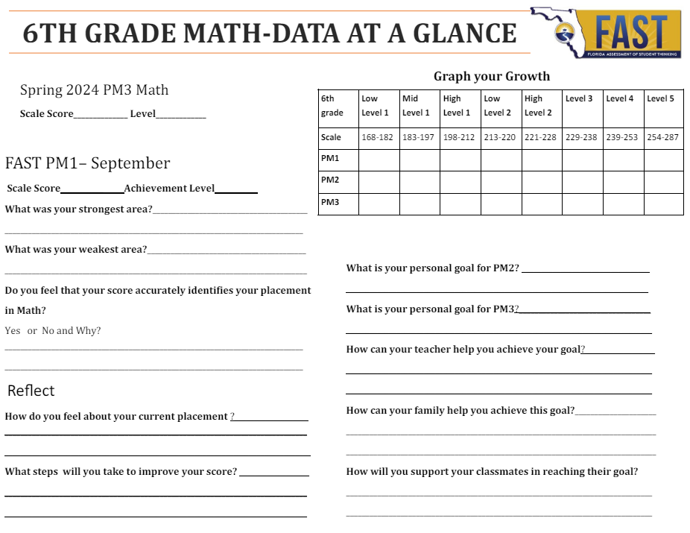
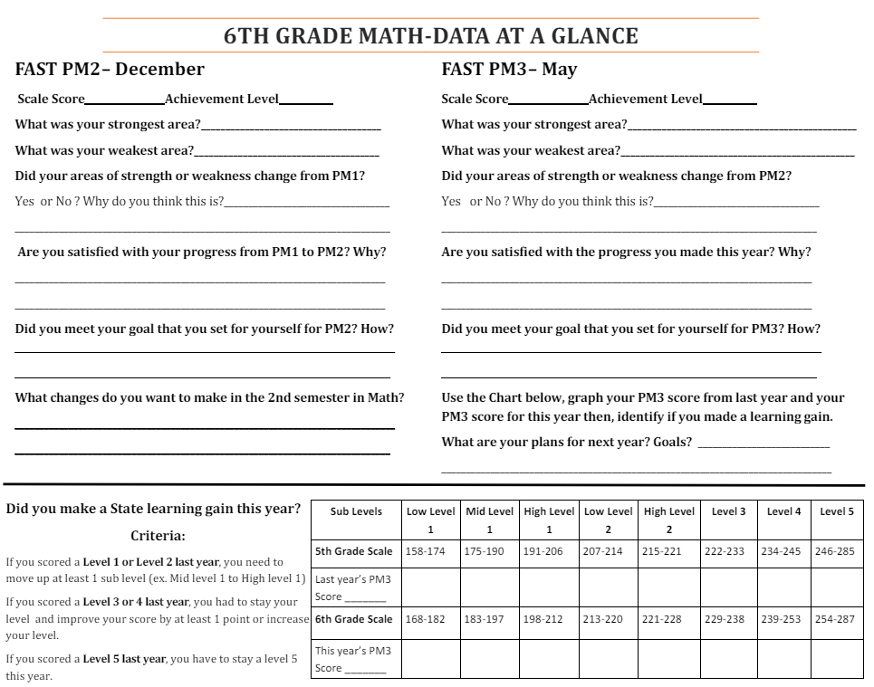
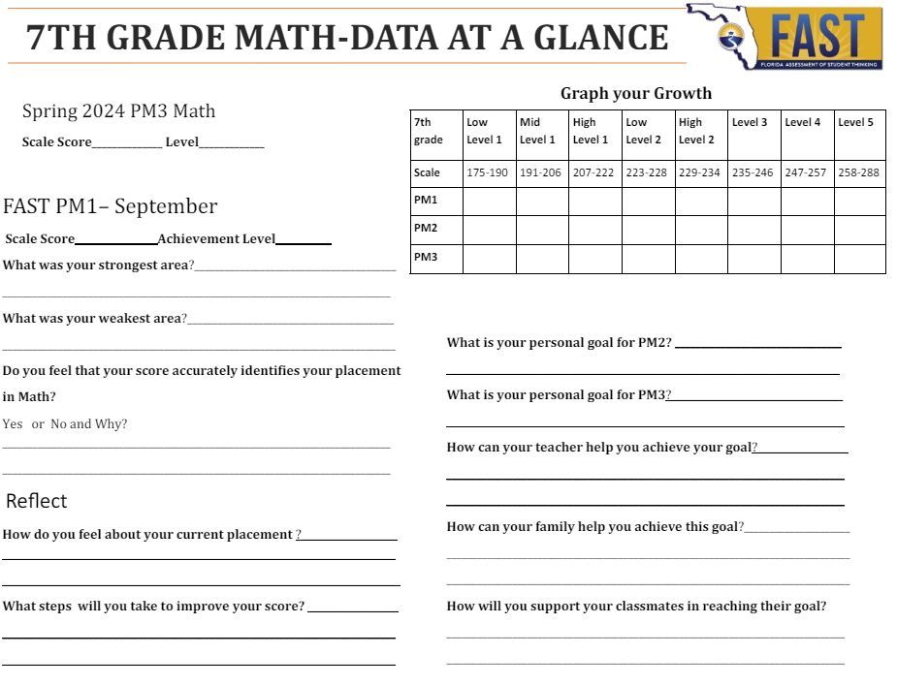
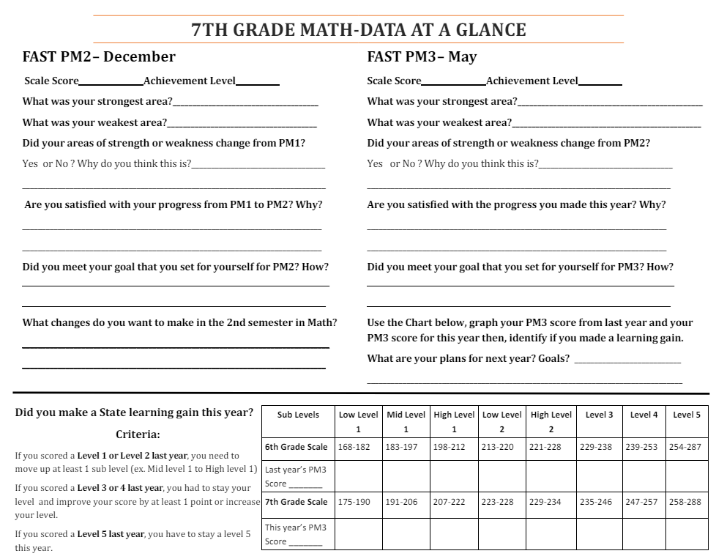
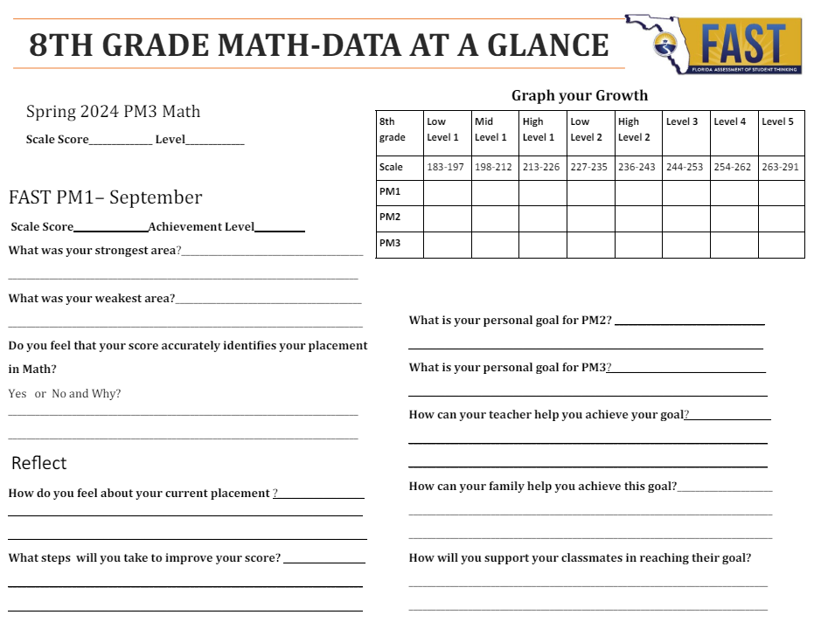
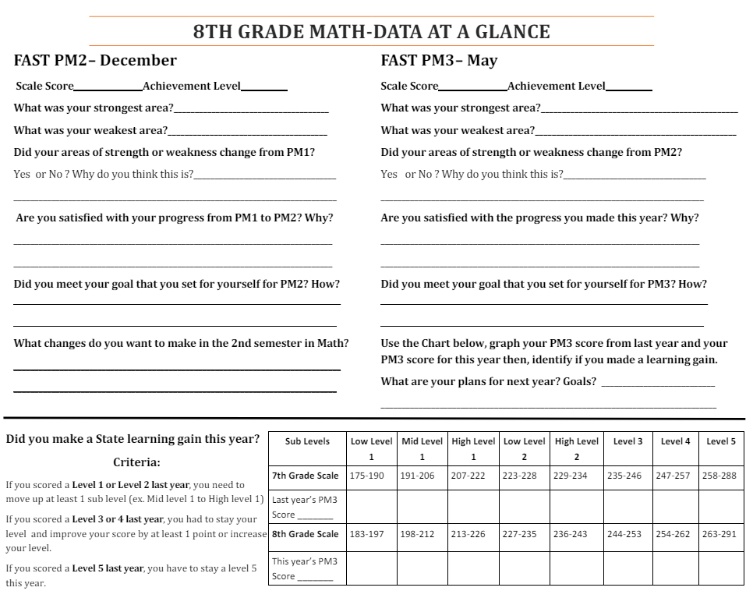
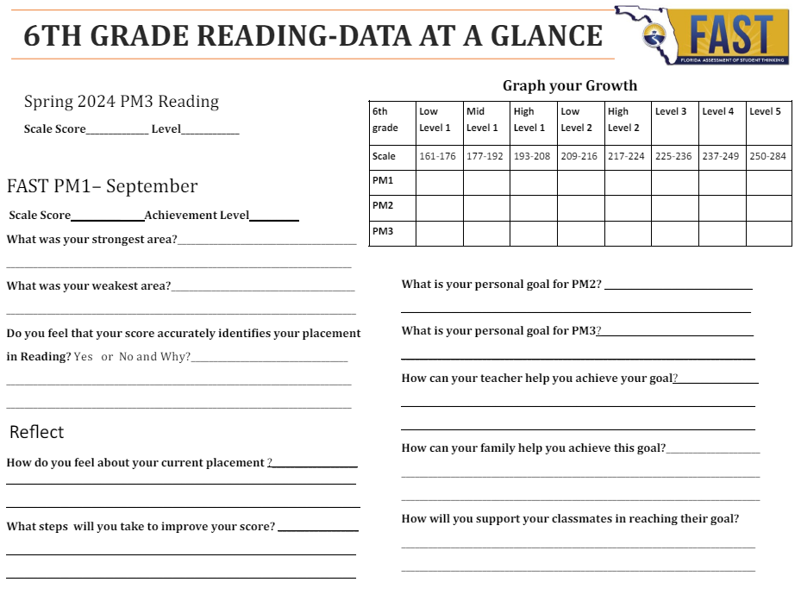
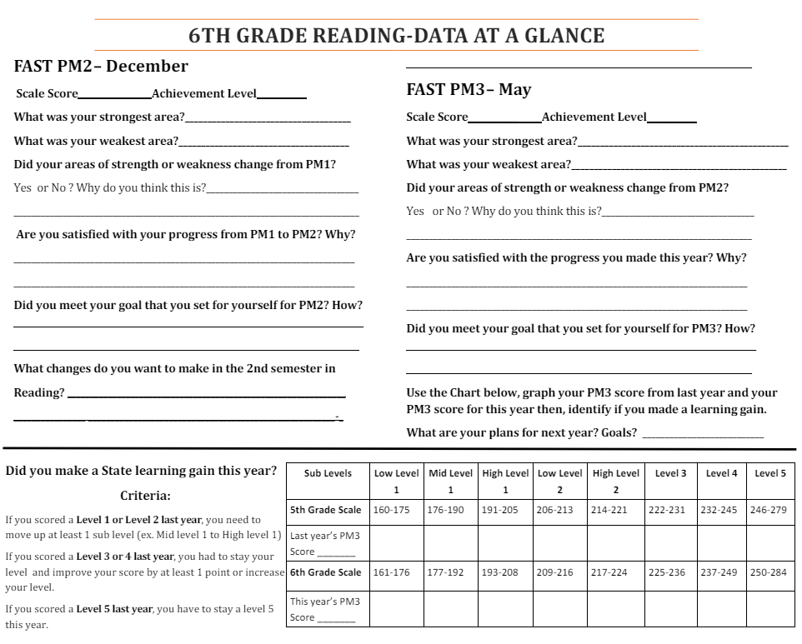
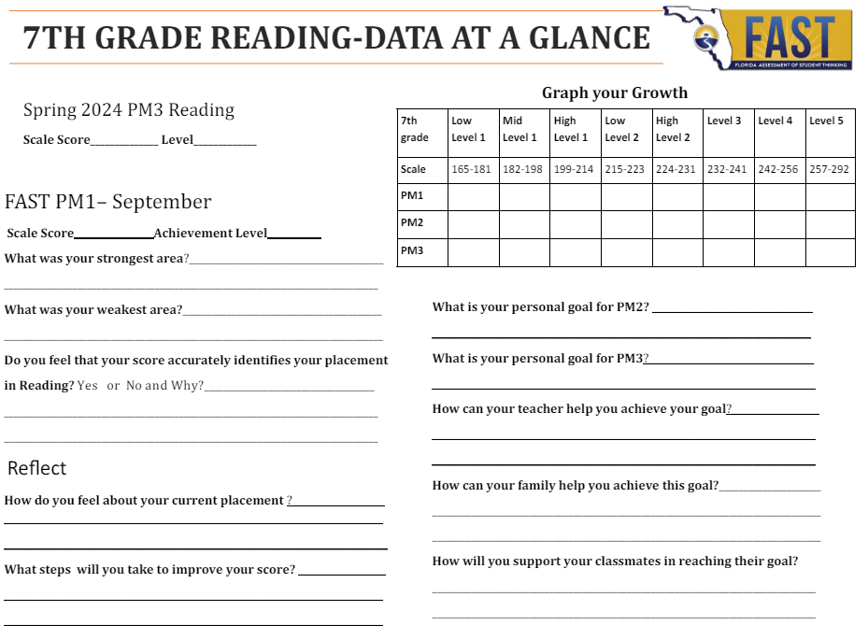
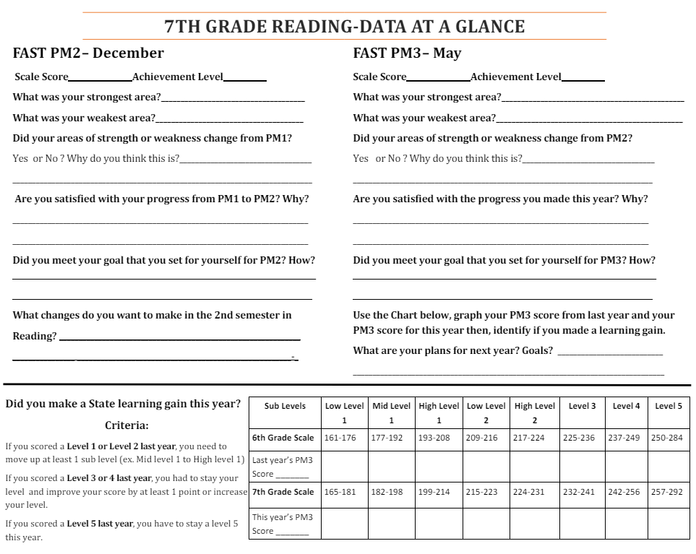
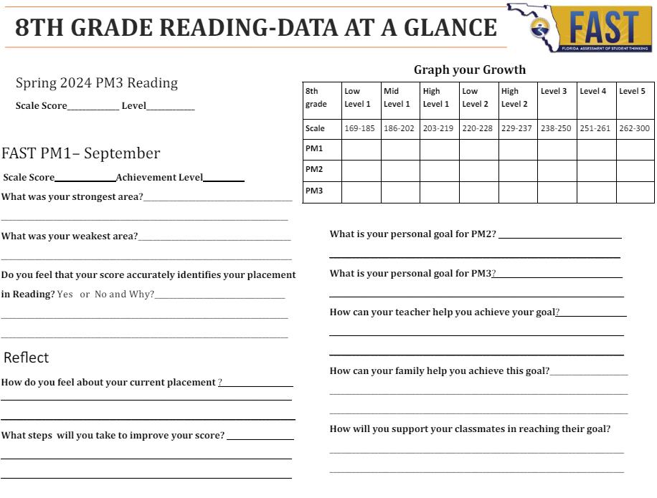
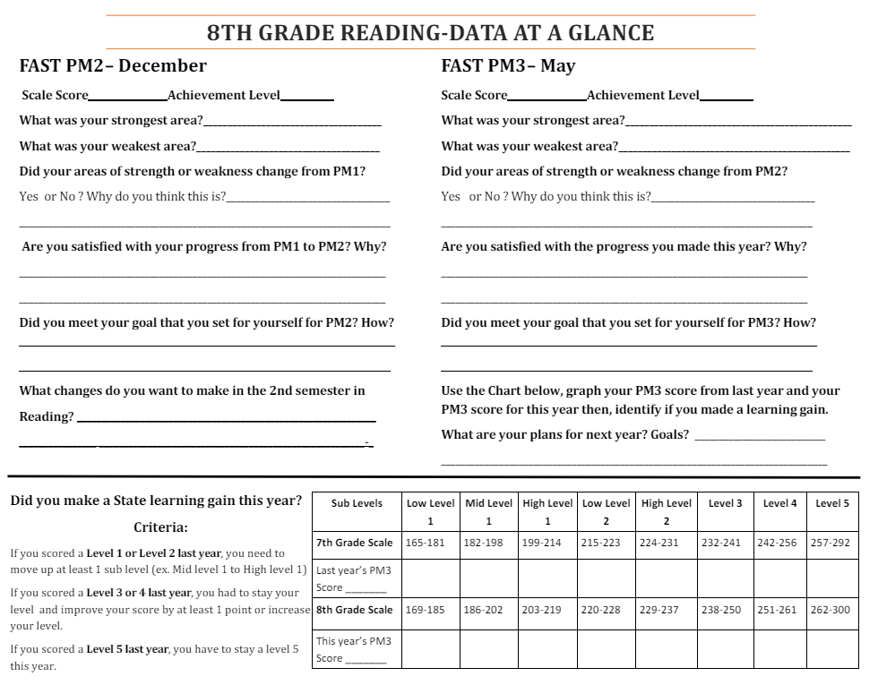

Q1 Goals- Week 1: 8/19-8/23 2024
When writing down your goal, be sure it is SMART:
Specific:
- Goals should be specific and easily understood. What are you going to do? Why is it important? What do you want to accomplish?

Measureable:
- Goals should have concrete criteria for measuring progress. What data will you use to measure your progress toward your goal?

Action-Oriented:
- Goals should be action-oriented. What actions are you going to take to accomplish your goal?

Realistic:
- Goals should be worth working toward and attainable. How do you know that it is reasonable for you to be able to accomplish your goal?

Timely:
- Goals should be achieved within a specific time frame. When is your deadline for accomplishing your goal?

SMART Goal #1:
_______________________________________________________________________________________________________________________________________
_____________________________________________

SMART Goal #2:
_______________________________________________________________________________________________________________________________________
_____________________________________________

SMART Goal #3:
_______________________________________________________________________________________________________________________________________
_____________________________________________

AR Progress Towards Goal:__________/2.2 points

Parent/Guardian/Mentor Signature:

__________________________________________________

1st 9 Weeks-Week 2: 8/26-8/30 2024
Class: ELA
- Current Grade: __________________________
- 0’s/Missing Assignments
_______________________________________
_______________________________________
- Action Plan for Grade Improvement:
_______________________________________
Class: Math
- Current Grade: __________________________
- 0’s/Missing Assignments
_______________________________________
_______________________________________
- Action Plan for Grade Improvement:
_______________________________________
Class: Science
- Current Grade: __________________________
- 0’s/Missing Assignments
_______________________________________
_______________________________________
- Action Plan for Grade Improvement:
_______________________________________
Class: Social Studies
- Current Grade: __________________________
- 0’s/Missing Assignments
_______________________________________
_______________________________________
- Action Plan for Grade Improvement:
_______________________________________
Class: Elective 1
- Current Grade: __________________________
- 0’s/Missing Assignments
_______________________________________
_______________________________________
- Action Plan for Grade Improvement:
- ______________________________________
Class: Elective 2
- Current Grade: __________________________
- 0’s/Missing Assignments
_______________________________________
_______________________________________
- Action Plan for Grade Improvement: _______________________________________

AR Progress Towards Goal:__________/4.44 points

Parent/Guardian/Mentor Signature:

___________________________________________

1st 9 Weeks-Week 3: 9/2-9/6 2024
Class: ELA
- Current Grade: __________________________
- 0’s/Missing Assignments
_______________________________________
_______________________________________
- Action Plan for Grade Improvement:
_______________________________________
Class: Math
- Current Grade: __________________________
- 0’s/Missing Assignments
_______________________________________
_______________________________________
- Action Plan for Grade Improvement:
_______________________________________
Class: Science
- Current Grade: __________________________
- 0’s/Missing Assignments
_______________________________________
_______________________________________
- Action Plan for Grade Improvement:
_______________________________________
Class: Social Studies
- Current Grade: __________________________
- 0’s/Missing Assignments
_______________________________________
_______________________________________
- Action Plan for Grade Improvement:
_______________________________________
Class: Elective 1
- Current Grade: __________________________
- 0’s/Missing Assignments
_______________________________________
_______________________________________
- Action Plan for Grade Improvement:
- ______________________________________
Class: Elective 2
- Current Grade: __________________________
- 0’s/Missing Assignments
_______________________________________
_______________________________________
- Action Plan for Grade Improvement: _______________________________________

AR Progress Towards Goal:__________/6.66 points

Parent/Guardian/Mentor Signature:

___________________________________________

1st 9 Weeks-Week 4: 9/9-913 2024
Class: ELA
- Current Grade: __________________________
- 0’s/Missing Assignments
_______________________________________
_______________________________________
- Action Plan for Grade Improvement:
_______________________________________
Class: Math
- Current Grade: __________________________
- 0’s/Missing Assignments
_______________________________________
_______________________________________
- Action Plan for Grade Improvement:
_______________________________________
Class: Science
- Current Grade: __________________________
- 0’s/Missing Assignments
_______________________________________
_______________________________________
- Action Plan for Grade Improvement:
_______________________________________
Class: Social Studies
- Current Grade: __________________________
- 0’s/Missing Assignments
_______________________________________
_______________________________________
- Action Plan for Grade Improvement:
_______________________________________
Class: Elective 1
- Current Grade: __________________________
- 0’s/Missing Assignments
_______________________________________
_______________________________________
- Action Plan for Grade Improvement:
- ______________________________________
Class: Elective 2
- Current Grade: __________________________
- 0’s/Missing Assignments
_______________________________________
_______________________________________
- Action Plan for Grade Improvement: _______________________________________

AR Progress Towards Goal:__________/8.88 points

Parent/Guardian/Mentor Signature:

___________________________________________

1st 9 Weeks-Week 5: 9/16-9/20 2024
Class: ELA
- Current Grade: __________________________
- 0’s/Missing Assignments
_______________________________________
_______________________________________
- Action Plan for Grade Improvement:
_______________________________________
Class: Math
- Current Grade: __________________________
- 0’s/Missing Assignments
_______________________________________
_______________________________________
- Action Plan for Grade Improvement:
_______________________________________
Class: Science
- Current Grade: __________________________
- 0’s/Missing Assignments
_______________________________________
_______________________________________
- Action Plan for Grade Improvement:
_______________________________________
Class: Social Studies
- Current Grade: __________________________
- 0’s/Missing Assignments
_______________________________________
_______________________________________
- Action Plan for Grade Improvement:
_______________________________________
Class: Elective 1
- Current Grade: __________________________
- 0’s/Missing Assignments
_______________________________________
_______________________________________
- Action Plan for Grade Improvement:
- ______________________________________
Class: Elective 2
- Current Grade: __________________________
- 0’s/Missing Assignments
_______________________________________
_______________________________________
- Action Plan for Grade Improvement: _______________________________________

AR Progress Towards Goal:__________/11.10 points

Parent/Guardian/Mentor Signature:

___________________________________________

1st 9 Weeks-Week 6: 9/23-9/27 2024
Class: ELA
- Current Grade: __________________________
- 0’s/Missing Assignments
_______________________________________
_______________________________________
- Action Plan for Grade Improvement:
_______________________________________
Class: Math
- Current Grade: __________________________
- 0’s/Missing Assignments
_______________________________________
_______________________________________
- Action Plan for Grade Improvement:
_______________________________________
Class: Science
- Current Grade: __________________________
- 0’s/Missing Assignments
_______________________________________
_______________________________________
- Action Plan for Grade Improvement:
_______________________________________
Class: Social Studies
- Current Grade: __________________________
- 0’s/Missing Assignments
_______________________________________
_______________________________________
- Action Plan for Grade Improvement:
_______________________________________
Class: Elective 1
- Current Grade: __________________________
- 0’s/Missing Assignments
_______________________________________
_______________________________________
- Action Plan for Grade Improvement:
- ______________________________________
Class: Elective 2
- Current Grade: __________________________
- 0’s/Missing Assignments
_______________________________________
_______________________________________
- Action Plan for Grade Improvement: _______________________________________

AR Progress Towards Goal:__________/13.32 points

Parent/Guardian/Mentor Signature:

___________________________________________

1st 9 Weeks-Week 7: 9/30-10/4 2024
Class: ELA
- Current Grade: __________________________
- 0’s/Missing Assignments
_______________________________________
_______________________________________
- Action Plan for Grade Improvement:
_______________________________________
Class: Math
- Current Grade: __________________________
- 0’s/Missing Assignments
_______________________________________
_______________________________________
- Action Plan for Grade Improvement:
_______________________________________
Class: Science
- Current Grade: __________________________
- 0’s/Missing Assignments
_______________________________________
_______________________________________
- Action Plan for Grade Improvement:
_______________________________________
Class: Social Studies
- Current Grade: __________________________
- 0’s/Missing Assignments
_______________________________________
_______________________________________
- Action Plan for Grade Improvement:
_______________________________________
Class: Elective 1
- Current Grade: __________________________
- 0’s/Missing Assignments
_______________________________________
_______________________________________
- Action Plan for Grade Improvement:
- ______________________________________
Class: Elective 2
- Current Grade: __________________________
- 0’s/Missing Assignments
_______________________________________
_______________________________________
- Action Plan for Grade Improvement: _______________________________________

AR Progress Towards Goal:__________/15.54 points

Parent/Guardian/Mentor Signature:

___________________________________________

1st 9 Weeks-Week 8: 10/7-10/11 2024
Class: ELA
- Current Grade: __________________________
- 0’s/Missing Assignments
_______________________________________
_______________________________________
- Action Plan for Grade Improvement:
_______________________________________
Class: Math
- Current Grade: __________________________
- 0’s/Missing Assignments
_______________________________________
_______________________________________
- Action Plan for Grade Improvement:
_______________________________________
Class: Science
- Current Grade: __________________________
- 0’s/Missing Assignments
_______________________________________
_______________________________________
- Action Plan for Grade Improvement:
_______________________________________
Class: Social Studies
- Current Grade: __________________________
- 0’s/Missing Assignments
_______________________________________
_______________________________________
- Action Plan for Grade Improvement:
_______________________________________
Class: Elective 1
- Current Grade: __________________________
- 0’s/Missing Assignments
_______________________________________
_______________________________________
- Action Plan for Grade Improvement:
- ______________________________________
Class: Elective 2
- Current Grade: __________________________
- 0’s/Missing Assignments
_______________________________________
_______________________________________
- Action Plan for Grade Improvement: _______________________________________

AR Progress Towards Goal:__________/17.76 points

Parent/Guardian/Mentor Signature:

___________________________________________

1st 9 Weeks-Week 9: 10/14-10/18 2024
Class: ELA
- Current Grade: __________________________
- 0’s/Missing Assignments
_______________________________________
_______________________________________
- Action Plan for Grade Improvement:
_______________________________________
Class: Math
- Current Grade: __________________________
- 0’s/Missing Assignments
_______________________________________
_______________________________________
- Action Plan for Grade Improvement:
_______________________________________
Class: Science
- Current Grade: __________________________
- 0’s/Missing Assignments
_______________________________________
_______________________________________
- Action Plan for Grade Improvement:
_______________________________________
Class: Social Studies
- Current Grade: __________________________
- 0’s/Missing Assignments
_______________________________________
_______________________________________
- Action Plan for Grade Improvement:
_______________________________________
Class: Elective 1
- Current Grade: __________________________
- 0’s/Missing Assignments
_______________________________________
_______________________________________
- Action Plan for Grade Improvement:
- ______________________________________
Class: Elective 2
- Current Grade: __________________________
- 0’s/Missing Assignments
_______________________________________
_______________________________________
- Action Plan for Grade Improvement: _______________________________________

AR Progress Towards Goal:__________/20 points

Parent/Guardian/Mentor Signature:

___________________________________________

Q1 Goal Reflection Week 9: 10/14-10/18 2024
Review your goals that you set at the beginning of this quarter.

SMART Goal #1 Topic: __________________________________________Did you meet the goal?__________________________
Why did this outcome occur? __________________________________________________________________________________________
Will you keep this goal? _________________________
If so, why? __________________________________________________________________________________________
If not, what area should you focus on now? _____________________________________________
SMART Goal #2 Topic: _________________________________________
Did you meet the goal?__________________________
Why did this outcome occur? __________________________________________________________________________________________
Will you keep this goal? _________________________
If so, why? __________________________________________________________________________________________
If not, what area should you focus on now? _____________________________________________
SMART Goal #3 Topic: __________________________________________Did you meet the goal?__________________________
Why did this outcome occur? __________________________________________________________________________________________
Will you keep this goal? _________________________
If so, why? __________________________________________________________________________________________
If not, what area should you focus on now? _____________________________________________

Parent Comment: ____________________________________________________________________________________________________________________________________________________________________________________________________________________________________________________________________________________________________________

Parent/Guardian/Mentor Signature:

__________________________________________________

Q2 Goals- Week 1: 10/21-10/25 2024
When writing down your goal, be sure it is SMART:
Specific:
- Goals should be specific and easily understood. What are you going to do? Why is it important? What do you want to accomplish?

Measureable:
- Goals should have concrete criteria for measuring progress. What data will you use to measure your progress toward your goal?

Action-Oriented:
- Goals should be action-oriented. What actions are you going to take to accomplish your goal?

Realistic:
- Goals should be worth working toward and attainable. How do you know that it is reasonable for you to be able to accomplish your goal?

Timely:
- Goals should be achieved within a specific time frame. When is your deadline for accomplishing your goal?

SMART Goal #1:
_______________________________________________________________________________________________________________________________________
_____________________________________________

SMART Goal #2:
_______________________________________________________________________________________________________________________________________
_____________________________________________

SMART Goal #3:
_______________________________________________________________________________________________________________________________________
_____________________________________________

AR Progress Towards Goal:__________/2.2 points

Parent/Guardian/Mentor Signature:
__________________________________________________

2nd 9 Weeks-Week 2: 10/28-11/1 2024
Class: ELA
- Current Grade: __________________________
- 0’s/Missing Assignments
_______________________________________
_______________________________________
- Action Plan for Grade Improvement:
_______________________________________
Class: Math
- Current Grade: __________________________
- 0’s/Missing Assignments
_______________________________________
_______________________________________
- Action Plan for Grade Improvement:
_______________________________________
Class: Science
- Current Grade: __________________________
- 0’s/Missing Assignments
_______________________________________
_______________________________________
- Action Plan for Grade Improvement:
_______________________________________
Class: Social Studies
- Current Grade: __________________________
- 0’s/Missing Assignments
_______________________________________
_______________________________________
- Action Plan for Grade Improvement:
_______________________________________
Class: Elective 1
- Current Grade: __________________________
- 0’s/Missing Assignments
_______________________________________
_______________________________________
- Action Plan for Grade Improvement:
- ______________________________________
Class: Elective 2
- Current Grade: __________________________
- 0’s/Missing Assignments
_______________________________________
_______________________________________
- Action Plan for Grade Improvement: _______________________________________

AR Progress Towards Goal:__________/4.44 points

Parent/Guardian/Mentor Signature: ___________________________________________

2nd 9 Weeks-Week 3: 11/4-11/8 2024
Class: ELA
- Current Grade: __________________________
- 0’s/Missing Assignments
_______________________________________
_______________________________________
- Action Plan for Grade Improvement:
_______________________________________
Class: Math
- Current Grade: __________________________
- 0’s/Missing Assignments
_______________________________________
_______________________________________
- Action Plan for Grade Improvement:
_______________________________________
Class: Science
- Current Grade: __________________________
- 0’s/Missing Assignments
_______________________________________
_______________________________________
- Action Plan for Grade Improvement:
_______________________________________
Class: Social Studies
- Current Grade: __________________________
- 0’s/Missing Assignments
_______________________________________
_______________________________________
- Action Plan for Grade Improvement:
_______________________________________
Class: Elective 1
- Current Grade: __________________________
- 0’s/Missing Assignments
_______________________________________
_______________________________________
- Action Plan for Grade Improvement:
- ______________________________________
Class: Elective 2
- Current Grade: __________________________
- 0’s/Missing Assignments
_______________________________________
_______________________________________
- Action Plan for Grade Improvement: _______________________________________

AR Progress Towards Goal:__________/6.66 points

Parent/Guardian/Mentor Signature: ___________________________________________

2nd 9 Weeks-Week 4:11/11-11/15 2024
Class: ELA
- Current Grade: __________________________
- 0’s/Missing Assignments
_______________________________________
_______________________________________
- Action Plan for Grade Improvement:
_______________________________________
Class: Math
- Current Grade: __________________________
- 0’s/Missing Assignments
_______________________________________
_______________________________________
- Action Plan for Grade Improvement:
_______________________________________
Class: Science
- Current Grade: __________________________
- 0’s/Missing Assignments
_______________________________________
_______________________________________
- Action Plan for Grade Improvement:
_______________________________________
Class: Social Studies
- Current Grade: __________________________
- 0’s/Missing Assignments
_______________________________________
_______________________________________
- Action Plan for Grade Improvement:
_______________________________________
Class: Elective 1
- Current Grade: __________________________
- 0’s/Missing Assignments
_______________________________________
_______________________________________
- Action Plan for Grade Improvement:
- ______________________________________
Class: Elective 2
- Current Grade: __________________________
- 0’s/Missing Assignments
_______________________________________
_______________________________________
- Action Plan for Grade Improvement: _______________________________________

AR Progress Towards Goal:__________/8.88 points

Parent/Guardian/Mentor Signature: ___________________________________________

2nd 9 Weeks-Week 5: 11/18-11/22 2024
Class: ELA
- Current Grade: __________________________
- 0’s/Missing Assignments
_______________________________________
_______________________________________
- Action Plan for Grade Improvement:
_______________________________________
Class: Math
- Current Grade: __________________________
- 0’s/Missing Assignments
_______________________________________
_______________________________________
- Action Plan for Grade Improvement:
_______________________________________
Class: Science
- Current Grade: __________________________
- 0’s/Missing Assignments
_______________________________________
_______________________________________
- Action Plan for Grade Improvement:
_______________________________________
Class: Social Studies
- Current Grade: __________________________
- 0’s/Missing Assignments
_______________________________________
_______________________________________
- Action Plan for Grade Improvement:
_______________________________________
Class: Elective 1
- Current Grade: __________________________
- 0’s/Missing Assignments
_______________________________________
_______________________________________
- Action Plan for Grade Improvement:
- ______________________________________
Class: Elective 2
- Current Grade: __________________________
- 0’s/Missing Assignments
_______________________________________
_______________________________________
- Action Plan for Grade Improvement: _______________________________________

AR Progress Towards Goal:__________/11.10 points

Parent/Guardian/Mentor Signature: ___________________________________________

2nd 9 Weeks-Week 6: 12/2-12/6 2024
Class: ELA
- Current Grade: __________________________
- 0’s/Missing Assignments
_______________________________________
_______________________________________
- Action Plan for Grade Improvement:
_______________________________________
Class: Math
- Current Grade: __________________________
- 0’s/Missing Assignments
_______________________________________
_______________________________________
- Action Plan for Grade Improvement:
_______________________________________
Class: Science
- Current Grade: __________________________
- 0’s/Missing Assignments
_______________________________________
_______________________________________
- Action Plan for Grade Improvement:
_______________________________________
Class: Social Studies
- Current Grade: __________________________
- 0’s/Missing Assignments
_______________________________________
_______________________________________
- Action Plan for Grade Improvement:
_______________________________________
Class: Elective 1
- Current Grade: __________________________
- 0’s/Missing Assignments
_______________________________________
_______________________________________
- Action Plan for Grade Improvement:
- ______________________________________
Class: Elective 2
- Current Grade: __________________________
- 0’s/Missing Assignments
_______________________________________
_______________________________________
- Action Plan for Grade Improvement: _______________________________________

AR Progress Towards Goal:__________/13.32 points

Parent/Guardian/Mentor Signature: ___________________________________________

2nd 9 Weeks-Week 7: 12/9-12/13 2024
Class: ELA
- Current Grade: __________________________
- 0’s/Missing Assignments
_______________________________________
_______________________________________
- Action Plan for Grade Improvement:
_______________________________________
Class: Math
- Current Grade: __________________________
- 0’s/Missing Assignments
_______________________________________
_______________________________________
- Action Plan for Grade Improvement:
_______________________________________
Class: Science
- Current Grade: __________________________
- 0’s/Missing Assignments
_______________________________________
_______________________________________
- Action Plan for Grade Improvement:
_______________________________________
Class: Social Studies
- Current Grade: __________________________
- 0’s/Missing Assignments
_______________________________________
_______________________________________
- Action Plan for Grade Improvement:
_______________________________________
Class: Elective 1
- Current Grade: __________________________
- 0’s/Missing Assignments
_______________________________________
_______________________________________
- Action Plan for Grade Improvement:
- ______________________________________
Class: Elective 2
- Current Grade: __________________________
- 0’s/Missing Assignments
_______________________________________
_______________________________________
- Action Plan for Grade Improvement: _______________________________________

AR Progress Towards Goal:__________/15.54 points

Parent/Guardian/Mentor Signature: ___________________________________________

2nd 9 Weeks-Week 8: 12/16-12/20 2024
Class: ELA
- Current Grade: __________________________
- 0’s/Missing Assignments
_______________________________________
_______________________________________
- Action Plan for Grade Improvement:
_______________________________________
Class: Math
- Current Grade: __________________________
- 0’s/Missing Assignments
_______________________________________
_______________________________________
- Action Plan for Grade Improvement:
_______________________________________
Class: Science
- Current Grade: __________________________
- 0’s/Missing Assignments
_______________________________________
_______________________________________
- Action Plan for Grade Improvement:
_______________________________________
Class: Social Studies
- Current Grade: __________________________
- 0’s/Missing Assignments
_______________________________________
_______________________________________
- Action Plan for Grade Improvement:
_______________________________________
Class: Elective 1
- Current Grade: __________________________
- 0’s/Missing Assignments
_______________________________________
_______________________________________
- Action Plan for Grade Improvement:
- ______________________________________
Class: Elective 2
- Current Grade: __________________________
- 0’s/Missing Assignments
_______________________________________
_______________________________________
- Action Plan for Grade Improvement: _______________________________________

AR Progress Towards Goal:__________/17.76 points

Parent/Guardian/Mentor Signature: ___________________________________________

2nd 9 Weeks-Week 9: 1/13-1/17 2025
Class: ELA
- Current Grade: __________________________
- 0’s/Missing Assignments
_______________________________________
_______________________________________
- Action Plan for Grade Improvement:
_______________________________________
Class: Math
- Current Grade: __________________________
- 0’s/Missing Assignments
_______________________________________
_______________________________________
- Action Plan for Grade Improvement:
_______________________________________
Class: Science
- Current Grade: __________________________
- 0’s/Missing Assignments
_______________________________________
_______________________________________
- Action Plan for Grade Improvement:
_______________________________________
Class: Social Studies
- Current Grade: __________________________
- 0’s/Missing Assignments
_______________________________________
_______________________________________
- Action Plan for Grade Improvement:
_______________________________________
Class: Elective 1
- Current Grade: __________________________
- 0’s/Missing Assignments
_______________________________________
_______________________________________
- Action Plan for Grade Improvement:
- ______________________________________
Class: Elective 2
- Current Grade: __________________________
- 0’s/Missing Assignments
_______________________________________
_______________________________________
- Action Plan for Grade Improvement: _______________________________________

AR Progress Towards Goal:__________/20 points

Parent/Guardian/Mentor Signature: ___________________________________________

Q2 Goal Reflection Week 9: 1/13-1/17 2025
Review your goals that you set at the beginning of this quarter.

SMART Goal #1 Topic: __________________________________________Did you meet the goal?__________________________
Why did this outcome occur? __________________________________________________________________________________________
Will you keep this goal? _________________________
If so, why? __________________________________________________________________________________________
If not, what area should you focus on now? _____________________________________________
SMART Goal #2 Topic: _________________________________________
Did you meet the goal?__________________________
Why did this outcome occur? __________________________________________________________________________________________
Will you keep this goal? _________________________
If so, why? __________________________________________________________________________________________
If not, what area should you focus on now? _____________________________________________
SMART Goal #3 Topic: __________________________________________Did you meet the goal?__________________________
Why did this outcome occur? __________________________________________________________________________________________
Will you keep this goal? _________________________
If so, why? __________________________________________________________________________________________
If not, what area should you focus on now? _____________________________________________

Parent Comment: ____________________________________________________________________________________________________________________________________________________________________________________________________________________________________________________________________________________________________________

Parent/Guardian/Mentor Signature:

__________________________________________________
Q3 Goals- Week 1: 1/20-1/24 2025
When writing down your goal, be sure it is SMART:
Specific:
- Goals should be specific and easily understood. What are you going to do? Why is it important? What do you want to accomplish?

Measureable:
- Goals should have concrete criteria for measuring progress. What data will you use to measure your progress toward your goal?

Action-Oriented:
- Goals should be action-oriented. What actions are you going to take to accomplish your goal?

Realistic:
- Goals should be worth working toward and attainable. How do you know that it is reasonable for you to be able to accomplish your goal?

Timely:
- Goals should be achieved within a specific time frame. When is your deadline for accomplishing your goal?

SMART Goal #1:
_______________________________________________________________________________________________________________________________________
_____________________________________________

SMART Goal #2:
_______________________________________________________________________________________________________________________________________
_____________________________________________

SMART Goal #3:
_______________________________________________________________________________________________________________________________________
_____________________________________________

AR Progress Towards Goal:__________/2.2 points

Parent/Guardian/Mentor Signature:
__________________________________________________

3rd 9 Weeks-Week 2: 1/27-1/31 2025
Class: ELA
- Current Grade: __________________________
- 0’s/Missing Assignments
_______________________________________
_______________________________________
- Action Plan for Grade Improvement:
_______________________________________
Class: Math
- Current Grade: __________________________
- 0’s/Missing Assignments
_______________________________________
_______________________________________
- Action Plan for Grade Improvement:
_______________________________________
Class: Science
- Current Grade: __________________________
- 0’s/Missing Assignments
_______________________________________
_______________________________________
- Action Plan for Grade Improvement:
_______________________________________
Class: Social Studies
- Current Grade: __________________________
- 0’s/Missing Assignments
_______________________________________
_______________________________________
- Action Plan for Grade Improvement:
_______________________________________
Class: Elective 1
- Current Grade: __________________________
- 0’s/Missing Assignments
_______________________________________
_______________________________________
- Action Plan for Grade Improvement:
- ______________________________________
Class: Elective 2
- Current Grade: __________________________
- 0’s/Missing Assignments
_______________________________________
_______________________________________
- Action Plan for Grade Improvement: _______________________________________

AR Progress Towards Goal:__________/4.44 points

Parent/Guardian/Mentor Signature: ___________________________________________

3rd 9 Weeks-Week 3: 2/3-2/7 2025
Class: ELA
- Current Grade: __________________________
- 0’s/Missing Assignments
_______________________________________
_______________________________________
- Action Plan for Grade Improvement:
_______________________________________
Class: Math
- Current Grade: __________________________
- 0’s/Missing Assignments
_______________________________________
_______________________________________
- Action Plan for Grade Improvement:
_______________________________________
Class: Science
- Current Grade: __________________________
- 0’s/Missing Assignments
_______________________________________
_______________________________________
- Action Plan for Grade Improvement:
_______________________________________
Class: Social Studies
- Current Grade: __________________________
- 0’s/Missing Assignments
_______________________________________
_______________________________________
- Action Plan for Grade Improvement:
_______________________________________
Class: Elective 1
- Current Grade: __________________________
- 0’s/Missing Assignments
_______________________________________
_______________________________________
- Action Plan for Grade Improvement:
- ______________________________________
Class: Elective 2
- Current Grade: __________________________
- 0’s/Missing Assignments
_______________________________________
_______________________________________
- Action Plan for Grade Improvement: _______________________________________

AR Progress Towards Goal:__________/6.66 points

Parent/Guardian/Mentor Signature: ___________________________________________

3rd 9 Weeks-Week 4: 2/10-2/14 2025
Class: ELA
- Current Grade: __________________________
- 0’s/Missing Assignments
_______________________________________
_______________________________________
- Action Plan for Grade Improvement:
_______________________________________
Class: Math
- Current Grade: __________________________
- 0’s/Missing Assignments
_______________________________________
_______________________________________
- Action Plan for Grade Improvement:
_______________________________________
Class: Science
- Current Grade: __________________________
- 0’s/Missing Assignments
_______________________________________
_______________________________________
- Action Plan for Grade Improvement:
_______________________________________
Class: Social Studies
- Current Grade: __________________________
- 0’s/Missing Assignments
_______________________________________
_______________________________________
- Action Plan for Grade Improvement:
_______________________________________
Class: Elective 1
- Current Grade: __________________________
- 0’s/Missing Assignments
_______________________________________
_______________________________________
- Action Plan for Grade Improvement:
- ______________________________________
Class: Elective 2
- Current Grade: __________________________
- 0’s/Missing Assignments
_______________________________________
_______________________________________
- Action Plan for Grade Improvement: _______________________________________

AR Progress Towards Goal:__________/8.88 points

Parent/Guardian/Mentor Signature: ___________________________________________

3rd 9 Weeks-Week 5: 2/17-2/21 2025
Class: ELA
- Current Grade: __________________________
- 0’s/Missing Assignments
_______________________________________
_______________________________________
- Action Plan for Grade Improvement:
_______________________________________
Class: Math
- Current Grade: __________________________
- 0’s/Missing Assignments
_______________________________________
_______________________________________
- Action Plan for Grade Improvement:
_______________________________________
Class: Science
- Current Grade: __________________________
- 0’s/Missing Assignments
_______________________________________
_______________________________________
- Action Plan for Grade Improvement:
_______________________________________
Class: Social Studies
- Current Grade: __________________________
- 0’s/Missing Assignments
_______________________________________
_______________________________________
- Action Plan for Grade Improvement:
_______________________________________
Class: Elective 1
- Current Grade: __________________________
- 0’s/Missing Assignments
_______________________________________
_______________________________________
- Action Plan for Grade Improvement:
- ______________________________________
Class: Elective 2
- Current Grade: __________________________
- 0’s/Missing Assignments
_______________________________________
_______________________________________
- Action Plan for Grade Improvement: _______________________________________

AR Progress Towards Goal:__________/11.10 points

Parent/Guardian/Mentor Signature: ___________________________________________

3rd 9 Weeks-Week 6: 2/24-2/28 2025
Class: ELA
- Current Grade: __________________________
- 0’s/Missing Assignments
_______________________________________
_______________________________________
- Action Plan for Grade Improvement:
_______________________________________
Class: Math
- Current Grade: __________________________
- 0’s/Missing Assignments
_______________________________________
_______________________________________
- Action Plan for Grade Improvement:
_______________________________________
Class: Science
- Current Grade: __________________________
- 0’s/Missing Assignments
_______________________________________
_______________________________________
- Action Plan for Grade Improvement:
_______________________________________
Class: Social Studies
- Current Grade: __________________________
- 0’s/Missing Assignments
_______________________________________
_______________________________________
- Action Plan for Grade Improvement:
_______________________________________
Class: Elective 1
- Current Grade: __________________________
- 0’s/Missing Assignments
_______________________________________
_______________________________________
- Action Plan for Grade Improvement:
- ______________________________________
Class: Elective 2
- Current Grade: __________________________
- 0’s/Missing Assignments
_______________________________________
_______________________________________
- Action Plan for Grade Improvement: _______________________________________

AR Progress Towards Goal:__________/13.32 points

Parent/Guardian/Mentor Signature: ___________________________________________

3rd 9 Weeks-Week 7: 3/10-3/14 2025
Class: ELA
- Current Grade: __________________________
- 0’s/Missing Assignments
_______________________________________
_______________________________________
- Action Plan for Grade Improvement:
_______________________________________
Class: Math
- Current Grade: __________________________
- 0’s/Missing Assignments
_______________________________________
_______________________________________
- Action Plan for Grade Improvement:
_______________________________________
Class: Science
- Current Grade: __________________________
- 0’s/Missing Assignments
_______________________________________
_______________________________________
- Action Plan for Grade Improvement:
_______________________________________
Class: Social Studies
- Current Grade: __________________________
- 0’s/Missing Assignments
_______________________________________
_______________________________________
- Action Plan for Grade Improvement:
_______________________________________
Class: Elective 1
- Current Grade: __________________________
- 0’s/Missing Assignments
_______________________________________
_______________________________________
- Action Plan for Grade Improvement:
- ______________________________________
Class: Elective 2
- Current Grade: __________________________
- 0’s/Missing Assignments
_______________________________________
_______________________________________
- Action Plan for Grade Improvement: _______________________________________

AR Progress Towards Goal:__________/15.54 points

Parent/Guardian/Mentor Signature: ___________________________________________

3rd 9 Weeks-Week 8: 3/17-3/21 2025
Class: ELA
- Current Grade: __________________________
- 0’s/Missing Assignments
_______________________________________
_______________________________________
- Action Plan for Grade Improvement:
_______________________________________
Class: Math
- Current Grade: __________________________
- 0’s/Missing Assignments
_______________________________________
_______________________________________
- Action Plan for Grade Improvement:
_______________________________________
Class: Science
- Current Grade: __________________________
- 0’s/Missing Assignments
_______________________________________
_______________________________________
- Action Plan for Grade Improvement:
_______________________________________
Class: Social Studies
- Current Grade: __________________________
- 0’s/Missing Assignments
_______________________________________
_______________________________________
- Action Plan for Grade Improvement:
_______________________________________
Class: Elective 1
- Current Grade: __________________________
- 0’s/Missing Assignments
_______________________________________
_______________________________________
- Action Plan for Grade Improvement:
- ______________________________________
Class: Elective 2
- Current Grade: __________________________
- 0’s/Missing Assignments
_______________________________________
_______________________________________
- Action Plan for Grade Improvement: _______________________________________

AR Progress Towards Goal:__________/17.76 points

Parent/Guardian/Mentor Signature: ___________________________________________

3rd 9 Weeks-Week 9: 3/24-3/28 2025
Class: ELA
- Current Grade: __________________________
- 0’s/Missing Assignments
_______________________________________
_______________________________________
- Action Plan for Grade Improvement:
_______________________________________
Class: Math
- Current Grade: __________________________
- 0’s/Missing Assignments
_______________________________________
_______________________________________
- Action Plan for Grade Improvement:
_______________________________________
Class: Science
- Current Grade: __________________________
- 0’s/Missing Assignments
_______________________________________
_______________________________________
- Action Plan for Grade Improvement:
_______________________________________
Class: Social Studies
- Current Grade: __________________________
- 0’s/Missing Assignments
_______________________________________
_______________________________________
- Action Plan for Grade Improvement:
_______________________________________
Class: Elective 1
- Current Grade: __________________________
- 0’s/Missing Assignments
_______________________________________
_______________________________________
- Action Plan for Grade Improvement:
- ______________________________________
Class: Elective 2
- Current Grade: __________________________
- 0’s/Missing Assignments
_______________________________________
_______________________________________
- Action Plan for Grade Improvement: _______________________________________

AR Progress Towards Goal:__________/20 points

Parent/Guardian/Mentor Signature: ___________________________________________

Q3 Goal Reflection Week 9: 3/24-3/28 2025
Review your goals that you set at the beginning of this quarter.

SMART Goal #1 Topic: __________________________________________Did you meet the goal?__________________________
Why did this outcome occur? __________________________________________________________________________________________
Will you keep this goal? _________________________
If so, why? __________________________________________________________________________________________
If not, what area should you focus on now? _____________________________________________
SMART Goal #2 Topic: _________________________________________
Did you meet the goal?__________________________
Why did this outcome occur? __________________________________________________________________________________________
Will you keep this goal? _________________________
If so, why? __________________________________________________________________________________________
If not, what area should you focus on now? _____________________________________________
SMART Goal #3 Topic: __________________________________________Did you meet the goal?__________________________
Why did this outcome occur? __________________________________________________________________________________________
Will you keep this goal? _________________________
If so, why? __________________________________________________________________________________________
If not, what area should you focus on now? _____________________________________________

Parent Comment: ____________________________________________________________________________________________________________________________________________________________________________________________________________________________________________________________________________________________________________

Parent/Guardian/Mentor Signature:

__________________________________________________
Q4 Goals- Week 1: 3/31-4/4 2025
When writing down your goal, be sure it is SMART:
Specific:
- Goals should be specific and easily understood. What are you going to do? Why is it important? What do you want to accomplish?

Measureable:
- Goals should have concrete criteria for measuring progress. What data will you use to measure your progress toward your goal?

Action-Oriented:
- Goals should be action-oriented. What actions are you going to take to accomplish your goal?

Realistic:
- Goals should be worth working toward and attainable. How do you know that it is reasonable for you to be able to accomplish your goal?

Timely:
- Goals should be achieved within a specific time frame. When is your deadline for accomplishing your goal?

SMART Goal #1:
_______________________________________________________________________________________________________________________________________
_____________________________________________

SMART Goal #2:
_______________________________________________________________________________________________________________________________________
_____________________________________________

SMART Goal #3:
_______________________________________________________________________________________________________________________________________
_____________________________________________

AR Progress Towards Goal:__________/2.2 points

Parent/Guardian/Mentor Signature:
__________________________________________________

4th 9 Weeks-Week 2: 4/7-4/11 2025
Class: ELA
- Current Grade: __________________________
- 0’s/Missing Assignments
_______________________________________
_______________________________________
- Action Plan for Grade Improvement:
_______________________________________
Class: Math
- Current Grade: __________________________
- 0’s/Missing Assignments
_______________________________________
_______________________________________
- Action Plan for Grade Improvement:
_______________________________________
Class: Science
- Current Grade: __________________________
- 0’s/Missing Assignments
_______________________________________
_______________________________________
- Action Plan for Grade Improvement:
_______________________________________
Class: Social Studies
- Current Grade: __________________________
- 0’s/Missing Assignments
_______________________________________
_______________________________________
- Action Plan for Grade Improvement:
_______________________________________
Class: Elective 1
- Current Grade: __________________________
- 0’s/Missing Assignments
_______________________________________
_______________________________________
- Action Plan for Grade Improvement:
- ______________________________________
Class: Elective 2
- Current Grade: __________________________
- 0’s/Missing Assignments
_______________________________________
_______________________________________
- Action Plan for Grade Improvement: _______________________________________

AR Progress Towards Goal:__________/4.44 points

Parent/Guardian/Mentor Signature: ___________________________________________

4th 9 Weeks-Week 3: 4/14-4/18 2025
Class: ELA
- Current Grade: __________________________
- 0’s/Missing Assignments
_______________________________________
_______________________________________
- Action Plan for Grade Improvement:
_______________________________________
Class: Math
- Current Grade: __________________________
- 0’s/Missing Assignments
_______________________________________
_______________________________________
- Action Plan for Grade Improvement:
_______________________________________
Class: Science
- Current Grade: __________________________
- 0’s/Missing Assignments
_______________________________________
_______________________________________
- Action Plan for Grade Improvement:
_______________________________________
Class: Social Studies
- Current Grade: __________________________
- 0’s/Missing Assignments
_______________________________________
_______________________________________
- Action Plan for Grade Improvement:
_______________________________________
Class: Elective 1
- Current Grade: __________________________
- 0’s/Missing Assignments
_______________________________________
_______________________________________
- Action Plan for Grade Improvement:
- ______________________________________
Class: Elective 2
- Current Grade: __________________________
- 0’s/Missing Assignments
_______________________________________
_______________________________________
- Action Plan for Grade Improvement: _______________________________________

AR Progress Towards Goal:__________/6.66 points

Parent/Guardian/Mentor Signature: ___________________________________________

4th 9 Weeks-Week 4: 4/21-4/25 2025
Class: ELA
- Current Grade: __________________________
- 0’s/Missing Assignments
_______________________________________
_______________________________________
- Action Plan for Grade Improvement:
_______________________________________
Class: Math
- Current Grade: __________________________
- 0’s/Missing Assignments
_______________________________________
_______________________________________
- Action Plan for Grade Improvement:
_______________________________________
Class: Science
- Current Grade: __________________________
- 0’s/Missing Assignments
_______________________________________
_______________________________________
- Action Plan for Grade Improvement:
_______________________________________
Class: Social Studies
- Current Grade: __________________________
- 0’s/Missing Assignments
_______________________________________
_______________________________________
- Action Plan for Grade Improvement:
_______________________________________
Class: Elective 1
- Current Grade: __________________________
- 0’s/Missing Assignments
_______________________________________
_______________________________________
- Action Plan for Grade Improvement:
- ______________________________________
Class: Elective 2
- Current Grade: __________________________
- 0’s/Missing Assignments
_______________________________________
_______________________________________
- Action Plan for Grade Improvement: _______________________________________

AR Progress Towards Goal:__________/8.88 points

Parent/Guardian/Mentor Signature: ___________________________________________

4th 9 Weeks-Week 5: 4/28-5/2 2025
Class: ELA
- Current Grade: __________________________
- 0’s/Missing Assignments
_______________________________________
_______________________________________
- Action Plan for Grade Improvement:
_______________________________________
Class: Math
- Current Grade: __________________________
- 0’s/Missing Assignments
_______________________________________
_______________________________________
- Action Plan for Grade Improvement:
_______________________________________
Class: Science
- Current Grade: __________________________
- 0’s/Missing Assignments
_______________________________________
_______________________________________
- Action Plan for Grade Improvement:
_______________________________________
Class: Social Studies
- Current Grade: __________________________
- 0’s/Missing Assignments
_______________________________________
_______________________________________
- Action Plan for Grade Improvement:
_______________________________________
Class: Elective 1
- Current Grade: __________________________
- 0’s/Missing Assignments
_______________________________________
_______________________________________
- Action Plan for Grade Improvement:
- ______________________________________
Class: Elective 2
- Current Grade: __________________________
- 0’s/Missing Assignments
_______________________________________
_______________________________________
- Action Plan for Grade Improvement: _______________________________________

AR Progress Towards Goal:__________/11.10 points

Parent/Guardian/Mentor Signature: ___________________________________________

4th 9 Weeks-Week 6: 5/5-5/9 2025
Class: ELA
- Current Grade: __________________________
- 0’s/Missing Assignments
_______________________________________
_______________________________________
- Action Plan for Grade Improvement:
_______________________________________
Class: Math
- Current Grade: __________________________
- 0’s/Missing Assignments
_______________________________________
_______________________________________
- Action Plan for Grade Improvement:
_______________________________________
Class: Science
- Current Grade: __________________________
- 0’s/Missing Assignments
_______________________________________
_______________________________________
- Action Plan for Grade Improvement:
_______________________________________
Class: Social Studies
- Current Grade: __________________________
- 0’s/Missing Assignments
_______________________________________
_______________________________________
- Action Plan for Grade Improvement:
_______________________________________
Class: Elective 1
- Current Grade: __________________________
- 0’s/Missing Assignments
_______________________________________
_______________________________________
- Action Plan for Grade Improvement:
- ______________________________________
Class: Elective 2
- Current Grade: __________________________
- 0’s/Missing Assignments
_______________________________________
_______________________________________
- Action Plan for Grade Improvement: _______________________________________

AR Progress Towards Goal:__________/13.32 points

Parent/Guardian/Mentor Signature: ___________________________________________

4th 9 Weeks-Week 7: 5/12-5/16 2025
Class: ELA
- Current Grade: __________________________
- 0’s/Missing Assignments
_______________________________________
_______________________________________
- Action Plan for Grade Improvement:
_______________________________________
Class: Math
- Current Grade: __________________________
- 0’s/Missing Assignments
_______________________________________
_______________________________________
- Action Plan for Grade Improvement:
_______________________________________
Class: Science
- Current Grade: __________________________
- 0’s/Missing Assignments
_______________________________________
_______________________________________
- Action Plan for Grade Improvement:
_______________________________________
Class: Social Studies
- Current Grade: __________________________
- 0’s/Missing Assignments
_______________________________________
_______________________________________
- Action Plan for Grade Improvement:
_______________________________________
Class: Elective 1
- Current Grade: __________________________
- 0’s/Missing Assignments
_______________________________________
_______________________________________
- Action Plan for Grade Improvement:
- ______________________________________
Class: Elective 2
- Current Grade: __________________________
- 0’s/Missing Assignments
_______________________________________
_______________________________________
- Action Plan for Grade Improvement: _______________________________________

AR Progress Towards Goal:__________/15.54 points

Parent/Guardian/Mentor Signature:

___________________________________________

4th 9 Weeks-Week 8: 5/19-5/23 2025
Class: ELA
- Current Grade: __________________________
- 0’s/Missing Assignments
_______________________________________
_______________________________________
- Action Plan for Grade Improvement:
_______________________________________
Class: Math
- Current Grade: __________________________
- 0’s/Missing Assignments
_______________________________________
_______________________________________
- Action Plan for Grade Improvement:
_______________________________________
Class: Science
- Current Grade: __________________________
- 0’s/Missing Assignments
_______________________________________
_______________________________________
- Action Plan for Grade Improvement:
_______________________________________
Class: Social Studies
- Current Grade: __________________________
- 0’s/Missing Assignments
_______________________________________
_______________________________________
- Action Plan for Grade Improvement:
_______________________________________
Class: Elective 1
- Current Grade: __________________________
- 0’s/Missing Assignments
_______________________________________
_______________________________________
- Action Plan for Grade Improvement:
- ______________________________________
Class: Elective 2
- Current Grade: __________________________
- 0’s/Missing Assignments
_______________________________________
_______________________________________
- Action Plan for Grade Improvement: _______________________________________

AR Progress Towards Goal:__________/17.76 points

Parent/Guardian/Mentor Signature:

___________________________________________

4th 9 Weeks-Week 9: 5/26-5/30 2025
Class: ELA
- Current Grade: __________________________
- 0’s/Missing Assignments
_______________________________________
_______________________________________
- Action Plan for Grade Improvement:
_______________________________________
Class: Math
- Current Grade: __________________________
- 0’s/Missing Assignments
_______________________________________
_______________________________________
- Action Plan for Grade Improvement:
_______________________________________
Class: Science
- Current Grade: __________________________
- 0’s/Missing Assignments
_______________________________________
_______________________________________
- Action Plan for Grade Improvement:
_______________________________________
Class: Social Studies
- Current Grade: __________________________
- 0’s/Missing Assignments
_______________________________________
_______________________________________
- Action Plan for Grade Improvement:
_______________________________________
Class: Elective 1
- Current Grade: __________________________
- 0’s/Missing Assignments
_______________________________________
_______________________________________
- Action Plan for Grade Improvement:
- ______________________________________
Class: Elective 2
- Current Grade: __________________________
- 0’s/Missing Assignments
_______________________________________
_______________________________________
- Action Plan for Grade Improvement: _______________________________________

AR Progress Towards Goal:__________/20 points

Parent/Guardian/Mentor Signature:

___________________________________________

Q4 Goal Reflection Week 9: 5/26-5/30 2025
Review your goals that you set at the beginning of this quarter.

SMART Goal #1 Topic: __________________________________________Did you meet the goal?__________________________
Why did this outcome occur? __________________________________________________________________________________________
Will you keep this goal? _________________________
If so, why? __________________________________________________________________________________________
If not, what area should you focus on now? _____________________________________________
SMART Goal #2 Topic: _________________________________________
Did you meet the goal?__________________________
Why did this outcome occur? __________________________________________________________________________________________
Will you keep this goal? _________________________
If so, why? __________________________________________________________________________________________
If not, what area should you focus on now? _____________________________________________
SMART Goal #3 Topic: __________________________________________Did you meet the goal?__________________________
Why did this outcome occur? __________________________________________________________________________________________
Will you keep this goal? _________________________
If so, why? __________________________________________________________________________________________
If not, what area should you focus on now? _____________________________________________

Parent Comment: ____________________________________________________________________________________________________________________________________________________________________________________________________________________________________________________________________________________________________________

Parent/Guardian/Mentor Signature:

__________________________________________________

