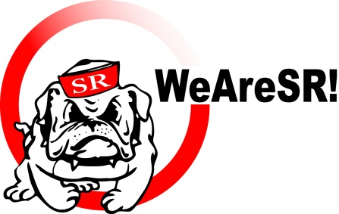
Art Boosters 2016-2017
Please return this form to Class by Friday 9/23/16

Welcome to The Art program at San Rafael High School !!

Do you know….
It costs about $75 per student to fund the basic art program that your student is enrolled in. Each year we depend on donations, both direct and through WeAreSR, to cover material costs. 100% of booster contributions go towards art materials and supplies. Your support enables the Ceramics, Photography, Art & Design and AP Art programs to provide the highest quality instruction and materials for your students.

We also need and appreciate volunteers, for activities such as participating in Art Booster meetings once a month, driving to events, hanging art, providing supplies or labor and volunteering at the Holiday Tree Lot. Let us know how you can help and we’ll call you when the need arises.

If you have questions about the Art Booster program, please contact parent Debbie Ward at dw_a_mom@hotmail.com.

We appreciate your support in any form you are willing and able to provide it!

Yes! I want to support ART at San Rafael High!

Please make checks payable to: SRHS Art Boosters

___ Direct Financial Support: Enclosed is my check for $_______ (basic support is $75 but any amount is appreciated!)

- Generous Gift of $250 or more: You will receive a creative gift from the Art department!

___ Indirect Financial Support: I am separately donating to the WeAreSR Annual Fund and understand that a portion (to be determined by WeAreSR) of my general fund donation will be shared with Art Boosters.

___ Tree Lot Support: I can help raise money for Art by working at the tree lot and designating my hours to Art.
I have provided my email address below so you can contact me when it is time to sign up.

___ Moral Support: I can help the San Rafael High Art Boosters by participating in Art Booster meetings once a month, driving to events, hanging art, providing supplies or labor and volunteering at the Holiday Tree Lot, etc
(please circle).

___ Art Boosters Email list: Include my email ____________________________________________ on the art boosters contact list to receive emails about special events and Art Booster fundraising, including tree lot shifts.

My SRHS student(s) is/are

Art Class(s) Period(s) Grade(s)

My name is: Phone:

Address:

SRHS Art Boosters is under the umbrella of WeAreSR!, a 501(c)3 non-profit organization. Tax ID #68-0043l06
WeAreSR! - P.O. Box 151203 - San Rafael, CA 94915-1203
Your donation is tax deductible to the extent allowed by law
Please keep a record of your cancelled check for tax purposes

