
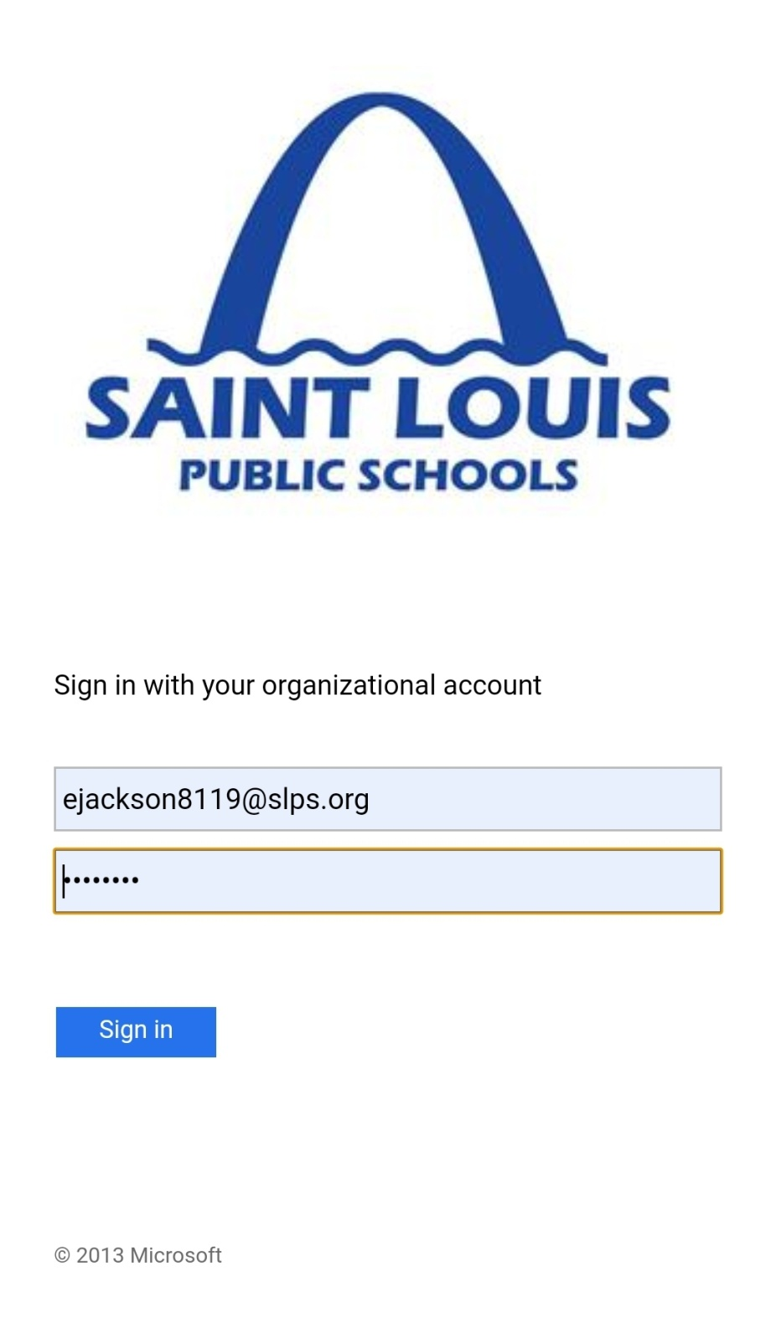
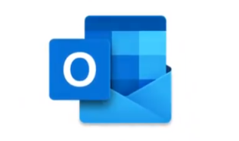

**Your email address is NOT your login**
How To Log in to Microsoft Office Email and Teams accounts
- Go to: https://www.office.com/?ref=login
- Click- Sign in
- Type in your- GatewayUsername@slps.org
- Type in your- Gateway Password

To check EMAIL– Click on Outlook

To get ASSIGNMENTS- Click on Teams

Office & Teams are also both downloadable.
FREE APPS

