HOW TO TIE A FOUR-IN-HAND AND WINDSOR KNOT TIE

Four In Hand Knot Windsor Knot
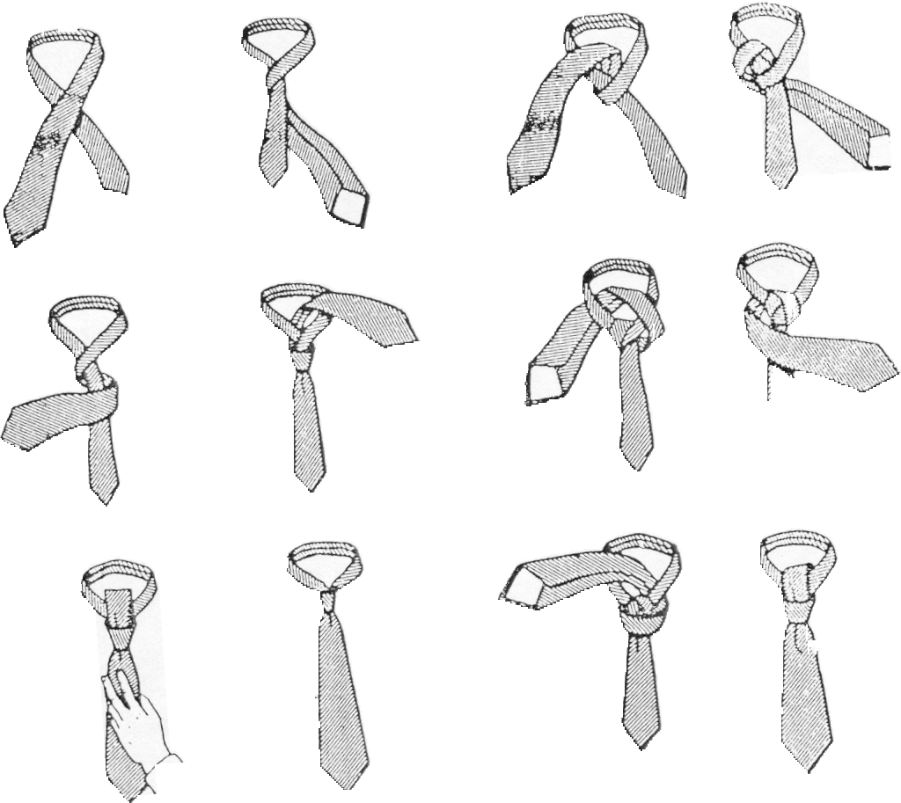

Four In Hand Knot: Start with the wide end of the tie on the right side; then cross the wide end over in back and to the left; bring it completely around the front to your right; bring it back and up through the center; pass it through the loop in front; tighten the knot neatly, forming a “dimple” with your index finger.

Windsor Knot: With the wide end of the tie about 12 inches longer than the narrow end. Make a loop as shown. Bring the wide end around and behind the narrow end up and put it through the loop and around in front of the narrow end; bring it through the loop of the tie, pull the wide end through the knot and shape carefully.

