Diets low in Magnesium have been found to increase anxiety-related behaviors. If you are feeling anxious, consider adding foods high in Magnesium, like chickpeas, to your diet.
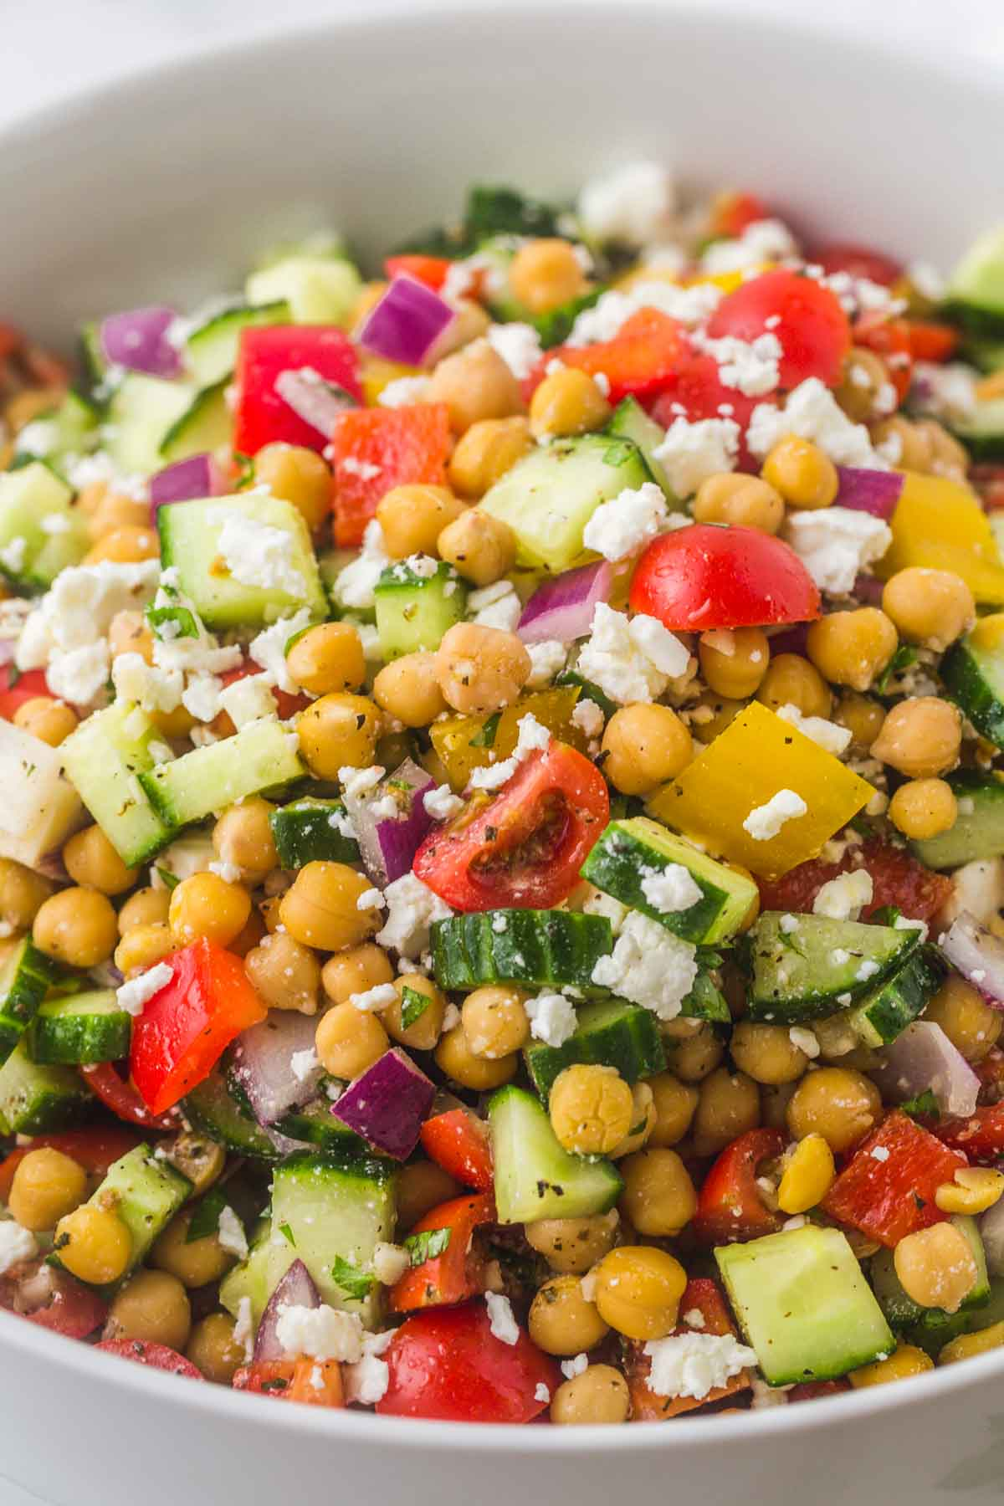
Ingredients
2 (15oz) cans chickpeas, drained
½ red onion, diced
1 medium cucumber, diced
½ cup feta cheese, crumbled
8 oz cherry tomatoes
¼ cup chopped fresh parsley, chopped
For the Dressing
3 Tbsp olive oil
2 Tbsp lemon juice
2 garlic cloves, crushed
½ tsp dried oregano
½ tsp dried basil
1 tsp salt
¼ tsp ground black pepper
Directions
- Make the dressing. In a small bowl, mix lemon juice, olive oil, garlic oregano, basil, salt, and pepper. Set aside.
- Add all vegetables, chickpeas, and ½ feta cheese and dressing to a bowl. Mix well.
- Garnish with the rest of the cheese and refrigerate for 1-2 hours for flavor will develop. Serve and enjoy.

