Gradebook
Teacher Connect®
eSchoolData

For additional assistance, please contact Information Systems: x1360
The Teacher Connect Gradebook is a customizable tool for teachers to use on a daily basis anywhere the internet is accessible. Teachers are able to utilize multiple grading methods, create assignment weights, run student specific performance reports, and much more.
All Teacher Connect Gradebook settings save to the teacher’s account, rather than to the cookies on their computer, and will be reflected upon each login, whether from school or from outside the district.

Overview

The Teacher Connect Gradebook is a customizable tool for teachers to use on a daily basis anywhere the internet is accessible. Teachers are able to utilize multiple grading methods, create assignment weights, run student specific performance reports, and much more.
All Teacher Connect Gradebook settings save to the teacher’s account, rather than to the cookies on their computer, and will be reflected upon each login, whether from school or from outside the district.
This guide focuses on using the Teacher Connect Gradebook to record Assignment scores and calculating Marking Period and final Grades.

Accessing Teacher Connect Gradebook
From the Staff Schedule Views screen, click on the Course # for the selected class. By default the combination TC Roster /Attendance screen will be presented. Alternately, right-click a Course # to directly access specific screens such as the TC Class Roster, TC Gradebook, TC Progress Report and TC Learning Standards.
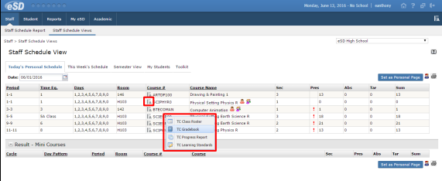
Once the Teacher Connect Roster/Attendance screen opens, a side menu presents icons to access the Gradebook, Progress Report or Learning Standards.

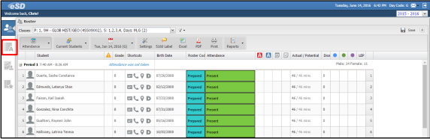

Note: Items specific to the Gradebook window will be covered in this guide. For additional information on the Teacher Connect Interface (layout , navigation and common tools), please refer to the Teacher Connect Interface User Guide.

Grading Information
To access information about Grading Formulas, Assignment Scores, Assessment Scores and Marking Period Grades relevant to the District select the Help Menu dropdown.
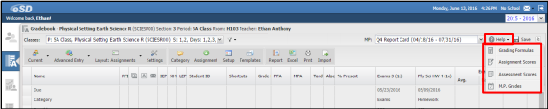
Grading Formulas – Presents information and examples for the grading formulas of Total Points Summation, Summation, Averaging/Summation Percentage and Raw Score to Percent.
Grading Options – Presents the options relevant to the District which are Marking Period/Final Grades (secondary grading) and Standard-Based Grades (elementary grading)
Assignment Scores –Presents Assignment scores relevant to the District
Marking Period Grades – Presents the grades relevant to the District

Gradebook Settings
Click Settings to establish the display preferences for the TC Gradebook..
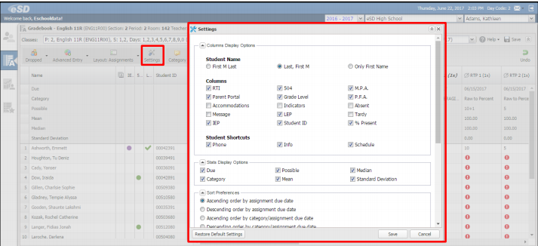
The Settings window contains six sections:
Columns Display Option – Teaches can choose how to display student names, and which columns and Student Shortcuts to display.
Stats Display Options – Allows teachers to choose which assignment statistics to display.
Sort Preferences – Controls the order in which assignments and categories display

Past Due Assignments – Allows teachers to control the value of Past Due Assignments in calculations.
- Past Due Assignments set to Blank will display the Past Due Icon only. These assignments will be EXCLUDED from Category calculations and also excluded from Marking Period calculations
- Past Due Assignments set to Zero will display both the Past Due Icon and a zero (0). The zero (0) will be INCLUDED in Category calculations, and also included in Marking Period calculations.
Assignment Scores Columns – Teachers using Marking period Grades should leave the Assignment Scores Columns visible.
Category Options – Allows teachers to set defaults for new assignment Categories
Click Save when settings have been selected. Users can also Restore Default Settings if needed.
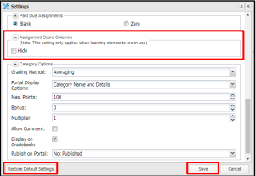

Classes Filter
The Classes Filter allows teachers to filter the Classes menu options to display All classes, only the Current Marking Period classes, or only Today’s classes. The filter selection is maintained when users switch classes and when they return to the Gradebook.
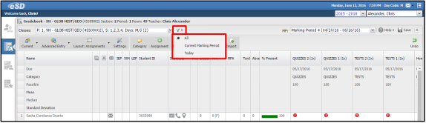

Gradebook Setup Tools
The TC Gradebook has various tools that allow teachers to set up Categories and Assignments for a class. Teachers should use the basic Setup option before using advanced features. Gradebook Advanced Features include Copy Assignments, Restore Assignments, Import Assignment Scores, Gradebook Templates and Gradebook Reports.

Setup Screen
Click Setup to open the Setup Screen.
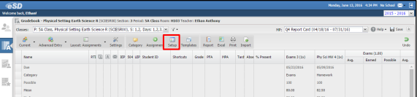

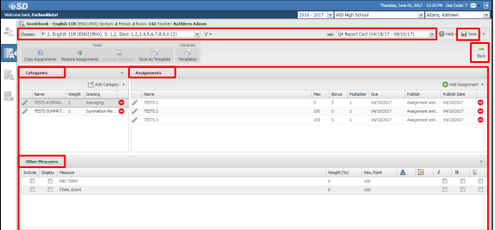

- Teachers can view, add and/or edit all the Categories, Assignments and Other Measures settings for the selected Class and Marking Period in one place

- Categories that are associated to a Gradebook Assignment Template will be shaded in pale yellow
- Click Save to apply the Setup changes to the Gradebook, then click Back  to close the Setup screen and return to the Gradebook

- The message “ Please wait for the page to load completely before clicking the Save button” will be displayed if Save is selected before the Setup page fully loads to prevent the loss of gradebook data.
Note: When users click on Back WITHOUT clicking Save, any changes made will be retained in the Setup screen but WILL NOT be applied to the Gradebook.
Note: the Add Category and Add Assignment windows can be accessed using the Category and Assignment buttons on the Gradebook toolbar without having to leave the Grade Entry screen.
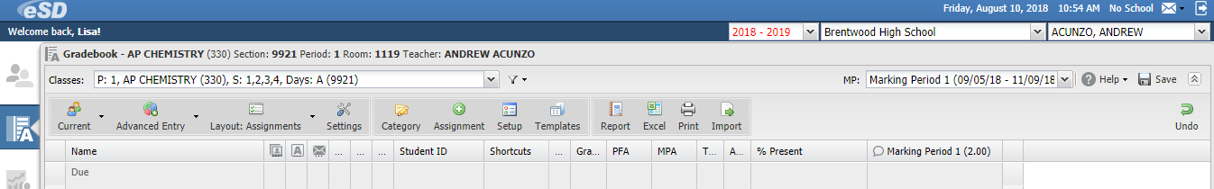

Adding Categories
Click Add Category. Enter the category Name and Weight (defaults to 1) and select the Grading method.
- Category names must be unique within the same Class, but the same Category can be used for multiple classes. Category names are NOT case-specific. For example, “Tests” and “TESTS” are considered the same Category

- The Grading Method defaults to Averaging
- Click the Edit Icon next to an existing Category to edit the Name, Weight, and/or Grading method

- Save all changes BEFORE clicking Back to return to the Gradebook
Click Advanced from the Add Category menu to open the Add Category window for full access to all of the category fields. Category settings will carry over to Assignments within the Category.
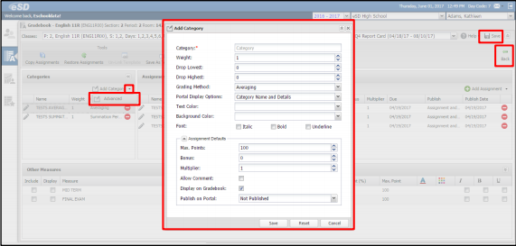
- When Drop Lowest and/or Drop Highest are greater than zero, the applicable value(s) in that Category will display the Strike-through icon

- Changing Text Color or Background Color of a Category will override the color settings of individual Assignments in that Category
Click the Delete icon to delete a new or existing Category
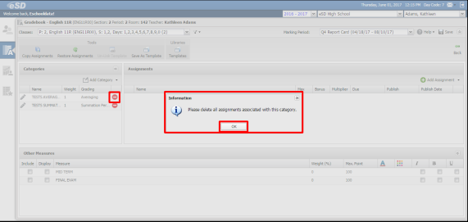
- Users will be prompted if assignments are associated to the category

- Categories CANNOT be deleted if Assignments with Assignment Grades are associated. Delete all Assignments and Assignment Grades in order to delete the Category

Adding Assignments
Click the desired Category, then click Add Assignment. Change the default Assignment Name and Max Points if needed. Select the Due date, Publish status and Publish Date (if applicable).
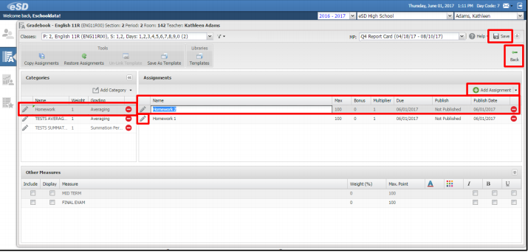
- Assignment names MUST be unique within the SAME Category, however, eSchoolData strongly recommends that Assignment names be unique across ALL Categories. Unique Assignment Names across ALL Categories avoids potential confusion when importing assignment scores using the Import Assignment Scores feature

- Assignment Names are NOT case-specific. For example, “Test 1” and TEST 1” are considered the same name

- Users will be prompted if the selected Due Date is outside the Marking Period’s date range

- Click Advanced from the Add Assignment menu to open the Add Assignment window for full access to all of the assignment fields.

- The Assignment Description can include a URL link to a website of document stored on the web, and will be available on the Portals when the Assignment is published

- The Save button is inactive until all required fields indicated by the red asterisk * are filled
- Save all changes before clicking Back to return to the Gradebook

- Click the Delete icon to delete a new or existing Assignment. Users will be prompted if assignment grades are associated to the assignment

- Assignments CANNOT be deleted if any Assignment Grades are associated with the assignment. Remove all assignment grades in order to delete the Assignment

Exclude Students from Assignments
Expand the Exclude Students section (collapsed by default) on the Add Assignment/Edit Assignment window to mark students as excluded from the assignment. Check the header row checkbox to exclude all students, or check individual students to exclude them.

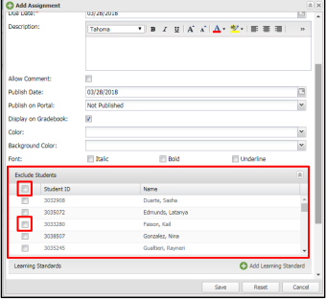

- Excluded Students display EX as the assignment grade automatically
- Excluded assignments are omitted from the student’s Gradebook tab in the Parent and Student Portals
Other Measures Section
The Other Measures section lists the Assessment Measures associated to the Course.
When a Marking Period is selected form the Marking Period menu, the Other Measures section will list ONLY those Assessment Measures whose Assessment Date falls with the selected Marking Period.
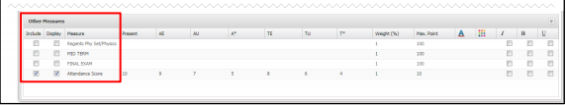
Hover over the Include and Display column headers to view a tooltip explanation for each.
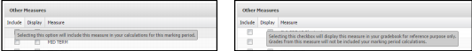

Check Display to view and/or enter Assessment scores during the selected Marking Period ( as determined by the Assessment’s Date), then select each assessment’s Display options:
- Text Color
- Background color
- Font Formatting

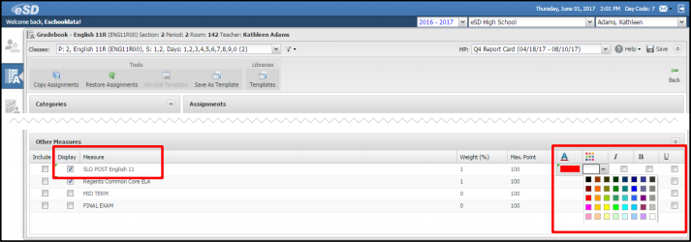

- Check Include to factor the assessment score into the selected Marking Period’s grade calculation
- Set the Weight for each assessment measure that is Included in the Marking Period Grade Calculation
- Assessments that are Included in a Marking Period’s grade calculations should also be Displayed during that Marking Period
- Sores for Assessments that are NEITHER Included nor Displayed in any Marking Period are entered from the Report Card Entry screen

Grade Entry : Assignments
Teachers can click directly on any cell to enter a grade, and can navigate across columns and rows using the arrow keys on the keyboard. Teachers can also navigate to the right using the Tab key, and navigate down using the Enter key.
Each grading cell, when clicked, will display:
A Delete Grade Icon - The Delete Grade Icon will delete the current grade
A Fill Down Icon - The Fill Down Icon will fill all empty cells in that column with the currently selected grade

Score Format
For Assignment scores, teachers can enter students’ Points Earned as a single “score” ( for example 50). They can also record points using “+bonus” and /or “–penalty” options (for example “50-3”, with or without spaces). To use the “+bonus”option, teachers must first define the bonus points when creating or editing the assignment.
When bonus points have been defined for an assignment, teachers MUST enter students’ Points Earned as “score +bonus” or “score+bonus-penalty” (for example “50+5-3”, with or without spaces) in order to validate the bonus points.
The “+bonus” and “-penalty” options allow teachers to clearly record and display bonus points for extra credit work, and penalties for late assignments, sloppy work, etc.

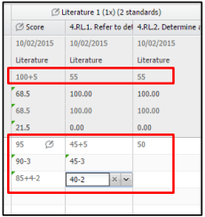

An error message appears when invalid scores are entered, explaining the invalid grade. The invalid grade is cleared when users click OK.

- The order of the “+bonus” and “-penalty” options is interchangeable
- If Bonus points have been defined, the Possible points (in the Stats row Score column) displays as Max. Points+Bonus points.
- Teachers can also create a “Bonus only” assignment by setting the Max.Points to zero (0) and defining the Bonus value

Category Averages
For each Category, the Category Averages display three columns: Avg/Earned/Possible points, and the user can hide any (or all) three columns.
- Avg column - Displays the student’s average for the category. This is calculated as (the sum of Assignemnt Scores (assignment Points divided by assignment Max.Points)]divided by [the number of assignments]. This calculation allows students to earn extra credit without penalizing those students who do not.
- Earned Column - Displays the student’s Earned Points for the category, calculated as the sum of (assignment Points Earned multiplied by Assignment Multipliers).
- Possible Column – displays the sum of the assignment Max. Points for the category.
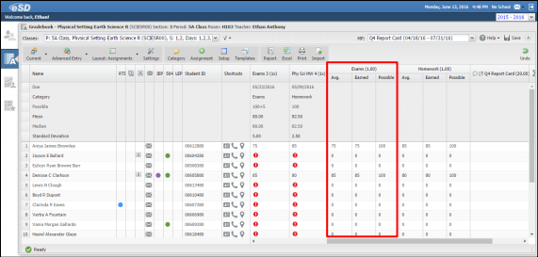
The Avg /Earned columns incorporate the following settings in the calculations:
- Assignment Multipliers
- Category Drop Lowest/Drop Highest settings
- Past Due Assignments Zero/Blank Settings
- Alpha Grade Numeric Equivalent Zero/Blank Settings

Gradebook Grade Entry Features
Undo/Save
The Undo button allows users to restore previous cell values, on a step by step basis, back to the last Save of the Teacher Connect Gradebook.
- Grades that have been changed since the last Save are indicated by the green triangle in the upper left corner of the cell
- The Status Bar in the bottom left corner of the TC Gradebook indicates the most recent activity
- Click Undo to undo the most recent grade change since the previous Save
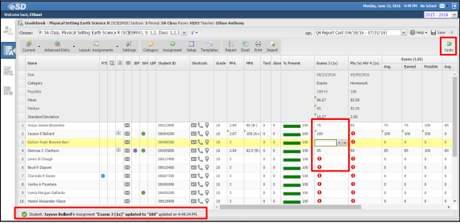
Click Save to save the Gradebook. A confirmation message will display after the Gradebook has saved.
Reminder: Users cannot “Undo” grade changes once the Gradebook is saved.
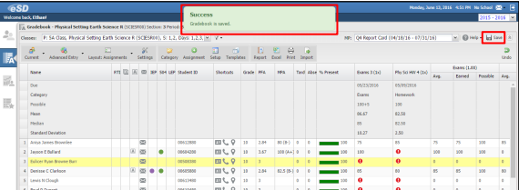

Tools Toolbar
The Tools Toolbar controls different views and settings of the TC Gradebook
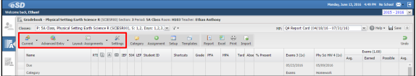
Grade Entry Options - Select Advanced Entry (default setting) or Rapid Entry to enable/disable the automatic calculation of Category and Marking Period Averages, or click the button to toggle between Advanced/Rapid Entry.
- Rapid Entry – minimizes the data displayed. All automatic Category/Marking Period Average/Statistics calculations are disabled for faster grade entry
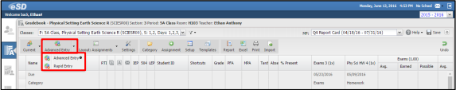
Layout – Select Assignments (Default setting) or Students from the Layout menu to transpose the layout of columns and rows or click the button to toggle between Assignments/Students.
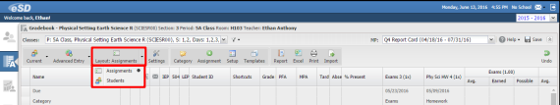
Layout options:
- Assignments Layout – Has rows of Students and columns of Assignments
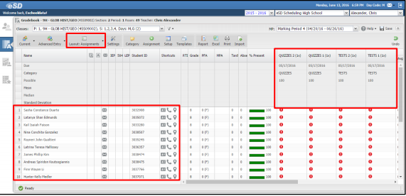
- Students Layout – Students Layout has rows of Assignments (or, in Report Card Entry, rows of MPs/Assessments) and columns of Students.
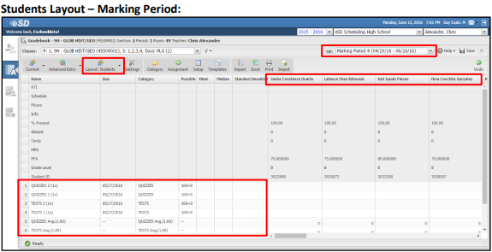
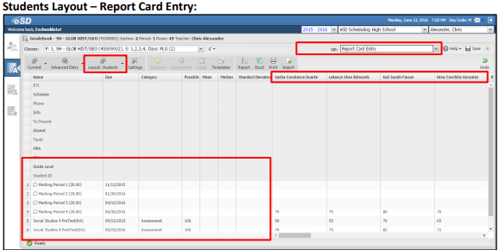

- Single-Student Layout – Is a variation of the Students Layout, showing only a single student.
    - From the Assignments Layout, double-click a student’s name of ID number to switch to Single-Student Layout.
    - Click the Previous Student/Next Student buttons, at bottom right, to move to another student.
    - Click the Layout button to return to the full list of students in Assignments

Settings – click Settings to establish Column Display Options, Stats Display Options, Sort Preferences, Past Due Assignments values, and visibility of the Assignment Scores Columns
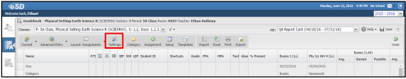

Grade Entry Area
The Grade Entry area displays Student IDs, Names, Grade Levels, Projected Final Averages (PFA), Marking Period Averages (MPA), Attendance data (Tardy, Absent, % Present) and Assignment/Category/Marking Period Grades for the selected Class and Marking Period.
- The formula to calculate the % Present is “(total days – absent days)/total days”
- The date range used for the Gradebook’s % Present calculation is the marking period start date through the current date or the marking period end date (whichever is earlier).
The Assigments Layout displays columns and icons to identify students as follows:
- Students whose parents have Parent Portal Accounts - Hover over the icon to display hyperlinked names of parents with portal accounts and details of their last login
- Students with Test Accomodations
Special Education (IEP) – Click to open the student’s IEP Plan
504 Plans – Click to open the student’s 504 Plan
RTI Plan
Limited English Proficiency

Student Shortcuts
Student Shortcuts within Teacher Connect Gradebook ( in the Advanced Entry View only) provide quick access to each student’s Profile Contacts and Schedule .
Uses can display any or all Student Shortcuts using the Settings menu.

Setup Toolbar
The Setup Toolbar allows users to add Categories and Assignments without leaving the Grade Entry screen. The Setup button opens the Setup screen (with additional advanced tools) and the Templates button opens the Templates Library screen (an advanced tool). For more information see the Advanced Gradebook Functions section, starting on page …
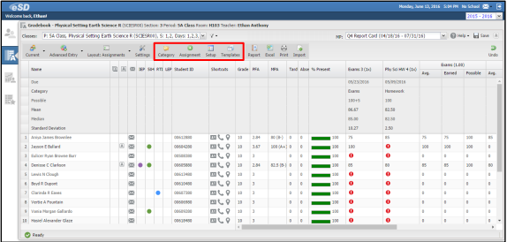
Report/Import/Export Toolbar
Using the Report/Import/Export Toolbar, users can create/run a Report, export the Gradebook to Excel, Print the Gradebook, or Import assignment scores, without leaving the Grade Entry screen. For more information see the Advanced Gradebook Functions section, starting on page …
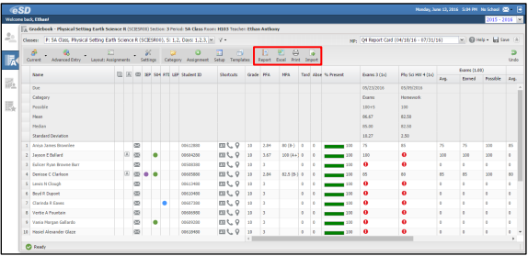

Column Menus
Hover over a Column Heading to display its drop down menu icon . All Column Drop-Down Menus allow teachers to Sort by that column in Ascending or Descending order, Lock or Unlock the column and select Columns to hide or unhide.
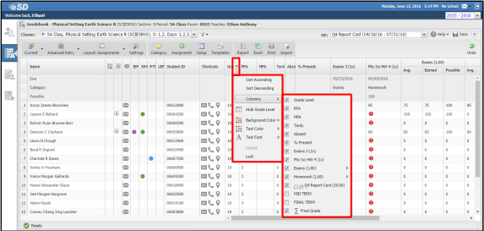

- Assignment and MP Grade column menus allow teaches to Hide/Show Only the selected Assignment/MP Grade, Edit/Delete the Assignment/Category, Publish or Unpublish Scores to the Parent Portal, Erase All grades, Calculate Numeric Grades (M.P Grade only), and Import (Assignment Name ) Scores ( Assignments only)
- Users can customize column appearance by Background Color, Text Color and Text Font (Italic/Bold/Underline) using the column header menu
- Import(Assignment Name) Scores will import scores for a single assignment. The import file MUST have two (2) columns ONLY: student IDs and assignment scores. Assignment scores that include bonus points must be formatted as “score+bonus” in order to have bonus points validated
Teachers can import scores for multiple assignments using the Import Tool (. For more information see the Advanced Gradebook Functions section, starting on page …

Marking Period Average
The Marking Period Average ( MPA) column, available on both the Marking Period and Report Card Entry screens, calculates the student’s running Marking Period Average ( and alpha grade equivalent, when applicable) for the current Marking Period.

MPA considers all of the following in calculations:
- Assignment Multipliers
- Category Weights
- Category Drop Lowest/Drop Highest Settings
- Past Due Assignments value (Zero/Blank)
- Alpha Grade Numeric Equivalent values (Zero/Blank/Number)

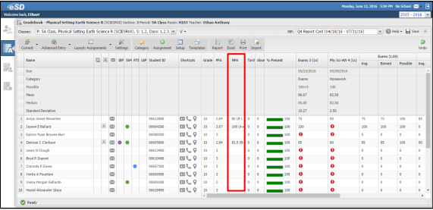

Projected Final Average
The Projected Final Average (PFA) column, available on both the Marking Period and Report Card Entry screens, calculates the student’s final average ( and alpha grade equivalent, when applicable ) as of the current date.

The P.F.A.values will update when the teacher next returns to the Gradebook.
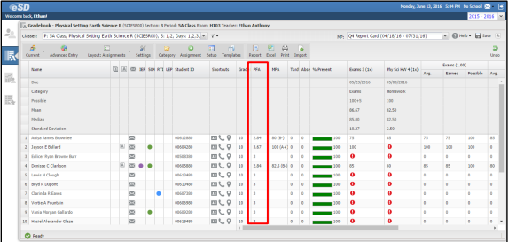

P.F.A. considers all weighting factors associated to marking periods and exams, follows the same order of precedence for Final Grade calculations and factors in the running marking period averages.

The logic for Projected Final Average is:
If MP grade exists for marking period:
- MP grade*[factor/weight added to numerator] and [factor/weight added to denominator]
Else if no MP grade exists and MPA exists for marking period:
- MPA*[factor/weight added to numerator] and [factor/weight added to denominator
Else if no MP grade and no MPA exist for marking period:
- No value added to numerator and no factor/weight added to denominator

Grade Entry: Marking Period
When the Marking Period Grade Entry window opens, the grade entry cells will be unlocked, so that teaches can enter Marking Period grades.
For teaches using the TC Gradebook, to calculate one student’s Marking Period grade from their Assignment grades, click in the cell and click the Calculator icon .
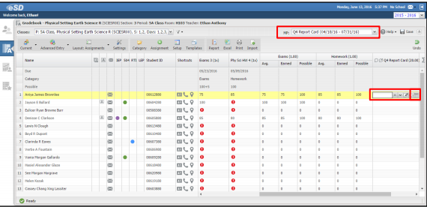

To calculate all students’ Marking Period grades at once, click Calculate Numeric Scores on the Marking Period column header’s drop-down menu.
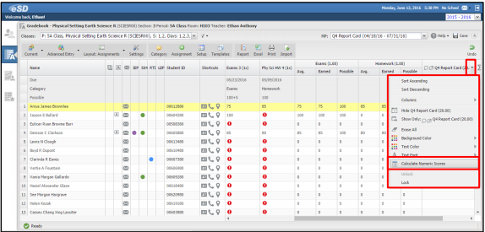

- An error message will be displayed if the calculated Marking Period grade is not an allowable value within the Grade Group associated to the course
- For Marking Period grades the Fill Down and Delete Grade Icons will also fill down and delete selected comments
- Calculate Numeric Scores is visible only when the Marking Period Grade Entry window is open
- The Erase All menu option will erase both grades and selected comments

Comments
If enabled, the Selected Comments icon will appear before the Marking Period Name in the column headers. The selected Comment window displays tallies of Selected and Maximum Comments
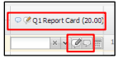
Click the Selected Comments Icon to select canned comments. Click the empty space in the Selected Comments field to display/hide the list of available comments.
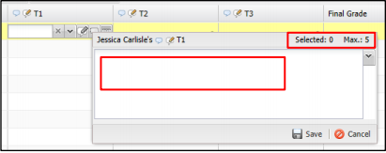

Scroll through the list of available Comments and click the desired comment to add it to the Selected Comments field. Click the Delete icon to delete a selected comment or, to delete ALL selected comments, click to the left of the bullets in the list of available comments.

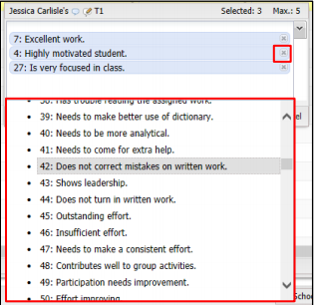
When finished selecting Comments, clicking in the empty space in the Selected Comments field will hide the list of available comments. Click Save.
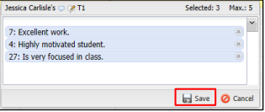
The Comment Icon AFTER the student’s score indicate that Comments have been entered. Hover over the Comment icon to display the comment (s).
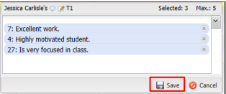

Grade Entry: Report Card
Teachers can use the Report Card Entry screen to enter grades for any Assessments associated to the course, Marking Period Grades and Comments and Final Grades.
Select Report Card Entry from the Marking Period drop-down menu.
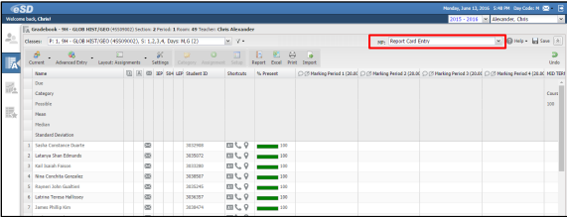
Note: When Report Card Entry is selected, the Add Category, Add Assignment, and Setup buttons are disabled for both the Advanced and Rapid Entry views.
- The Fill Down and Delete Grade Icons will also fill down and delete both grades and selected comments
- The Erase All menu option will erase both grades and selected comments
Other Measure Grades

Marking Period Grades
Marking Period Grades and Marking Period Comments can be entered or calculated using the Report Card Entry screen, in the same manner as on the Marking Period entry screen. If they were entered or calculated on a Marking Period screen, they will carry over automatically to the Report Card Entry screen.
An alpha grade equivalent will display in parentheses next to a Numeric grade, based on the school’s Grade Conversion table. A Numeric Grade Equivalent will display in parentheses next to an Alpha Grade, based on the schools Grades table.
Report Card Entry can also be used to enter Marking Period Grades and Comments for classes that do not use the Gradebook for Assignment Grades.

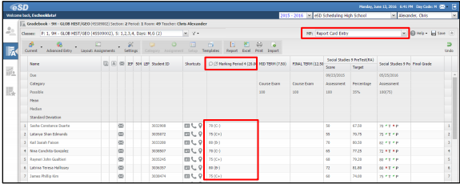
Final Grades
Final Grades can also be entered using the Report Card Entry screen.
- Final Grades are rounded to whole numbers.
- If no weights have been entered, The Final Grade will be calculated to a straight average
- Final Grades are displayed in the Final Course Grade column on Report Cards, the Final Grade column of Transcripts and used in Class Rank calculations for completed courses
- Final course grades that have been overridden from the Student Profile Transcript tab are displayed in the Gradebook on the Report Card Entry screen.These overridden grades can be overridden again from the Gradebook by those with proper permissions.ONLY
- Final Grades entered or calculated on the course’s final Marking Period screen will carry over automatically to the Report Card Entry screen.

Advanced Gradebook Functions
There are a variety of Gradebook functions that allow advanced users to Copy Assignments, create and use Templates, create and run Reports, Export or Print the Gradebook, and Import assignment scores en masse.
Setup Screen Toolbar Row
The Setup Screen Toolbar Row contains two toolbars, Tools and Libraries, which allow users to copy assignments from one class to another, create and apply Gradebook templates and access the Templates Library
Tools Toolbar
The Tools toolbar contains four advanced Gradebook tools:
- Copy Assignments – Allows the user to copy assignments from one class/marking period to another class and/or marking period
- Restore Assignments – Allows users to easily restore inadvertently deleted assignments, individually or en masse
- The Un-Link Template/Save As Template tools work in tandem, allowing the user to create a Gradebook Template from the selected class’ marking period assignments or unlink the class form the established Gradebook Template

    - When the selected class is NOT associated to a Gradebook Template, the Save As Template button is active (the Un-Link Template button is greyed out)
    - When the selected class has been associated to a Gradebook Template, the Un-Link Template button is active (the Save As Template button is greyed out)
    - Hover over the Un-Link Template button to see which Template is linked
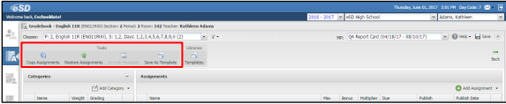
Libraries Toolbar – Allows users to access the Templates Library
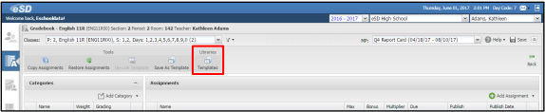
The Templates Library can also be accessed directly from the Gradebook, by selecting Templates from the Setup Menu.
Copy Assignments
There are two ways to copy assignments, with slight differences between them:
- From the Grade Entry screen, teachers can Save and Copy an assignment to other classes. This option allows a single assignment to be copied to multiple classes at the same time, and the assignment’s Due Date CAN be adjusted for each target class (if needed) during the process
- From the Setup screen, teachers can Copy Assignments to another class. This option allows multiple assignments to be copied to a single class at the same time, but the assignments’ Due Dates CANNOT be adjusted during the process
Grade Entry : Save and Copy
From the Grade Entry screen, click the Assignment button to open the Add Assignment page. Enter the new assignment details, then click the Save & Copy button.
Note: Save and Copy is also available when teachers Edit an existing assignment from the Grade Entry page.
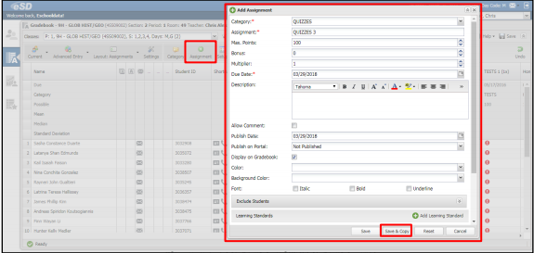
In the Save & Copy Assignment window, check the applicable target classes and, if needed, select a different Due Date. When finished, click Apply to copy the assignment.
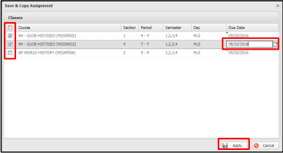
Note: Check the Header Row checkbox to select ALL classes

Setup Screen: Copy Assignments
From the Setup screen, click Copy Assignments to open the Copy Assignments window.
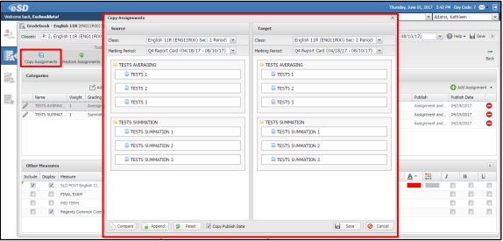
- The Source field displays the assignments from the selected Class and Marking Period
- In the Target field, select the Class and Marking Period to which assignments should be copied
- Any existing categories and assignments will automatically display in the Target field
- Click the Compare button to identify and select the Source categories and assignments that do not already exist in the Target
- Selected Source categories will be outlined in blue, with selected Source assignments shaded blue
- Click on individual item(s) to deselect them. Deselected categories will no longer be outlined in blue, with deselected assignments no longer shaded blue.
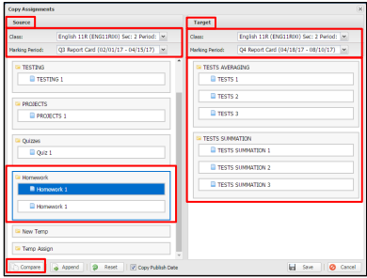
Tip: Deselect all Assignments within a Category to copy over only the Category, without copying any Assignments.

Hover over the Append button to view the tooltip. Copy Publish Date is checked by default, uncheck if applicable. Click the Append button to add the selected items to the Target
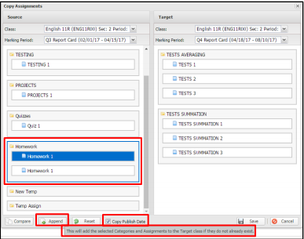
- Added categories will be outlined in blue in the Target field, with added assignments shaded blue.
- Click Reset to remove all added items from the Target, if added in error
- After all categories and assignments have been added to the Target, click Save
- The copied categories and assignmets will appear in the Gradebook for the selected class and marking period
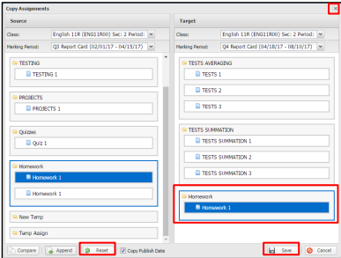
Note:
After Save, the Copy Assignments window stays open to allow additional copying of assignments. Click Close when done.
Users will receive an error message if Save is clicked when no categories or assignments have been added to the Target Class.

Restore Assignments
Click Restore Assignments to open the Restore Assignments window, which lists all deleted assignments for the selected Class and Marking Period.
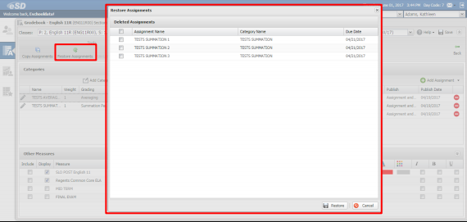
Click the checkboxes for the desired assignments, or click the header row checkbox to select all assignments, then click Restore.
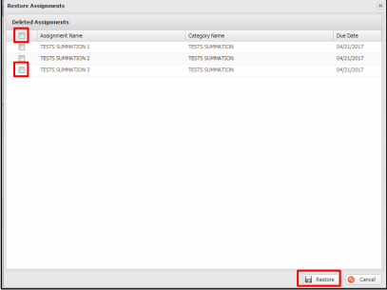
- The deleted assignments are restored to the Gradebook
- If a deleted assignment is associated with a deleted category, the category is also restored to the Gradebook
- If an assignment and/or category currently exists in the Gradebook with the same name as the deleted assignment and/or category, the word “restored” will be appended to the name of the restored assignment or category
- eSchoolData has recently added a validation preventing the deletion of assignments with associated student grades

Gradebook Templates
When there is no Gradebook Template associated to the class, the Save As Template button will be active.
- Click Save As Template to save the selected class’ marking period assignments as a Gradebook Template.
- Enter the Name for the New Template and a Description (optional), then Save
- Template names must be unique. Users will receive a warning message if a template name has already been used
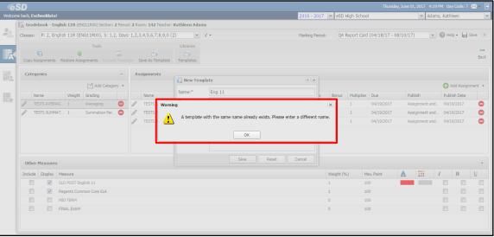

- Gradebook Templates can be assigned to multiple classes, and to multiple marking periods per class.
- If a Gradebook Template is customized for a specific course, include a reference to the applicable Course in the template Name.

Un-Link Templates
When the class has been associated to a Gradebook Template, the Un-Link Template button will be active.
- Click Un-Link Template to unlink the class from the associated Template, then click Yes in the confirmation message
- Hover over the Un-Link Template button to see which Template has been applied to the class

Templates Library
The Templates Library opens the Gradebook Assignment Templates, which is divided into three sections:
- Templates – Lists the available Gradebook Templates
- Categories – Lists the Categories in the selected Gradebook Template
- Assignments – Lists the Assignments in the selected Category
Each time the Templates Library is opened, the Templates section is expanded by default.
- Users can Collapse or Resize the Templates section to allow more space for Categories and Assignments
- Click Back to return to the previous screen
If the selected Class has a Template associated to the current Marking Period, the template will be highlighted in the Templates section, listed as the Selected Template (above the Categories section), and the Template’s Categories and Assignments will display by default. If the selected class does NOT have a template associated to the current Marking Period, the user can select a Template from the Templates section.

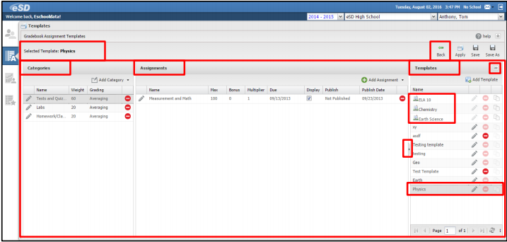
- For all Teacher-defined Templates carried forward from the previous year, check to confirm that the Grading method for each Category is listed
- Users can adjust the width of the sections by dragging the white space between sections

Users can:
- Add Templates
- Add Categories
- Add Assignments to new or existing teacher-defined templates
- Edit or Delete existing teacher-defined Templates, Categories, or Assignments
- Save Template changes
- Copy teacher-defined Templates using Save As
- Apply a Gradebook Template to various classes
Note: Templates cannot be deleted if they have been applied to a class
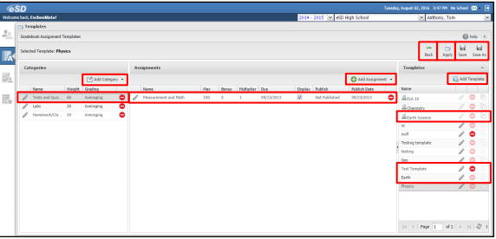

From the Linked Gradebook, users can:
- Modify the Due Dates and Publish Dates of assignments associated to the Gradebook Template. If users subsequently add an Assignment to a Gradebook Template that is linked to a Gradebook with modified Due/Publish Dates, the modified Dates are maintained in the Gradebook
- When users delete an assignment from the Gradebook Template, the assignment is deleted from the linked Gradebook(s) IF no grades are associated to the assignment. Otherwise the assignment and grades remain.
- When users delete a category from the Gradebook Template, the category ( and assignments within the category) are deleted from the linked Gradebook(s) IF no grades are associated to the assignments within the category. Otherwise, the category, assignments and grades remain.
- There is NO auto-save for Gradebook Templates – users MUST click Save or Save As to save changes to Templates, including adding/removing categories and/or assignments

Add Template
Click the Add Template button. Enter a Name for the New Template and a Description (optional), then click Save.
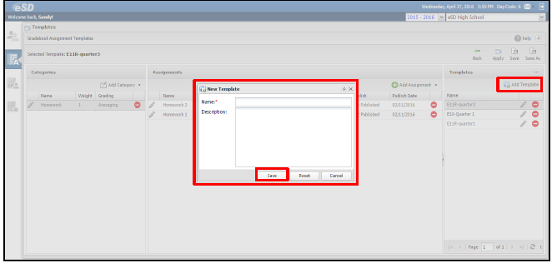
The new Template is automatically selected in the Templates list. Add Categories and Assignments as desired, then click Save.

Copy Teacher-Defined Template (Save As)
Select a teacher-defined Gradebook Template from the Templates list and click Save As to save that template as a New Template. Enter a Name for the New Template and a Description (optional), then click Save.
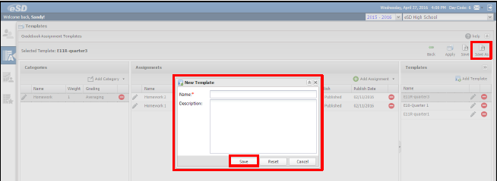
Click OK to close the “Template is saved successfully” message. The new Template is automatically selected in the Templates list. Edit the Categories and Assignments as desired, then click Save.

Apply Gradebook Template
Select the desired Gradebook Template from the Templates list and click Apply to apply that template to classes.
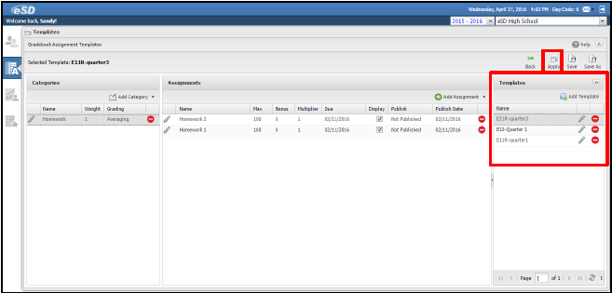
In the Apply Template window, for each desired Course Section, check the Marking Periods to which the Gradebook Template should be applied. When finished, click Save.
- Any Marking Periods to which the Assignment Template has already been applied will be checked and greyed out
- Any Marking Periods which have another Assignment Template previously applied by a teacher (main teacher or co- teacher) will be greyed out
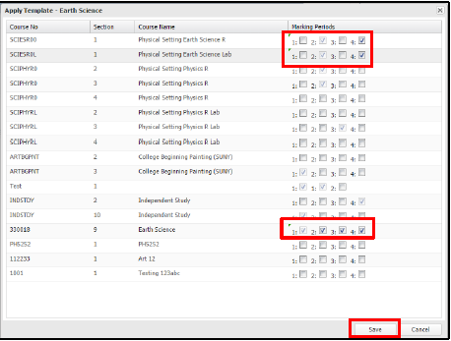

Export Gradebook
Click the Excel button to export the displayed data. Click Open to open the file or select other options form the Save menu.
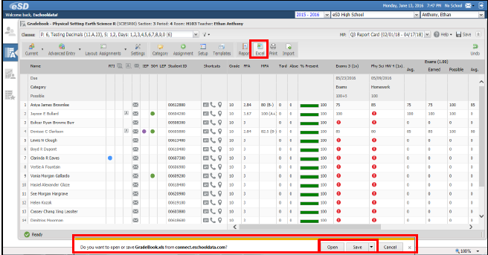

Print Gradebook
Click the Print button, then click Send to Printer to print the displayed data.
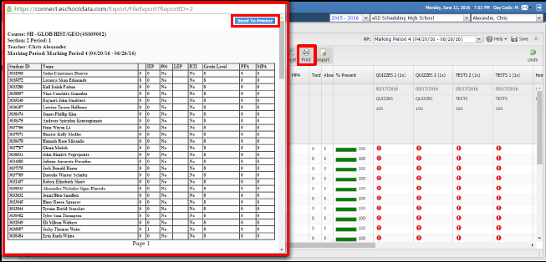
Note: Safari users must open Safari’s Settings and Uncheck Block Pop-Up window in order for the Print button to function correctly.

Import Assignment Scores
Click the Import button to start the process of importing assignment scores. In the Import Scores window, click Download Import Template with Data. Save and/or open the Import Template (an excel file containing assignments and students’ assignment scores form the selected class’ gradebook).
This file is the template to which the import files should conform.
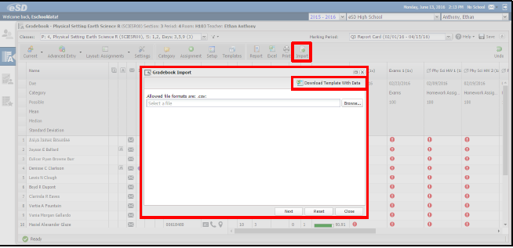
Use the Excel file to enter missing assignment scores and/or to change existing scores. Users can also add assignments to the Import Template. For assignments that are being added to the Import Template, Assignment Name, Date and Max Points are required.
Users can also import assignments and scores that are exported from another system, provided:
- The import file conforms to the example below
Note: If Student IDs are not available in the other system, delete the Student ID column from the import file. The import will then match on the First Name and Last Name fields.
- At least ONE Category exists in the TC Gradebook for the selected Marking Period.
To be available for selection during the assignment import, applicable Categories MUST exist in the TC Gradebook PRIOR TO the import.
When finished, save the import file as a .csv file.
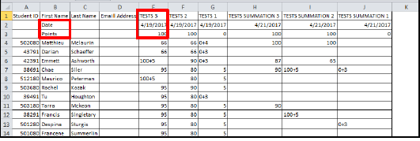
Note: If Assignment Name, Date and/or Max Points are missing for any assignment, the Import will fail.
Once the .csv import file is saved, click the Import button to import the assignment data. In the Gradebook Import window, click Browse to locate your completed import file. After the file has been selected, click Next.
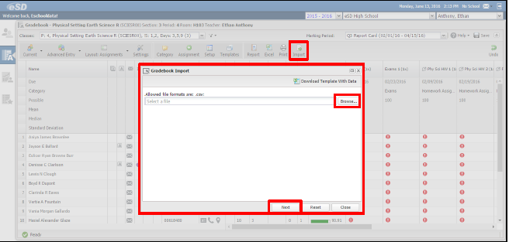
The New Assignments page will list the assignments that do not currently exist in the Gradebook.
For each new assignment, select the Category to which it should be assigned. Applicable Categories must exist in the TC Gradebook PRIOR TO the import in order to be available for selection during the assignment import.
When finished, click Import Assignments, then click Yes to confirm the import of assignments.
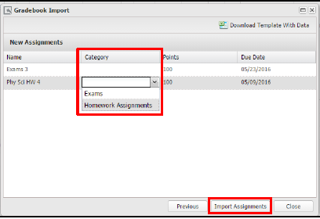
- Click OK to close the Assignment Import success message
- Click Close to cancel the import process, or click Previous to return to the file selection page

The Gradebook Import window will then display the data to be imported, check the displayed data for invalid scores (displayed in red), then click Import Grades to process the import. Click Yes to confirm the import of assignment grades.
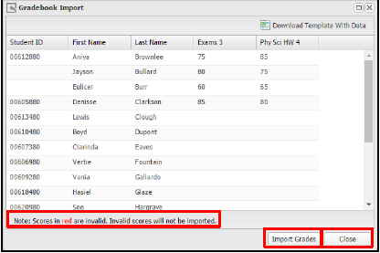
Once the import process completes, the imported scores display a green checkmark icon . Click Close to close the import window.
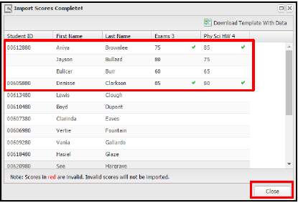
If the imported scores include Bonus Points that cause the student’s core to be higher than the assignment’s Max Points, the student’s score will have to be formatted properly AFTER the import has completed.
- Invalid scores will NOT be imported. Users must correct the invalid scores in the Excel file and save the file again as a .csv file
- If the Student ID Column is included in the import file and records are missing Student IDs, those records will NOT be imported
- The Student ID Column must be omitted from the import file in order to match on the First Name and Last Name fields

Information Technology Department
Phone: | (631) 434-2308
Fax: | (631) 434-3999
Email: | esd@bufsd.org

Coordinator | Guy D. Nelson

