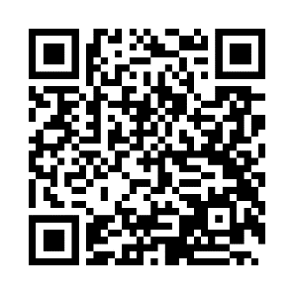
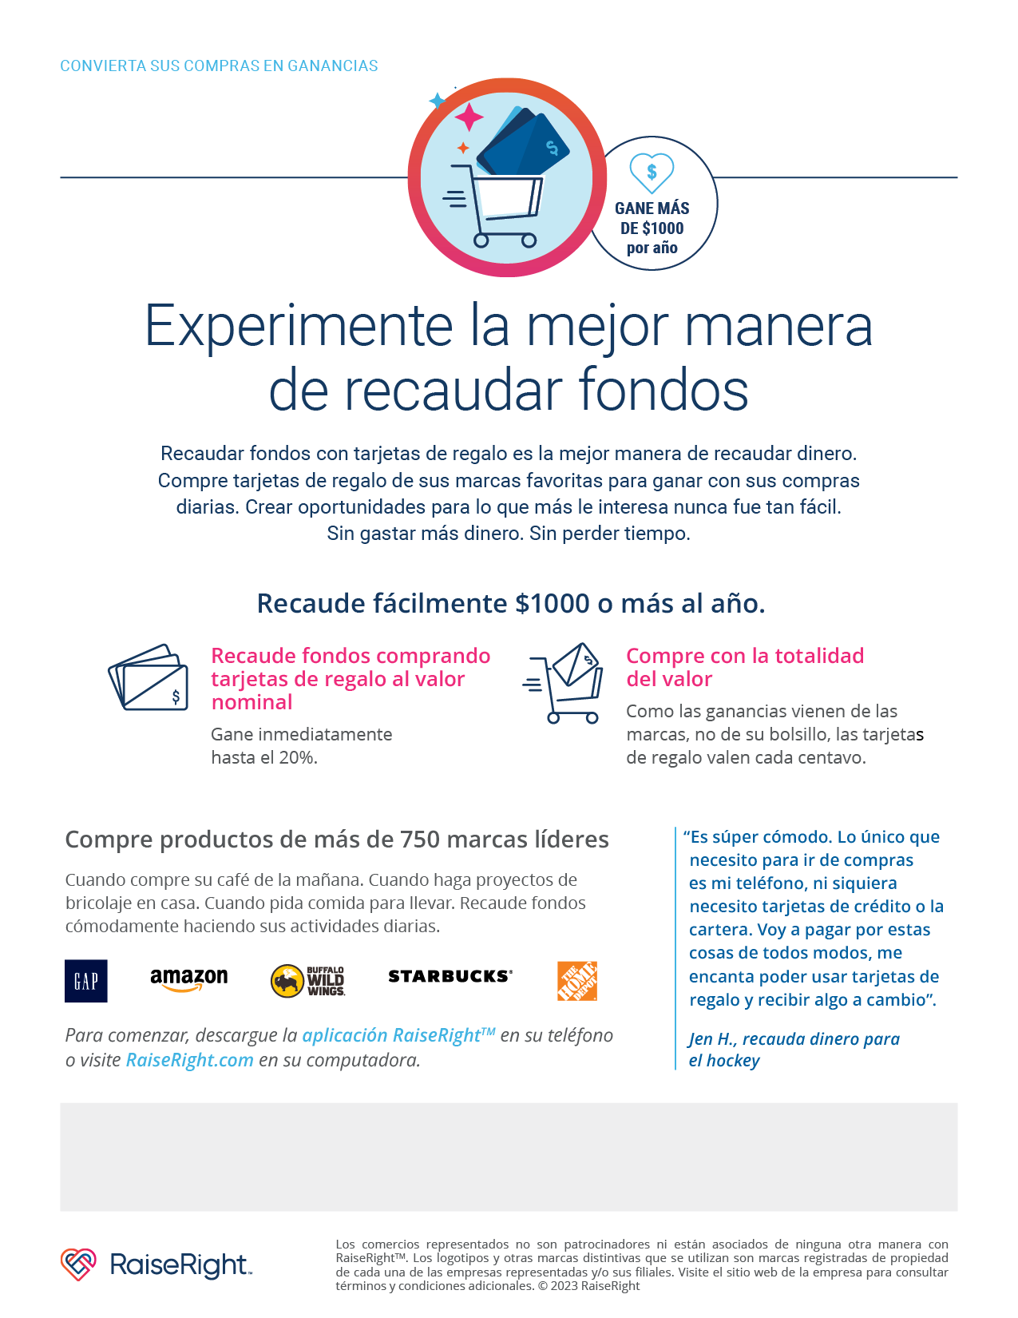
To enroll in the PVCA RAISERIGHT program scan the QR code with your phone or use enrollment code 72E9D189834L
For questions contact: Jessica Gonzalez at PVCSTRIP965@GMAIL.COM

