
CES Health
News
10/2020

October Awareness
- Domestic Violence Awareness Month
- Eye Injury Prevention Month
- Health Literacy Month
- Healthy Lung Month
- Home Eye Safety Month
- National ADHD Awareness Month
- National Breast Cancer Awareness Month
- National Bullying Prevention Month
- National Dental Hygiene Month
- National Down Syndrome Awareness Month
- National Medical Librarians Month
- National Physical Therapy Month
- Pregnancy and Infant Loss Awareness Month
- Spina Bifida Awareness Month
- Sudden Infant Death Syndrome (SIDS) Awareness Month
- World Cerebral Palsy Day (Oct. 6)
- Mental Illness Awareness Week (Oct. 6–12)
- World Mental Health Day (Oct. 10)
- National Depression Screening Day (Oct. 10)
- Bone and Joint Health National Action Week (Oct. 12–20)
- Metastatic Breast Cancer Awareness Day (Oct. 13)
- International Infection Prevention Week (Oct. 13–19)
- Pregnancy and Infant Loss Awareness Day (Oct. 15)
- National Latino AIDS Awareness Day (Oct. 15)
- World Food Day (Oct. 16)
- World Pediatric Bone and Joint Day (Oct. 19)
- Respiratory Care Week (Oct. 20–26)
- National Health Education Week (Oct. 21–25)
- National Healthcare Quality Week (Oct. 20–26)
- International Stuttering Awareness Day (Oct. 22)
- World Psoriasis Day (Oct. 29)

Reminder: Health Assessment and Immunization for Kindergarten requirements are due on or before October 30, 2020.

Flu Prevention
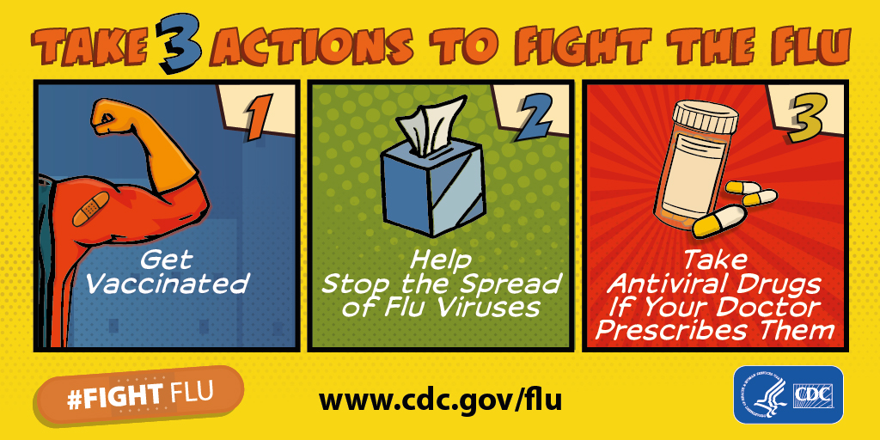

Infection control: Wear mask and handwashing

Websites
https://www.healthline.com/health/breast-cancer

https://www.cdc.gov/flu/season/faq-flu-season-2019-2020.htm

https://www.adha.org/national-dental-hygiene-month

https://www.awarenessdays.com/awareness-days-calendar/eye-injury-prevention-month-2020/

monday | tuesday | wednesday | thursday | friday
 |  |  | 1 | 2
5 | 6 | 7 | 8  ½ day  PD | 10
12 | 13 | 14 | 15 | 16
19 | 20 | 21 | 22 | 23
26 | 27 | 28 | 29 | 30

