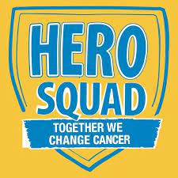
Pennies for Patients Campaign 2021
Heroes are never alone, they band together! Central Elementary has decided to take on blood cancer and our mission is to help find a cure. We are excited to announce that our school has officially kicked off Hero Squad program today! Your student will be bringing home collection information that explains the program and the exciting Hero Gear that can be earned!
By participating in Hero Squad, your student will learn about teamwork, bravery, social awareness, and will become part of a Squad that supports blood cancer patients, letting them know they are not alone. Hero Squad emphasizes the importance of social and emotional learning and gaining the experience of helping both children and adults in their fight against blood cancer right in our community.
Join our Squad by working together with your student by visiting HeroSquad.org, find Central’s page and select “Join Your School” or “Classroom Team” to start getting support from friends and family from all over. By raising money, students will earn fun Hero Gear at various fundraising levels. You can even link your child’s fundraising page to Facebook -this is the coolest way parents and guardians can support your student’s fundraising efforts!
To learn more about what joining the Hero Squad means, check out this super cool assembly video.
Heroes don’t always wear capes. By participating in the Hero Squad, families can easily show the community that you have done your part to help others and work to beat cancer! Visit HeroSquad.org to get started today! We appreciate your support!
Theme Days:

Red Out Team Up Super Hero Squad Central School Spirit
Monday, 19 Tuesday, 20 Thursday, 22 Friday, 23

