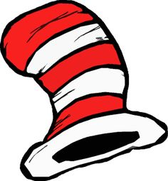
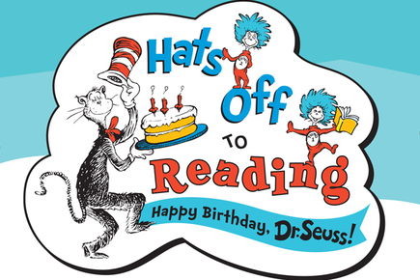
National Read Across America
Dress Up Week
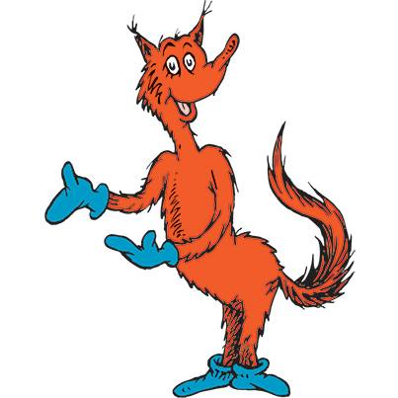
Monday- Cat in the Hat- Hat Day

Tuesday- Fox in Socks- Crazy Sock Day

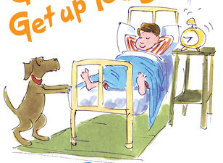
Wednesday-Wacky Wednesday-Crazy Dress Day

Thursday- I Am Not Going to Get Up Today!-Pajama Day

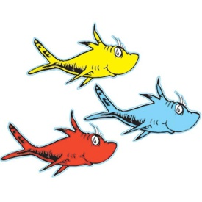

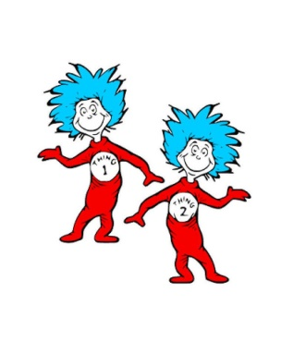
Friday- Oh the Places You Will Go!- College t-shirt Day
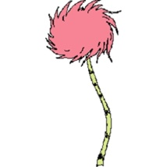
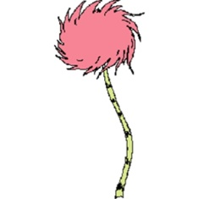
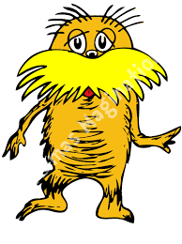
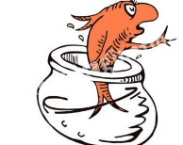

Read Across America Week is a nationwide reading celebration that takes place annually around March 2—Dr. Seuss’s birthday. Across the country, thousands of schools, libraries, and community centers participate by bringing together kids, teens, and books.

