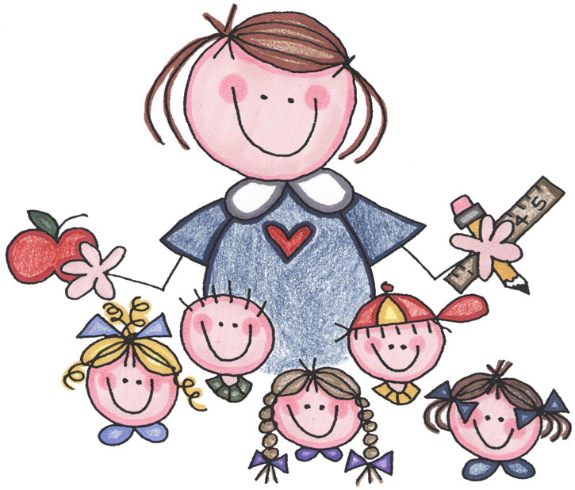

DISCIPLINE PLAN

My classroom discipline plan allows every child the opportunity to manage his or her own behavior and will be in effect at all times.

CLASSROOM RULES

- Always keep hands, feet and objects to yourself.
- Always raise your hand when you want to speak.
- Always line up and walk quietly.
- Always be respectful to others.
- Always follow the teacher’s directions.

Our classroom will use a clip chart to monitor behavior. A clip chart is a great tool that allows students to be rewarded for positive behavior, while discouraging negative behavior. Each student has a clothespin, or clip, with his or her name on it. Everyone will start on “Ready To Learn” at the beginning of the day, and clips can be moved up and down throughout the day based on behavior.

*On Our Way to a Fantastic Second Grade Day! – This level is reserved for outstanding behavior. A student who reaches this level will earn a special note home and prize.
*Outstanding! – Students can move to this level for continuing to display good behavior. You should be proud of your child for reaching this level!
*Super Day! – Students will move to this level for showing that they are making the right behavior decisions. Ending the day on this level is great!
*Ready to Learn – Every student will start the day on the Ready to Learn level. As the day goes on, clips can be moved up and down based on behavior. This is a good place to be!
*Think About It – A student will be moved the Think About It level as a warning about his/her behavior, and a reminder to follow the rules.
*Slow Down – Students who continue to display poor behavior and move down to this level will lose 10 minutes of recess time.
*Parent Contact – When a student moves to the Parent Contact level, the teacher will notify parents via note or phone call. A visit to the Principal’s office might also be in order. Students on this level will lose their entire recess time.
-----------------------------------------------------------------------------------------------------------

I have read and understand Mrs. Haley’s Classroom Rules.
Please sign and return:______________________________

