Math 4 Name _________________________________
5-3 Practice Date___________
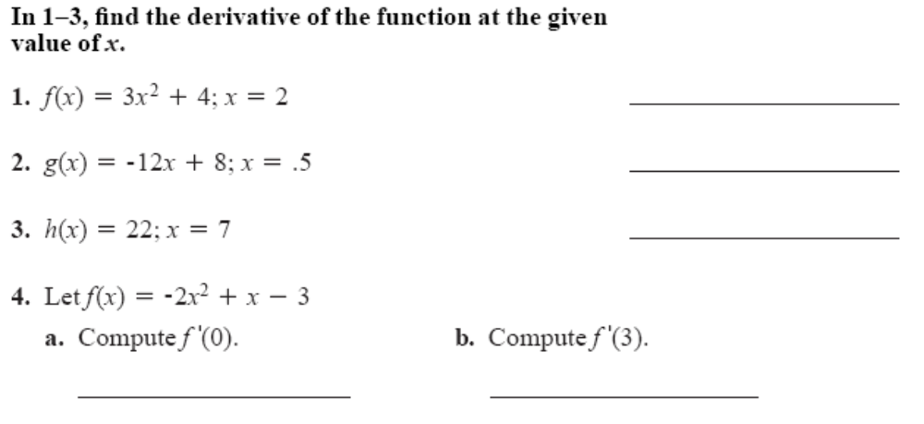

Use the algebraic definition to find the equation of the derivative for each function.
***Show your work on another piece of paper.***

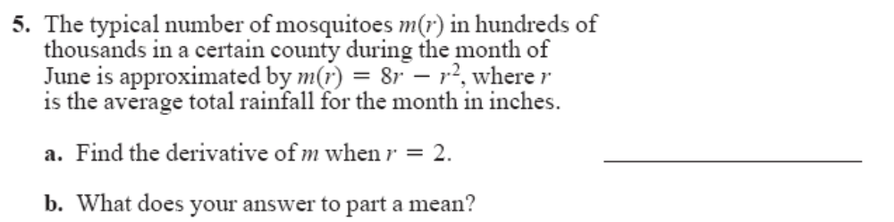
Use the algebraic definition to find the equation of the derivative for the function.
Show your work on another piece of paper.

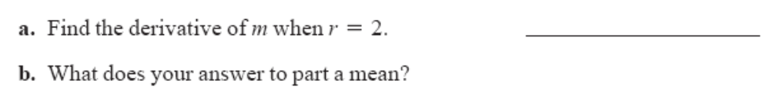

Use the algebraic definition to find the equation of the derivative for the function.
Show your work on another piece of paper.

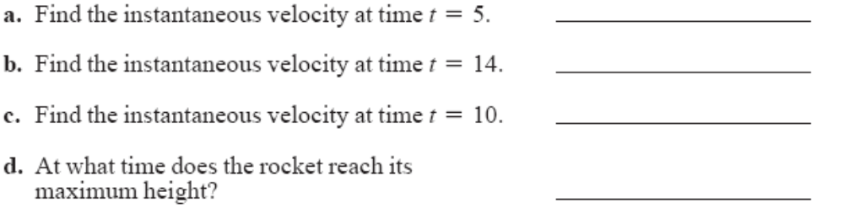

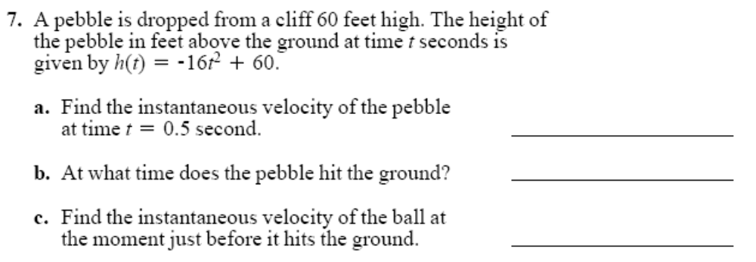

Use the algebraic definition to find the equation of the derivative for the function.
Show your work on another piece of paper.

