Math 1 Name_______________________________
4-2 Practice Date________

- The patterns in spread of good deeds by the Pay It Forward process occur in other quite different situations. For example, when bacteria infect some part of your body, they often grow and split into pairs of genetically equivalent cells over and over again.


- Suppose a single bacterium lands in a cut on your hand. It begins spreading an infection by growing and splitting into two bacteria every 20 minutes.

- Complete a table showing the number of bacteria after each 20-minute period in the first three hours. (Assume none of the bacteria are killed by white blood cells.)
Number of 20-min periods | 1 | 2 | 3 | 4 | 5 | 6 | 7 | 8 | 9
Bacteria Count | 2 | 4
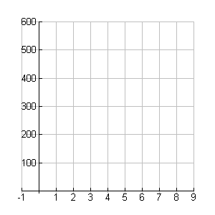
- Plot the (number of time periods, bacteria count) values.

- Describe the pattern of growth of bacteria causing the
infection.

- Write a rule showing how the number of bacteria N can be calculated from the number of stages x in the growth and division process.

- How are the table, graph and symbolic rules describing bacteria growth similar to and different from the Pay It Forward examples? How are they similar to, and different from, typical patterns of linear functions?

- Imagine a tree that each year grows 3 new branches from the end of each existing branch. Assuming the your tree is a single stem when it is planted:

- How many new branches would you expect to appear in the first year of new growth? How about in the second year of new growth?

- Write a rule that relates the number of new branches B to the year of growth R.

- In what year will the number of new branches first be greater than 15,000?


- News stories spread rapidly in modern society. With broadcasts over television, radio, and the internet, millions of people hear about important events within hours. The major news providers try hard to report only stories that they know are true. But quite often rumors get started and spread around a community by word of mouth alone. Suppose that to study the spread of information through rumors, two students started this rumor at 5 p.m. one evening: “Because of the threat of a huge snowstorm, there will be no school tomorrow and probably for the rest of the week.” The next day they surveyed students at the school to find out how many heard the rumor and when they heard it.

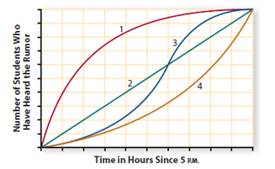
- Describe the rumor pattern suggested by each of the graphs below?
Graph 1:

Graph 2:

Graph 3:

Graph 4:

b. Which pattern of change in number of students who have heard the rumor is most likely to match experimental results in case:
i. the rumor is spread by word of mouth from one student to another?

ii. the rumor is mentioned on radio and television broadcasts between 5 and 6 P.M.?
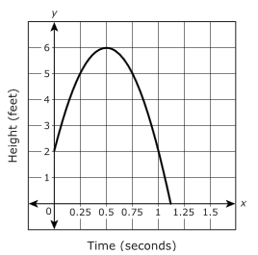
4. A tennis ball was 2 feet off the ground when a tennis player hit it so that the ball traveled up in the air before coming back to the ground. The height of the tennis ball is described by the graph shown. Numbers along the x-axis represent the time, in seconds, after the ball was hit, and the numbers along the y-axis represent the height, in feet, of the ball at time x.
Use the graph to estimate the average rate of change of the height of the ball for the first 0.25 seconds after being hit. Make sure to include the units with your answer.
*(NO CALCULATOR)*

5. At the beginning of an experiment, the number of bacteria at time t = 0 was one. The number of bacteria in the colony t minutes after the initial count is modeled by the function 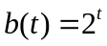. What is the average rate of change in the number of bacteria for the first 5 minutes of the experiment? Make sure to include the units with your answer.
*(NO CALCULATOR)*

- Partially completed tables for four relations between variables are given below. In each case, decide if the table shows an exponential or linear pattern of change. Based on that decision, fill in the missing numbers for the tables. Using function notation, write explicit rules for the patterns.

x | 0 | 1 | 2 | 3 | 4 | 5 | 6 | 7 | 8
f(x) |  |  |  | 8 | 16 | 32

x | 0 | 1 | 2 | 3 | 4 | 5 | 6 | 7 | 8
g(x) |  |  |  | 40 | 80 | 160

x | 0 | 1 | 2 | 3 | 4 | 5 | 6 | 7 | 8
y(x) |  |  |  | 48 | 56 | 64

x | 0 | 1 | 2 | 3 | 4 | 5 | 6 | 7 | 8
z(x) |  |  |  | 125 | 625 | 3,125

