NEW! Updated Resource list for parents and students
School Counseling and Guidance Resources

National Suicide Prevention Lifeline- 1-800-273-8225 suicdepreventionlifeline.org
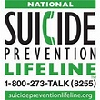

https://www.mbfpreventioneducation.org/kids/ - bully prevention and resources for help
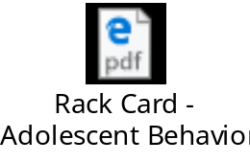
https://capitalregionalmedicalcenter.com – Adolescent outpatient therapy
https://www.schoolcounselor.org/school-counselors/professional-development/learn-more/coronavirus-resources - American School Counselor Association (ASCA)- (info. On SAT/ACT, College Admissions, and more)

https://www.leonschools.net/studentservices - More school counseling resources in Leon County Schools

