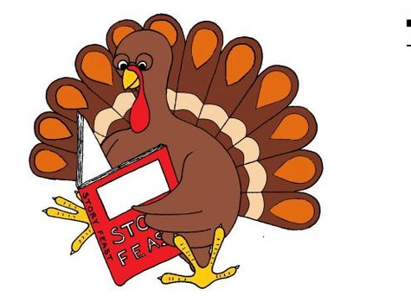
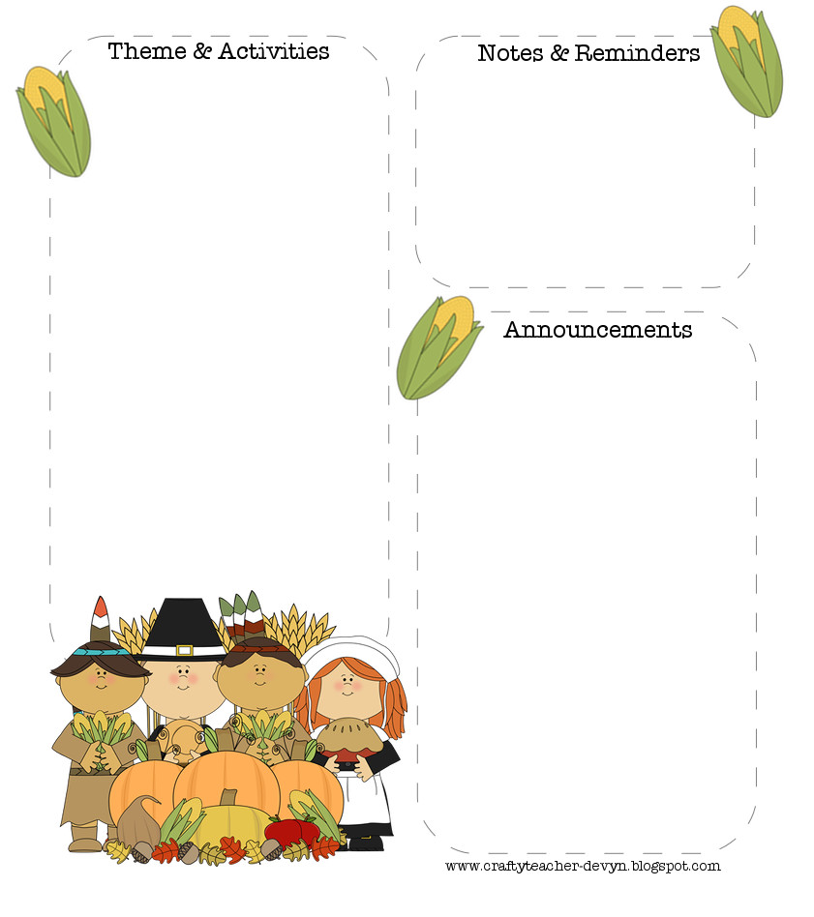
Our class shared their creative Thanksgiving Turkeys!
Happy Thanksgiving!

November 19th- 23rd- Thanksgiving Break No School

December 20th- Winter Craft Party

December 21st- Polar Express movie

Please keep practicing those new sight words each week!

Read EVERY Night

Week Topic:
Time For Work

Essential Question:
What do people use to do their jobs?

Wonders
Letter Sounds
Blending and Segmenting
Sight Words (you)
Writing Sentences with Details & Adjectives

Math
Addition

Social Studies
Thanksgiving- Long Ago & Today
Community Helpers

Morning Worktation
O Words
Vowels
Community Helper Bingo
Thanksgiving Scholastic

Afternoon Centers
Turkey Tanagram
Long Ago & Today Sorting
Thanksgiving bracelet

Mrs. Smiley’s News
November 16, 2018

