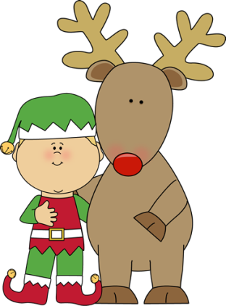

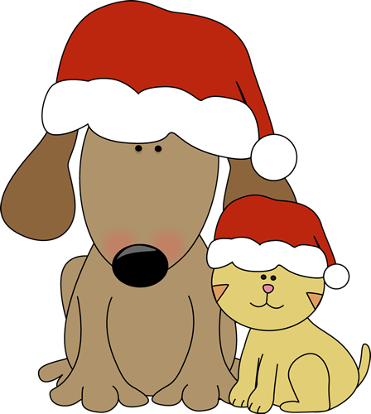

Important Dates
12/21-1/8 Holiday/Teacher Planning
1/8 School Reopens

Thank you
Thank you Aneesh’s mommy for reading to us and for bringing us treats from India!
Thank you for volunteering at
our craft party and for sending in the
donations.
Thank you also for the generous holiday gifts!
I will treasure your kindness always!

Holidays Around the World

Wonders
Letter Sounds
Vowels
Decoding Words
Sight Words
Holiday Stories
Math
Mid-Year Go Math Test
Social Studies:
Holidays Around the World

Mrs. Smiley’ s Class
Merry Christmas! See you in 2019!

December 21, 2018

Work Stations: Santa Game, ornaments, Grinch activities (masks, writing, Whoville town and snack), making words spinner game, word search, holidays around the world web

