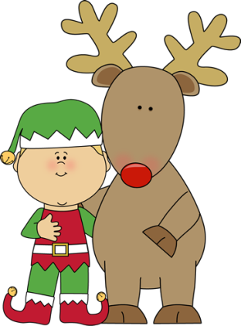



Mrs. Smiley’ s Class
December 14, 2018

Theme: How do people in our neighborhood and communities pitch in?
What Holidays DO WE Celebrate during this season?
Wonders
Letter Sounds
Blending and Segmenting cvc words
Vowel sounds
Decoding Words in leveled readers
Sight Words (to, go, and, you, do)
Phonetic Spelling
Adjectives
Expository Writing
Math
Mid-Year Math Test
Social Studies
Holidays Around the World


Work Stations: Fill in the missing beginning sound, making words, Writing about books that we read, writing about being a good citizen, Wants and needs stockings Your Turn book, leveled readers, Unit books, journals
Afternoon Centers: Holiday Senses Book,

Important Dates

December 20th- Winter Craft Party
December 21st- Polar Express movie
December 24- January 7th
January 8^{th –} Students return
Thank you Flury family for visiting our
classroom, reading to us and bringing us treats!

Please keep practicing those new sight words each week!

Re

