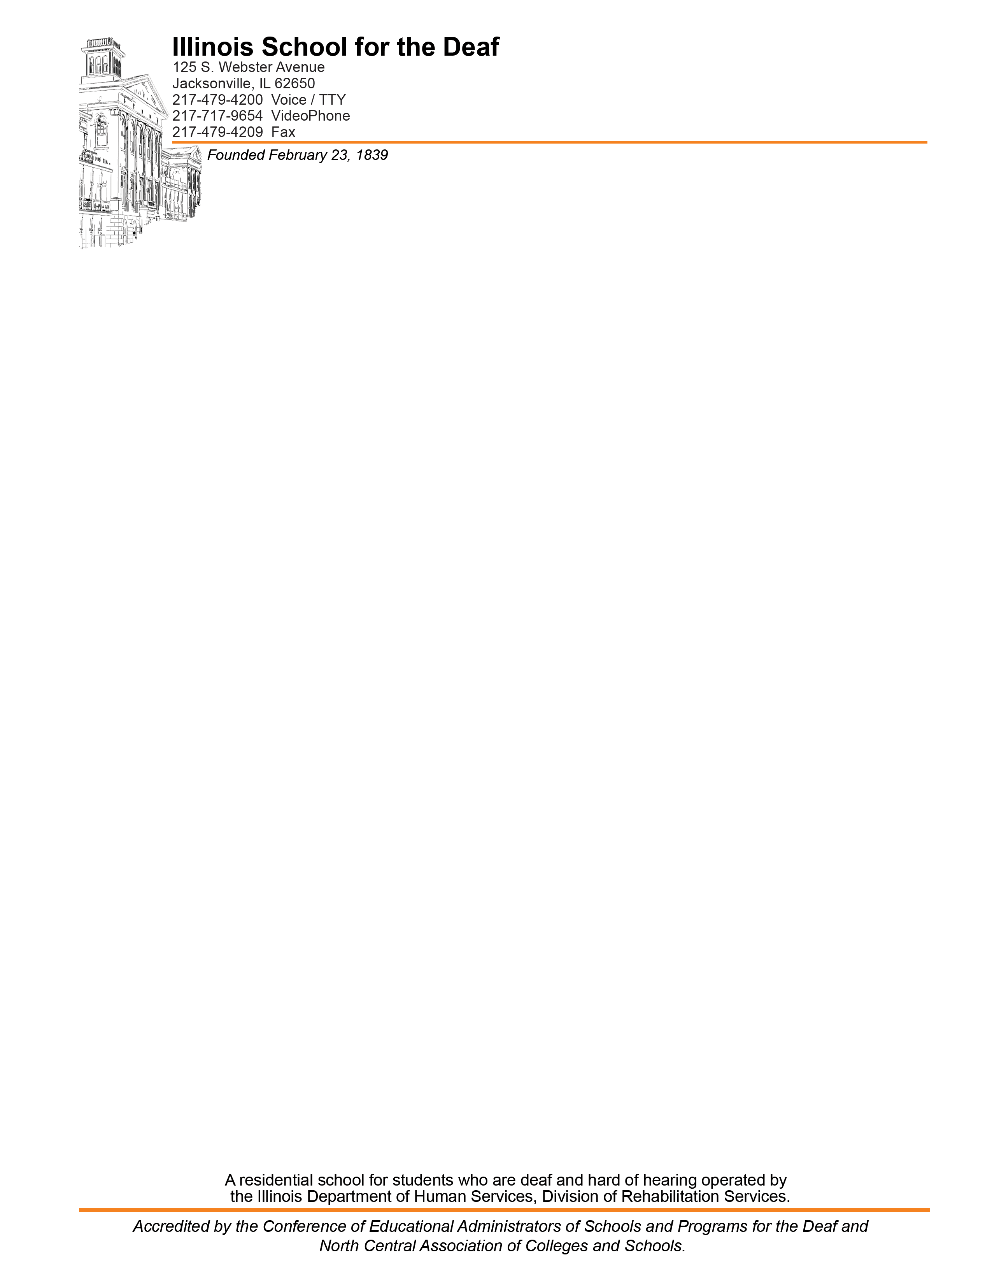

To: ISD Parents and Staff
From: Chris Fairfield, ISD Chief Engineer
Date: April 23, 2024

Re: Extermination schedule for 2024-2025

The following is a list of the dates American Pest Control will be on campus. On these dates American will spray pest control chemicals if required. ISD follows the latest Pest Control techniques. Chemicals are only used as part of our integrated pest management policy. The Illinois Department of Public Health outlines in detail the procedures we are to follow to prevent the use of chemicals in most situations.

We will follow the guidelines set in the Illinois Structural Pest Control Act (225 IL. 235/3.24).
Should applications of pest control chemicals be required between these dates, notice will be given to those parents and staff on our registry list prior to the application except in case of immediate health concern cases. If you would like to be included on our Pest Control Registry, please reply with your desire to be added to the notice registry to this e-mail.

American Pest Control will be on campus on the following dates:

July 5th and 19th, 2024
August 2nd and 16th, 2024
September 6th and 20th, 2024
October 4th and 18th, 2024
November 1st and 15th, 2024
December 6th and 20th, 2024
January 10th and 24th, 2025
February 7th and 21st, 2025
March 7th and 21st, 2025
April 4th and 18th, 2025
May 2nd and 16th, 2025
June 6th and 20th, 2025

