ASVAB Graphs
1. In the following figure, what is the area of the shaded circle inside of the square?
A. 512
B. 256
C. 16
D. 50.24
E. 12.57
2. In the figure below, determine the area of the shaded region of the figure.
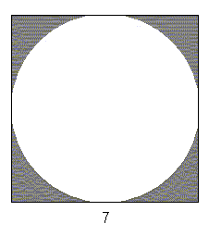
A. 9.354
B. 10.52
C. 16.437
D. 49
E. 104.86
3. What are the coordinates of point A on the following graph?
A. (-3, -4)
B. (-4, 3)
C. (3, -4)
D. (-4, -3)
E. (3, 4)
4. What was the average number of babies that Dr. Jones delivered each year from 1995 to 1998?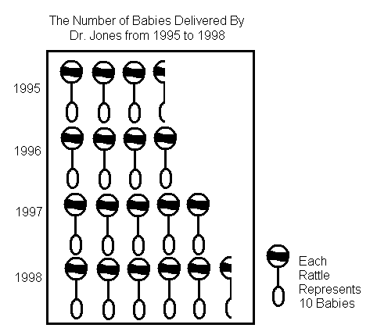
A. 35
B. 40
C. 45
D. 50
E. 55
5. How many babies did Dr. Jones deliver in 1998?
A. 25
B. 35
C. 45
D. 55
E. 65
6. If Dr. Jones delivered 85 babies in 1999, how many rattles would represent this number?
A. 6 ½
B. 7
C. 7 ½
D. 8
E. 8 ½

7. If XYZ Auto Company sold 23,000 vehicles in 1999, how many were SUV's?
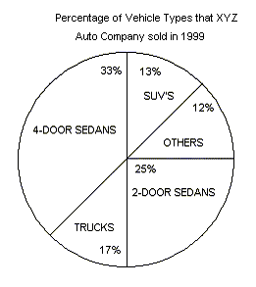
A. 2,990
B. 3,030
C. 3,450
D. 4,760
E. 4,775
8. If 7,650 trucks were sold in 1999, how many total vehicles were sold in 1999 by XYZ Auto Company?
A. 35,000
B. 40,000
C. 45,000
D. 50,000
E. 55,000
9. If 3,750 2-door sedans were sold in 1999, then how many 4-door sedans were sold in 1999 by XYZ Auto Company?
A. 3,578
B. 4,950
C. 5,120
D. 5,670
E. 5,845
10. How much did the infant gain in the first month of life?
A. 6 ounces
B. 12 ounces
C. 15 ounces
D. 8 lbs 8 ounces
E. 9 lbs 4 ounces

11. What was the average weight of the infant from April to October, rounded to the nearest ounce?
A. 10 lbs
B. 10 lbs 5 ounces
C. 10 lbs 9 ounces
D. 11 lbs 5 ounces
E. 11 lbs 9 ounces
12. Between which two months did the infant gain the most weight?
A. April and May
B. June and July
C. July and August
D. August and September
E. September and October
13. In the graph below, no axes or origin is shown. If point B's coordinates are (10,3), which of the following coordinates would most likely be A's?

A. (17, -2)
B. (10, 6)
C. (6, 8)
D. (-10, 3)
E. (-2, -17)
14. How many boys attended the 1995 convention?
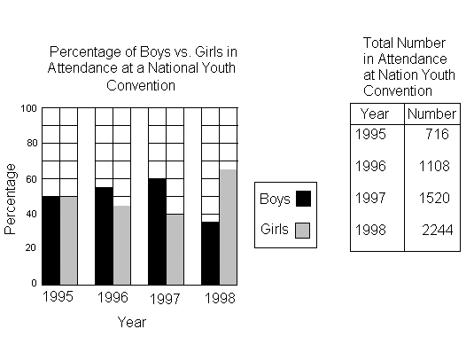
A. 358
B. 390
C. 407
D. 540
E. 716
15. Which year did the same number of boys and girls attend the conference?
A. 1995
B. 1996
C. 1997
D. 1998
E. None
16. Which two years did the least number of boys attend the convention?
A. 1995 and 1996
B. 1995 and 1998
C. 1996 and 1997
D. 1996 and 1992
E. 1997 and 1998
Answer Key
1. E
2. B
3. C
4. C
5. D
6. E
7. A
8. C
9. B
10. B
11. C
12. D
13. C
14. A
15. A
16. A

