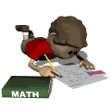
Homework Reflection
Self Expressive

How can I plan to improve next time?

What is a goal I need to work on?
Understanding

How did I do?

How do I know?

Interpersonal
What have I learned about my work habits?

How do my work habits affect my school performance?
Mastery
What did I do to get my homework done?

What steps did I follow? Where did I work? When did I get it finished?

