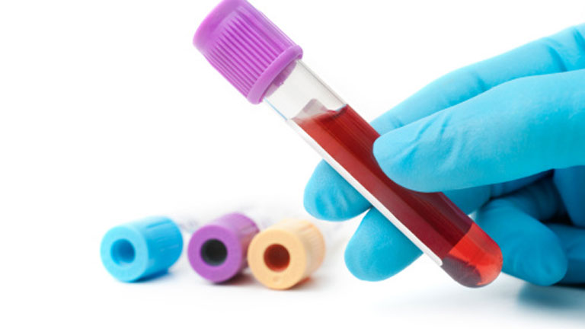Phlebotomy Program Application –Seniors Only
**This program is for Allied Health Pathway Students **

Please Note: Complete all sections of this application. If you have no information to enter in a section, please write N/A. Application due Date January 12, 2018:

(Please print or type)

Name and Address
Name (First, MI, Last):

Address:

City: | State: |  | Zip Code:
Home Phone: |  | Cell Phone:
E-mail Address: |  | May we use e-mail to contact you?  Yes  No 

Additional Information
Parent / Guardian Name: | Phone:
Parent / Guardian Name: | Phone:
Name of High School Attending: | Cumulative G.P.A.:
Please check off the health science classes you have completed:
_____Medical Terminology _____Intro. To Health Occupations A _____Intro. To Health Occupations B

_____Emergency Procedures _____Allied Health Core Skills _____Medical Math

_____Body Systems _____Anatomy A _____Anatomy B

Please list any extra-curricular activities you have participated in:

Work / Community Service History
Job Title: | From: | To: |  | Hrs/Week: | Employer:
Address: |  |  | Phone:
Supervisor: |  |  | May we contact this employer?  Yes  No 
Reason for leaving? |  |  | Responsibilities:
Job Title: | From: | To: |  | Hrs/Week: | Employer:
Address: |  |  | Phone:
Supervisor: |  |  | May we contact this employer?  Yes  No 
Reason for leaving? |  |  | Responsibilities:
Job Title: | From: | To: |  | Hrs/Week: | Employer:
Address: |  |  | Phone:
Supervisor: |  |  | May we contact this employer?  Yes  No 
Reason for leaving? |  |  | Responsibilities:

References
Name: | Address: | Phone:
Name: | Address: | Phone:
Name: | Address: | Phone:

Why would you like to participate in the phlebotomy program?

Signature: | Date:
I certify that all of the answers and statements on this application are true and complete to the best of my knowledge. I understand that should an investigation disclose untruthful or misleading answers, my application may be rejected, my name removed from consideration, or my participation in the program terminated.

Please Note:
- Include 2 references with your application.
- Return completed applications and recommendation letters to Mrs. Lomache (room 9 at North and 2051 at Central), Ms. Lewis or Mrs. Woodall.
- You will be dealing with drawing blood and handling blood products
Potential Program Cost: $115.00 for state licensure exam

