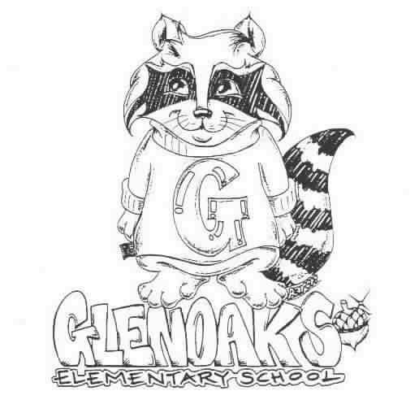 THE GLENOAKS GREEN SHEET
for the week of NOVEMBER 5TH , 2018
Theme for NOVEMBER - CITIZENSHIP
A Thought: “Responsibility finds a way, irresponsibility makes excuses.”
Gene Bedley

THE GLENOAKS INSTRUCTIONAL FOCUS STATEMENT

The Glenoaks community will work together to ensure that all students improve in reading comprehension. Research based learning experiences will lead to academic growth as measured by student performance on multiple assessments.
Monday, 11/05 | VALET SERVICE – 4th GRADE – MS. HOLDEN’S CLASS  10/29 – 11/05/2018  Instrumental Music - Students must be responsible for bringing their own instrument to school. All string orchestra instruments must be dropped off for tuning before 8:00 a.m. every Monday  Girls on the Run- 3:00 – 4:30 pm
Tuesday, 11/06 | 7:15 am Extra Chorus Rehearsal  Election Day !
Wednesday, 11/07 | 8:15 am Chorus  Banking Day – School starts at 9:10 a.m.  Girls on the Run- 3:00 – 4:30 pm
Thursday, 11/08 | 8:30 am PTA Board Mtg7
Friday, 11/09 | Kona Ice
Upcoming Dates To Remember | Nov 12 – Holiday – Veteran’s Day  Nov. 16 – No School – Teacher Prep Day  Nov. 19 – 23 – Thanksgiving Break  Nov 15 – End of First Trimester  Nov 29 – Report Cards come home  Nov 29 - Bandit Run

Please check our school’s website, www.Glenoakselementary.org for upcoming events, information, and the school calendar at Glenoakselementary.org. On the website in the “Thursday Folder” there are flyers for upcoming events, afterschool programs, etc. All school holidays, minimum days, no student days, etc. are all listed. It is a great source of information

TO ALL PARENT/GUARDIANS: If you have not already done so, please log on to the parent portal and either update or verify your student’s contact information as soon as possible. It is vital that all information be current and up to date. If you have any questions, please see the flyer on Glenoakselemenary.org. OR http://parent.gusd.net.

FIRST GRADE PARENTS: Your child’s Report of Health Examination for School is now due. If you have not already done so, please turn it in to the front office. If you have any questions, please call the health office. This needs to be turned in only once.

SCHOOL NOTIFICATIONS AND MESSAGES FROM MR. DI MUNDO: If you are not receiving Mr. Di Mundo’s all-call messages please contact the office and provide an updated telephone number.

MORNING DROP OFF: Please remember that if you are walking to school and entering through the back entrance, do NOT walk through the car entrance. Please use the pedestrian entrance. Thank you for keeping our students safe!

ABSENCES FROM SCHOOL: We are required to secure an absence excuse from a parent or guardian when a child is absent from school. This excuse can be included in a written note to the teacher, email or a phone call to the front office staff or teacher and must be received within three days of the student’s return to school. When the reason for absence is illness, the specific nature must be given, such as cold, fever, sore throat, etc. According to state law, the only excused absences are for illness, medical treatment, bereavement, religious holiday and some legal commitments. Family vacations or personal business are considered unexcused reasons for absence. Please schedule these types of things when your children are out of school.

DRESS CODE: All shoes worn on the playground must include ties or straps that are tied securely or buckled. All shoes must cover the foot. Flip-flops, Crocs, and other heel-less sandals are not allowed at any time. Please refer to the Glenoaks Handbook online for full details.

CLASSROOM SUPPLIES AND DONATIONS: Please contact your child’s teacher to see what is on his/her wish list for any classroom supplies. Pencils, hand sanitizer, Kleenex, glue sticks are some of the items always welcome. Teacher emails can be found on the Glenoakselemetnary.org website.

VOLUNTEERING IN CLASS: In order to volunteer in a classroom, library, computer lab or on campus, you will need to have a Tuberculosis (TB) Clearance on file with our office.

