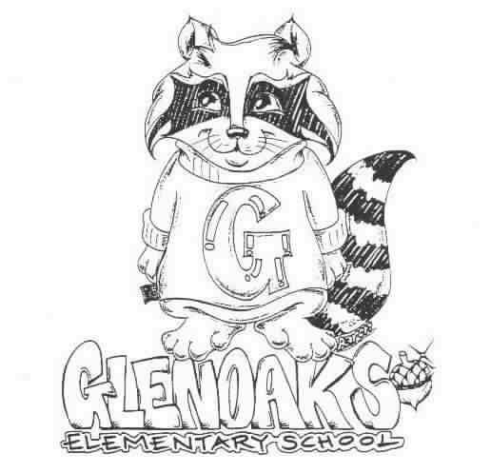 THE GLENOAKS GREEN SHEET
for the week OCTOBER 1 st, 2018
Theme for OCTOBER - COOPERATION
A Thought: “Responsibility finds a way, irresponsibility makes excuses.”
Gene Bedley

THE GLENOAKS INSTRUCTIONAL FOCUS STATEMENT

The Glenoaks community will work together to ensure that all students improve in reading comprehension. Research based learning experiences will lead to academic growth as measured by student performance on multiple assessments.
Monday, 10/1 | VALET SERVICE – 3RD GRADE – MR. GLANDIAN’S CLASS  Oct 1st through 12th  Instrumental Music - Students must be responsible for bringing their own instrument to school. All string orchestra instruments must be dropped off for tuning before 8:00 a.m. every Monday  Rotary Club Annual Coats for Kids Drive – Through Friday – Drop off in office.  Girls on the Run- 3:00 – 4:30 pm
Tuesday, 10/2
Wednesday, 10/3 | Banking Day – School starts at 9:10 a.m.  GESF Mtg – 6:30 pm
Thursday, 10.4 | Reflections Gallery Night – 6:30 pm Auditorium
Friday, 10/5
Upcoming Dates To Remember | Oct 9 - Glenoaks Dine-Out Night – Blaze Pizza & The Baked Bear  Oct. 10 – Walk to School Day  Oct. 12 – Kona Ice 2:00 – 3:00 pm  Oct 12 – 2nd Grade Field Trip  Oct. 15 - 15 – TB Clinic – District  Oct 19 – 6th Grade Field Trip  6th Grade Movie Night  Oct 31 – Halloween Glow Sale – 12:45 – 3:00 pm

Please check our school’s website, www.Glenoakselementary.org for upcoming events, information, and the school calendar at Glenoakselementary.org. On the website in the “Thursday Folder” there are flyers for upcoming events, afterschool programs, etc. All school holidays, minimum days, no student days, etc. are all listed. It is a great source of information

TO ALL PARENT/GUARDIANS: If you have not already done so, please log on to the parent portal and either update or verify your student’s contact information as soon as possible. It is vital that all information be current and up to date. If you have any questions, please see the flyer on Glenoakselemenary.org. or
http://parent.gusd.net.

DISTRICT TB CLINIC: This is a reminder that all volunteers must have a TB clearance prior to their first day of volunteer work. If your TB test was given by our district four years ago, you need to have a new test. Upcoming TB test clinic is:
TEST: READING:

DATE: Monday, October 15, 2018 DATE: Wednesday, October 17, 2018
TIME: 1:30- 4:45 PM TIME: 1:00 – 4:45 PM

LOCATION: Administration Building-Board Room LOCATION: Administration Building
223 North Jackson St. Health Services, Rm 203
Glendale, CA 91206 223 North Jackson St.
Glendale, CA 91206

COATS FOR KIDS DRIVE: If you have any jackets, raincoats, or sweatshirts that no longer fit the people in your home, please consider donating them to the Coats for Kids drive! We have a box to collect them in the office, so just bring your extra coats down when you get to school.

FIRST GRADE PARENTS: Your child’s Report of Health Examination for School is now due. If you have not already done so, please turn it in to the front office. If you have any questions, please call the health office.

GLENOAKS RESTAURANT NIGHT: Tuesday, October 9th from 4:00 – 9:00 pm -- Eat in or take out. Blaze Pizza 990 Town Center Drive, La Canada, CA; Skip the cooking and support our school. This is a great and easy way to help raise money for our school. Flyers will come home in Thursday’s folder. Blaze Pizza generously donates 20% of our sales back to Glenoaks. It’s an easy way to give back to our school plus, you don’t have to cook!! THEN…..

Go next door to the Baked Bear and have a delicious custom ice cream sandwich for dessert, 965 Foothill Blvd.. Suite 225 E-B, La Canada, CA. Another great way to support our school. They also will donate 20% back to Glenoaks for sales that night.

SCHOOL NOTIFICATIONS AND MESSAGES FROM MR. DI MUNDO: If you are not receiving Mr. Di Mundo’s all-call messages please contact the office and provide an updated telephone number.

MORNING DROP OFF: Please remember that if you are walking to school and entering through the back entrance, do NOT walk through the car entrance. Please use the pedestrian entrance. Thank you for keeping our students safe!

ABSENCES FROM SCHOOL: We are required to secure an absence excuse from a parent or guardian when a child is absent from school. This excuse can be included in a written note to the teacher, email or a phone call to the front office staff or teacher and must be received within three days of the student’s return to school. When the reason for absence is illness, the specific nature must be given, such as cold, fever, sore throat, etc. According to state law, the only excused absences are for illness, medical treatment, bereavement, religious holiday and some legal commitments. Family vacations or personal business are considered unexcused reasons for absence. Please schedule these types of things when your children are out of school.

DRESS CODE: All shoes worn on the playground must include ties or straps that are tied securely or buckled. All shoes must cover the foot. Flip-flops, Crocs, and other heel-less sandals are not allowed at any time. Please refer to the Glenoaks Handbook online for full details.

CLASSROOM SUPPLIES AND DONATIONS: Please contact your child’s teacher to see what is on his/her wish list for any classroom supplies. Pencils, hand sanitizer, Kleenex, glue sticks are some of the items always welcome. Teacher emails can be found on the Glenoakselemetnary.org website.

VOLUNTEERING IN CLASS: In order to volunteer in a classroom, library, computer lab or on campus, you will need to have a Tuberculosis (TB) Clearance on file with our office. There will be no exceptions. Please make sure to get your TB clearance in as soon as possible. The TB clearance is good for four years. NOTE: A positive skin test means that a person has been exposed to TB germs sometime during his/her life. It does not indicate that a person has TB or is contagious. If you’ve tested positive in the past, DO NOT take another TB test. You will need to have an X-ray.

***

