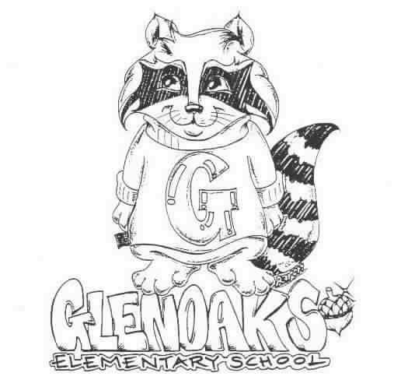 THE GLENOAKS GREEN SHEET
for the week of…September 10th, 2018
Theme for SEPTEMBER: FAIRNESS

A Thought: “Responsibility finds a way, irresponsibility makes excuses.”
Gene Bedley

THE GLENOAKS INSTRUCTIONAL FOCUS STATEMENT

The Glenoaks community will work together to ensure that all students improve in reading comprehension. Research based learning experiences will lead to academic growth as measured by student performance on multiple assessments.
Monday, 09/10 | VALET SERVICE – MRS. TEOH– 3RD GRADE  Instrumental Music - Students must be responsible for bringing their own instrument to school. All string orchestra instruments must be dropped off for tuning before 8:00 a.m. every Monday
Tuesday, 09/11
Wednesday, 09/12 | Banking Day – School starts at 9:10 a.m.
Thursday, 09/13
Friday, 09/14 | Reflection Project DUE!!
Upcoming Dates To Remember | Sept 21st – Hometown Fair - Yipee!

Please check our school’s website, www.Glenoakselementary.org for upcoming events, information, and the school calendar at Glenoakselementary.org. On the website in the “Thursday Folder” there are flyers for upcoming events, afterschool programs, etc. All school holidays, minimum days, no student days, etc. are all listed. It is a great source of information

REFLECTIONS ART ENTRIES for the 50th Annual PTA Reflections Art program are due next Friday September 14th. Channel your inner artist with this year's theme "Heroes Around Me". Rules and entry form can be found on the Glenoaks Homepage.

ROCKY’S HOMESTOWN FAIR: 5:30 – 8:30 PM Step right up and take a chance at one of the 10 Carnival games that will be at Rocky's Hometown Fair on September 21st. The Glenoaks Foundation will be putting on quite an event with new fun classic games,a double obstacle course, giant slide, dunk tank, frisbee art, cake walk and much much more. Send your money in this week to your child’s teacher or to the office,or purchase online, for the extremely discounted activity wristband for only $20 each. (regular price at the door is $30 each) Individual Tickets are also available for purchase.
Have questions or want to buy in person? then see our booth after school on Tuesday and Thursday in front of the auditorium. Orders must be in by this Thursday, September 13th to your child's teacher or to the office with cash or checks.

You won't want to miss out on this FUNRAISER!!!! See the fliers that went home in last Thursday's folders for more details!

FIRST GRADE PARENTS: Your child’s Report of Health Examination for School is now due. If you have not already done so, please turn it in to the front office. If you have any questions, please call the health office.

SCHOOL NOTIFICATIONS AND MESSAGES FROM MR. DI MUNDO: If you are not receiving Mr. Di Mundo’s all-call messages please contact the office and provide an updated telephone number.

MORNING DROP OFF: Please remember that if you are walking to school and entering through the back entrance, do NOT walk through the car entrance. Please use the pedestrian entrance. Thank you for keeping our students safe!

ABSENCES FROM SCHOOL: We are required to secure an absence excuse from a parent or guardian when a child is absent from school. This excuse can be included in a written note to the teacher, email or a phone call to the front office staff or teacher and must be received within three days of the student’s return to school. When the reason for absence is illness, the specific nature must be given, such as cold, fever, sore throat, etc. According to state law, the only excused absences are for illness, medical treatment, bereavement, religious holiday and some legal commitments. Family vacations or personal business are considered unexcused reasons for absence. Please schedule these types of things when your children are out of school.

DRESS CODE: All shoes worn on the playground must include ties or straps that are tied securely or buckled. All shoes must cover the foot. Flip-flops, Crocs, and other heel-less sandals are not allowed at any time. Please refer to the Glenoaks Handbook online for full details.

CLASSROOM SUPPLIES AND DONATIONS: Please contact your child’s teacher to see what is on his/her wish list for any classroom supplies. Pencils, hand sanitizer, Kleenex, glue sticks are some of the items always welcome. Teacher emails can be found on the Glenoakselemetnary.org website.

VOLUNTEERING IN CLASS: In order to volunteer in a classroom, library, computer lab or on campus, you will need to have a Tuberculosis (TB) Clearance on file with our office. There will be no exceptions. Please make sure to get your TB clearance in as soon as possible. The TB clearance is good for four years. Our District will be having a TUBERCULOSIS SCREENING clinic some time in the next month or two, free of charge. We will update you on the exact date and time. You may also choose to see your own doctor, or you may go to the Glendale Health Clinic. NOTE: A positive skin test means that a person has been exposed to TB germs sometime during his/her life. It does not indicate that a person has TB or is contagious. If you’ve tested positive in the past, DO NOT take another TB test. You will need to have an X-ray.

***

