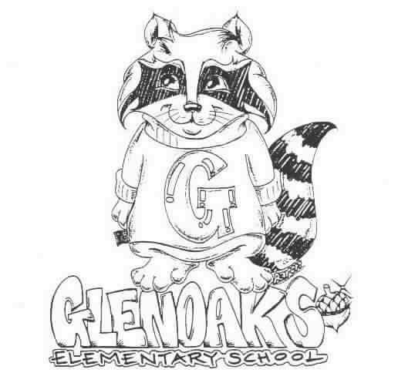 THE GLENOAKS GREEN SHEET
for the week of…September 4th, 2018
Theme for SEPTEMBER: FAIRNESS

A Thought: “Responsibility finds a way, irresponsibility makes excuses.”
Gene Bedley

THE GLENOAKS INSTRUCTIONAL FOCUS STATEMENT

The Glenoaks community will work together to ensure that all students improve in reading comprehension. Research based learning experiences will lead to academic growth as measured by student performance on multiple assessments.
Monday, 09/3 | Labor Day – No School
Tuesday, 09/04 | Parker Anderson classes begin  Two Guys Fundraiser - Extended for this whole week!
Wednesday, 09/05 | Banking Day – School starts at 9:10 a.m.  FALL PICTURE DAY  Two Guys from Italy Fundraiser  GESF Mtg – 6:30 pm
Thursday, 09/06 | Two Guys from Italy Fundraiser  PTA Board Mtg – 8:30 am
Friday, 09/07 | Two Guys from Italy Fundraiser
Upcoming Dates To Remember

Please check our school’s website, www.Glenoakselementary.org for upcoming events, information, and the school calendar at Glenoakselementary.org. On the website in the “Thursday Folder” there are flyers for upcoming events, afterschool programs, etc. All school holidays, minimum days, no student days, etc. are all listed. It is a great source of information

GLENOAKS RESTAURANT NIGHT: Has been extended this whole week…Two Guys are always so generous to Glenoaks. Please try and support them and Glenoaks. Eat in or take out. Two Guys from Italy, 405 N. Verdugo Road, Glendale; (818) 240-0020. Skip the cooking and support our school. This is a great and easy way to help raise money for our school. Eat in or take out. Flyers will come home in Thursday’s folder.

SCHOOL NOTIFICATIONS AND MESSAGES FROM MR. DI MUNDO: If you are not receiving Mr. Di Mundo’s all-call messages please contact the office and provide an updated telephone number.

MORNING DROP OFF: Please remember that if you are walking to school and entering through the back entrance, do NOT walk through the car entrance. Please use the pedestrian entrance. Thank you for keeping our students safe!

FIRST GRADE PARENTS: Your child’s Report of Health Examination for School is now due. If you have not already done so, please turn it in to the front office. If you have any questions, please call the health office.

ABSENCE FROM SCHOOL: We are required to secure an absence excuse from a parent or guardian when a child is absent from school. This excuse can be included in a written note to the teacher, email or a phone call to the front office staff or teacher and must be received within three days of the student’s return to school. When the reason for absence is illness, the specific nature must be given, such as cold, fever, sore throat, etc. According to state law, the only excused absences are for illness, medical treatment, bereavement, religious holiday and some legal commitments. Family vacations or personal business are considered unexcused reasons for absence. Please schedule these types of things when your children are out of school.

DRESS CODE: All shoes worn on the playground must include ties or straps that are tied securely or buckled. All shoes must cover the foot. Flip-flops, Crocs, and other heel-less sandals are not allowed at any time. Please refer to the Glenoaks Handbook online for full details.

CLASSROOM SUPPLIES AND DONATIONS: Please contact your child’s teacher to see what is on his/her wish list for any classroom supplies. Pencils, hand sanitizer, Kleenex, glue sticks are some of the items always welcome. Teacher emails can be found on the Glenoakselemetnary.org website.

VOLUNTEERING IN CLASS: In order to volunteer in a classroom, library, computer lab or on campus, you will need to have a Tuberculosis (TB) Clearance on file with our office. There will be no exceptions. Please make sure to get your TB clearance in as soon as possible. The TB clearance is good for four years. Our District will be having a TUBERCULOSIS SCREENING clinic some time in the next month or two, free of charge. We will update you on the exact date and time. You may also choose to see your own doctor, or you may go to the Glendale Health Clinic. NOTE: A positive skin test means that a person has been exposed to TB germs sometime during his/her life. It does not indicate that a person has TB or is contagious. If you’ve tested positive in the past, DO NOT take another TB test. You will need to have an X-ray.

***

