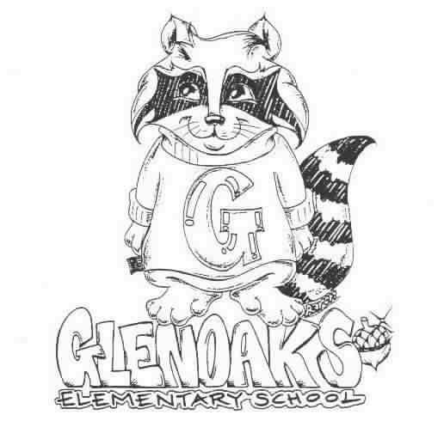GLENOAKS GREEN SHEET
for the week of February 11, 2019
Theme for FEBRUARY - HONESTY
A Thought: Honesty Is The BEST Policy”
Benjamin Franklin

THE GLENOAKS INSTRUCTIONAL FOCUS STATEMENT

The Glenoaks community will work together to ensure that all students improve in reading comprehension. Research based learning experiences will lead to academic growth as measured by student performance on multiple assessments.
Monday, 02/11 | Valet service – 1st grade – Ms. Junge’s ’s class 02/04/19  NO SCHOOL – Lincoln’s Birthday Holiday  Girls on The Run – to register go to www.gotrla.org/program-registration  Program runs Feb. 25th through May 8th  GLENOAKS ENROLLMENT BEGINS FEBRUARY 26TH!
Tuesday, 02/12
Wednesday, 02/13 | Banking Day – School starts at 9:10 a.m.  Girls on the Run- 3:00 – 4:30 pm
Thursday, 02/14 | HAPPY VALENTINE’S DAY  Unconcert – GHS Field Trip 4th, 5th & 6th grades  
Friday, 02/15 | Kona Ice –
Upcoming Dates To Remember | Feb 18th - NO SCHOOL – Washington’s Birthday Holiday  Feb. 20th & 21st – GESF Science Fun Fair  Feb. 22 – Final rehearsal honors Band/Orchestra 8:00 – noon GHS  GUSD Honor Band/Orchestra Performance 7:00 PM GHS

Please check our school’s website, www.Glenoakselementary.org for upcoming events, information, and the school calendar at Glenoakselementary.org. On the website in the “Thursday Folder” there are flyers for upcoming events, afterschool programs, etc. All school holidays, minimum days, no student days, etc. are all listed. It is a great source of information

FIRST GRADE PARENTS: Your child’s Report of Health Examination for School is now due. If you have not already done so, please turn it in to the front office NO LATER THAN MARCH 6th. If you have any questions, please call the health office. This needs to be done only once, so if you have already turned it in you do not need to turn in another one.

ALL 6TH GRADE PARENTS: All 6th graders are REQUIRED to turn in proof of their T-dap vaccination. The District is requesting 100% compliance within the next few months. If your child has not turned in his/her vaccination record please do so as soon as possible. If you have any questions, please call the school office. There are numerous locations that offer the T-dap vaccines for a fee. Free vaccinations are also available at the Glendale Health Center, located at 501 N Glendale Avenue, Glendale, CA; (818) 500-5762. Please call for hours.

VALENTINE’S DAY STORE: Looking for a gift for your teacher, parent or friend, then search no more! Come to the Glenoaks PTA Valentine Shop on February 8th and choose something special from our shop. Merchandise for sale will include: teddy bears, small mylar balloons, light up roses, necklaces, pens and much more! Items cost $1-$5 each. All proceeds support our school. PLUS you also can get Items Delivered on Valentines Day to the classroom!• Send a teacher, secretary, yard duty, volunteer, principal, etc. a Flower Gram for $2.00 each.• Send another student a Candy Gram for $1.00 each. Personal messages & money for grams can be turned into the front office any time before the 8th or at the Glenoaks Store after school on Feb 8th. No orders will be taken after the deadline. All grams will be delivered to class on Thursday, February 14th.
TO ALL PARENT/GUARDIANS: If you have not already done so, please log on to the parent portal and either update or verify your student’s contact information as soon as possible. It is vital that all information be current and up to date. If you have any questions, please see the flyer on Glenoakselemenary.org. OR http://parent.gusd.net.

GLENOAKS SCIENCE FUN FAIR: Feb. 20th – Students bring and present their science project to class.

Feb. 21st - Parent/Family Science Fair Night – 6:00 – 7:00 pm – Auditorium

SCHOOL NOTIFICATIONS AND MESSAGES FROM MR. DI MUNDO: If you are not receiving Mr. Di Mundo’s all-call messages please contact the office and provide an updated telephone number.

ABSENCES FROM SCHOOL: Please remember to call in your child’s absence within three days of your student returning to school. It is important that all absences are cleanred.
We are required to secure an absence excuse from a parent or guardian when a child is absent from school. This excuse can be included in a written note to the teacher, email or a phone call to the front office staff or teacher and must be received within three days of the student’s return to school. When the reason for absence is illness, the specific nature must be given, such as cold, fever, sore throat, etc. According to state law, the only excused absences are for illness, medical treatment, bereavement, religious holiday and some legal commitments. Family vacations or personal business are considered unexcused reasons for absence. Please schedule these types of things when your children are out of school.

DRESS CODE: All shoes worn on the playground must include ties or straps that are tied securely or buckled. All shoes must cover the foot. Flip-flops, Crocs, and other heel-less sandals are not allowed at any time. Please refer to the Glenoaks Handbook online for full details.

CLASSROOM SUPPLIES AND DONATIONS: Please contact your child’s teacher to see what is on his/her wish list for any classroom supplies. Pencils, hand sanitizer, Kleenex, glue sticks are some of the items always welcome. Teacher emails can be found on the Glenoakselemetnary.org website.

VOLUNTEERING IN CLASS: In order to volunteer in a classroom, library, computer lab or on campus, you will need to have a Tuberculosis (TB) Clearance on file with our office.

