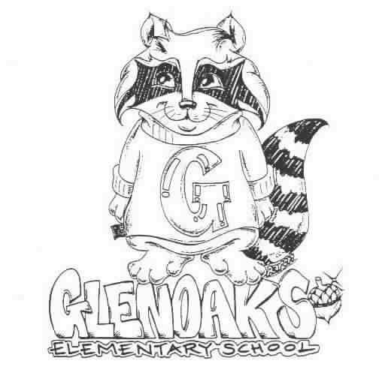
THE GLENOAKS GREEN SHEET
for the week of January 7, 2019
Theme for JANUARY - RESPECT
“A Thought: “Responsibility finds a way, irresponsibility makes excuses.” Gene Bedley

THE GLENOAKS INSTRUCTIONAL FOCUS STATEMENT

The Glenoaks community will work together to ensure that all students improve in reading comprehension. Research based learning experiences will lead to academic growth as measured by student performance on multiple assessments.
Monday, 01/07 | VALET SERVICE – 1ST GRADE – MRS. WEST’S CLASS  01/07 – 01/18/19  Instrumental Music - Students must be responsible for bringing their own instrument to school. All string orchestra instruments must be dropped off for tuning before 8:00 a.m. every Monday  Girls on the Run- 3:00 – 4:30 pm
Tuesday, 01/08
Wednesday, 01/09 | Banking Day – School starts at 9:10 a.m.  Girls on the Run- 3:00 – 4:30 pm
Thursday, 01/10 | 8:30 a.m. PTA Board Mtg – Auditorium  2:30 – 3:15 pm Spelling Bee practice
Friday, 01/11
Upcoming Dates To Remember | Jan. 15 – Restaurant Night – Chipotle  Jan 18 - 11:00 a.m. - 6th Grade Panoramic Photo

Please check our school’s website, www.Glenoakselementary.org for upcoming events, information, and the school calendar at Glenoakselementary.org. On the website in the “Thursday Folder” there are flyers for upcoming events, afterschool programs, etc. All school holidays, minimum days, no student days, etc. are all listed. It is a great source of information

ALL 6TH GRADE PARENTS: All 6th graders are REQUIRED to turn in proof of their T-dap vaccination. The District is requesting 100% compliance within the next few months. If your child has not turned in his/her vaccination record please do so as soon as possible. If you have any questions, please call the school office. There are numerous locations that offer the T-dap vaccines for a fee. Free vaccinations are also available at the Glendale Health Center, located at 501 N Glendale Avenue, Glendale, CA; (818) 500-5762. Please call for hours.

GLENOAKS RESTAURANT NIGHT: Tuesday, January 15th – Make dinner a selfless act by joining us for a fundraiser to support Glenoaks Elementary School PTA. Come in to the Chipotle located at 132 North Glendale Avenue in Glendale on Tuesday, January 15th between 4:00pm and 8:00pm. Bring in the flyer, show it on your smartphone, or tell the cashier you’re supporting the cause to make sure that 33% of the proceeds will be donated to Glenoaks Elementary School PTA. Yes, 33% !!!! Amazing!

Online orders will not be included in the fundraiser total. To ensure your purchase is counted in the fundraiser, be sure to order and pay in-restaurant. Gift card purchases during fundraisers do not count towards total donated sales, but purchases made with an existing gift card will count.

TO ALL PARENT/GUARDIANS: If you have not already done so, please log on to the parent portal and either update or verify your student’s contact information as soon as possible. It is vital that all information be current and up to date. If you have any questions, please see the flyer on Glenoakselemenary.org. OR http://parent.gusd.net.

FIRST GRADE PARENTS: Your child’s Report of Health Examination for School is now due. If you have not already done so, please turn it in to the front office. If you have any questions, please call the health office. This needs to be done only once, so if you have already turned it in you do not need to turn in another one.

SCHOOL NOTIFICATIONS AND MESSAGES FROM MR. DI MUNDO: If you are not receiving Mr. Di Mundo’s all-call messages please contact the office and provide an updated telephone number.

ABSENCES FROM SCHOOL: Please remember to call in your child’s absence within three days of your student returning to school. It is important that all absences are cleanred.
We are required to secure an absence excuse from a parent or guardian when a child is absent from school. This excuse can be included in a written note to the teacher, email or a phone call to the front office staff or teacher and must be received within three days of the student’s return to school. When the reason for absence is illness, the specific nature must be given, such as cold, fever, sore throat, etc. According to state law, the only excused absences are for illness, medical treatment, bereavement, religious holiday and some legal commitments. Family vacations or personal business are considered unexcused reasons for absence. Please schedule these types of things when your children are out of school.

DRESS CODE: All shoes worn on the playground must include ties or straps that are tied securely or buckled. All shoes must cover the foot. Flip-flops, Crocs, and other heel-less sandals are not allowed at any time. Please refer to the Glenoaks Handbook online for full details.

CLASSROOM SUPPLIES AND DONATIONS: Please contact your child’s teacher to see what is on his/her wish list for any classroom supplies. Pencils, hand sanitizer, Kleenex, glue sticks are some of the items always welcome. Teacher emails can be found on the Glenoakselemetnary.org website.

VOLUNTEERING IN CLASS: In order to volunteer in a classroom, library, computer lab or on campus, you will need to have a Tuberculosis (TB) Clearance on file with our office.

