How to Access Books to Read at Home
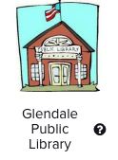 | Glendale Public Library  You can sign up for a free library e-card to check out books at https://pgpl.iii.com  You can find books in the Glendale Public Library’s Digital Books section  https://www.eglendalelac.org/kids  Your child also can access the Glendale Public library link in their Clever log in page.
 | EPIC  You can access free ebooks on https://getepic.com or you can download the app.  - Ask your child’s teacher for your class code and pin (or parents can sign up free for 30 days)
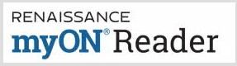  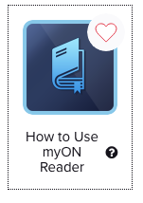 | myON Reader  Students may access online texts in myON Reader.  1) Click on the myON Reader link in Clever, or go to https://www.myon.com/school/readathome  2) School Name: Read at Home (don’t use “Horace Mann”)  3) Username: readnow (don’t use your own personal username)  4) Password: myon (not your personal password)  On the Clever page, there is a page with directions of how to find myON texts with AR tests.
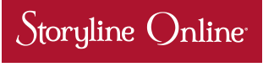 | Storyline Online®, streams videos featuring celebrated actors reading children’s books alongside creatively produced illustrations. You can access the link in Clever, or go to www.storylineonline.net
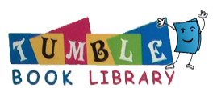 | We have a temporary free subscription to TumbleBook Library. You can access a wide selection of books, and many award winning books. You can access it through a link in Clever, or go to Glendale Public Library website and click on the TumbleBook Library link.

