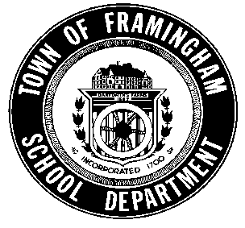
Framingham Public Schools
Robert A. Tremblay, Ed.D. Superintendent of Schools

BILINGUAL EDUCATION DEPARTMENT
Ms. Genoveffa Grieci, Director • Ms. Jennifer LaBollita, Assistant Director
73 Mt. Wayte Avenue, Suite #5, Framingham, MA. 01702
Telephone: 508-626-9171

How to Request a Written Translation

Framingham Public Schools provides accurate and timely translations to families whose first language is not English. The district wide translations' office is in place to provide translations/interpreting services exclusively for parents to facilitate communication and involvement. Written translations are done only from English into Spanish and Portuguese.

- Please use the form below to request a translation. Using “Save as”, save the form to your computer, fill it out and email it to translationcoordinator@framingham.k12.ma.us. Also attach the document(s) to be translated. Please specify your time frame and any special requests so as to be sure that the translator can accommodate your needs. The maximum turnaround time for translation of ordinary documents is five school days. We will do our best to accommodate your needs but we CANNOT guarantee the completion of the translation before the turnaround time. For materials that are unusually challenging and/or long with highly academic terminology, complex phrasing, etc., we will provide you with an estimate deadline after reviewing the materials and assigning a translator.

- All Spanish and Portuguese translators are FPS employees.

- In order to keep quality assurance and consistency, all the requests should follow this protocol. If the request does not come through the Translation Department, payment will be responsibility of your school and or department.

- If the translation is for a PTO or grant funded event, please solicit them to provide the funds. District funds will not be used for PTO translations or translations for grant funded events for the SY 18-19. District funds are not used to pay for outside organizations.

- The Special Education Department will continue to manage the process for translating Special Education documents. Please contact their office directly as specialized knowledge is required for these translations.


FPS Written Translations Request Form

Name: ________________________________________ Date: ______________________
School/Department: ___________________________________________________________

Name of the document(s):________________________________________________________
Target language(s):________________________________________________________
Desired Deadline: ________________________
Indicate if there is a translator of preference: _________________________________
Context/Comments to help with the translation: ____________________________________________________________________________________________________________________________________________________________
Special Requests: __________________________________________________________
Is this to be used for a grant? If yes, grant info for billing purposes: __________________________

Once the form is completed, please email it to translationcoordinator@framingham.k12.ma.us along with the document(s) to be translated (one form and email per project/request is enough no matter how many files are sent for translation within the same request). You will receive a confirmation email first, and the translated document(s) once translation is completed.

August 2018

