
Eugene School District 4j
Synergy Quick Reference Guide

Enabling/Disabling ParentVUE/StudentVUE
1 | To hide schedules, grades and/or gradebook from ParentVUE and StudentVUE as grades are being entered, navigate to SIS  - System folder  - ParentVUE  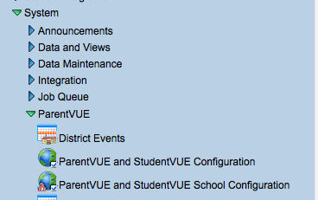  - ParentVUE and StudentVUE School Configuration
2 | This screen lists the modules that can be opened for parents and students, if the District configuration is also open. Currently, most schools are allowing all to view Current Schedule, Grade, Gradebook and Class Websites.  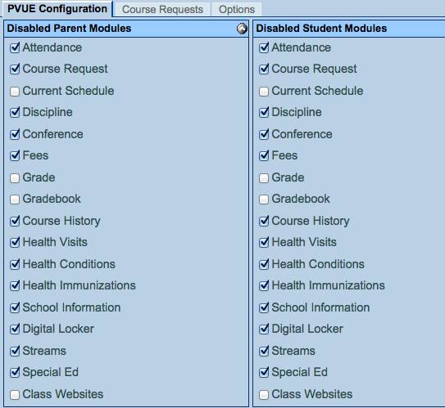  Any module that does not have a check mark is currently enabled. To disable from view any of these modules, check the box to the left of that title in BOTH the ParentVUE column and the StudentVUE column.
3 | 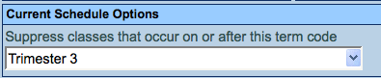  To hide schedules for future terms from view, scroll down to the Current Schedule Options area. Use the down arrow to select the trimester you wish to suppress from view. The trimester selected and forward will be suppressed. If this field is left blank, schedules for all trimesters will display.
Version 8.0.6
Tech/mg/1/14

