
Eugene School District 4J
Synergy Quick Reference Guide

Setting the Grading Window for TeacherVUE

1 | Before teachers can enter Progress or Final Grades in TeacherVUE, Registrars will need to set the number of days before and after the grading day that grades will be editable.  To enter these parameters in TeacherVue, navigate to  - Grading  - Setup  - Grading Setup  - TVUE Options tab  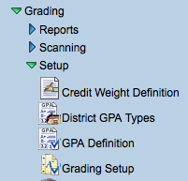
2 | 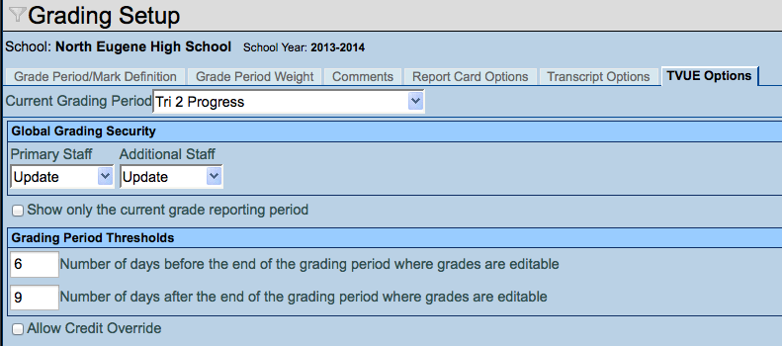  Select the Current Grading Period from the drop down arrow in the first field.  - Keep Update in Primary Staff  - Keep Update in Additional Staff  In the first box in the Grading Period Thresholds area, enter the number of days BEFORE grading day that your Teachers will be able to edit grades. (Grading day will NOT be counted in this number.)  In the second box in the Grading Period Thresholds area, enter the number of days AFTER grading day that your Teachers will be able to edit grades. (The Grading day will NOT be counted in this number.)

Version 8.0.6
Tech/mg/1/14

