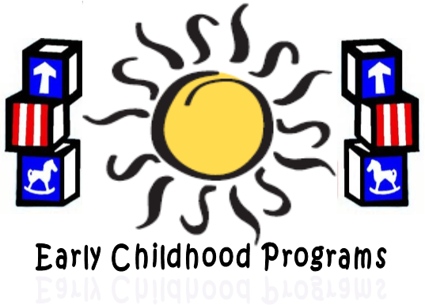

Health Information

Hand washing is the primary way to prevent the spread of illness. Signs are posted at each sink describing the hand washing procedure. To ensure a healthy environment, all staff, children, and visitors are asked to wash their hands when:
- Entering the classroom
- After diapering or using the toilet
- After handling bodily fluids ( blowing or wiping a nose, coughing on a hand or touching blood, mucus, or vomit)
- Before and after handling food
- Before and after water play, sand, rice or other tactile experience

Diapering procedures are posted at changing tables in the Early Head Start classrooms. As a substitute, you would be changing diapers.

Tooth brushing - Care of children’s gums and teeth are an important part of our daily routine.
- Infants – have their gums wiped with gauze after feeding.
- Children under two years old begin using toothbrushes after meals without toothpaste.
- Children over two, brush after meals with a pea sized portion of toothpaste.

Cleaning is an ongoing routine. A bleach solution is made daily, following a formula posted in
the classrooms. Virex is used to disinfect surfaces at our “green school” sites, including Baker Center. This solution is used to:
- Sanitize the sinks after tooth brushing
- Wipe down tables before and after meals
- Clean the diaper changing area
- Clean rest mats
- Clean classroom toys and materials

First Aid kits are in each classroom. They have emergency supplies such as Kleenex, gloves, gauze pads, Band-Aids and hand sanitizer. These items are to be used for emergency care. All children with an injury must be seen by the school nurse. The hand sanitizer is to be used only by adults when running water is not available. Follow up with hand washing as soon as possible.

Health Alerts are kept in a red folder, which is kept in the back of the lesson plan book or other designated location. This confidential information is to be reviewed by the substitute teacher.

Health and Safety Checklist is completed weekly by the classroom teaching team and turned into the Health Liaison monthly. This document is to ensure the classroom environment and play ground are safe and issues are taken care of quickly.

Child Abuse Policy- An important factor in providing quality care to young children is ensuring their health and safety by protecting them from abuse and neglect. Child abuse occurs as a response to stress. Meeting the many needs of young children can naturally trigger this stress. In addition financial strain, isolation, illness, work and lack of resources can contribute to the stress of adults who care for children. Anyone can report child abuse and neglect by calling the hotline 1-800-96-ABUSE. The staff is required by law to report any suspected cases of child abuse and neglect to the proper authorities. Failure to do so may result in a fine of imprisonment.

Nutrition is a key feature to the Head Start program. We provide two thirds of the children’s nutrition through breakfast, lunch and snacks. No outside food is allowed in the classroom for the children. Teachers plan cooking experiences on a regular basis. We ask that volunteers and staff eat nutritious food when with the children, to set a good example.

