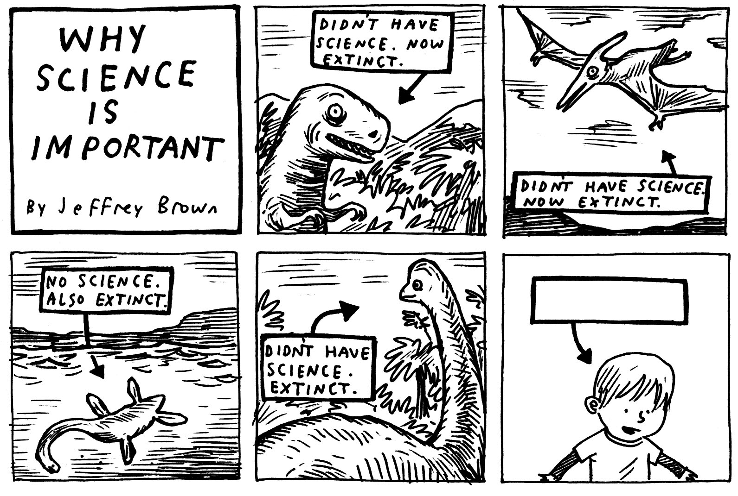
Mrs. Pagano’s Science Laws
Course Requirements for 7th Grade Science

Please place this document in the front of your three ring binder notebook.
In order to have a successful year in science, it is important to know what is required of you. Read and sign this sheet with your parents and then insert it at the front of your 3 ring binder notebook.
- Notebooks: You must keep a 1 inch three ring binder notebook with loose leaf paper in it. In addition to a binder you will also need a science lab notebook (to keep in class).
- Homework: Homework not turned in will receive a zero. Each day late on homework will result in 25 points deducted from the homework assignment. Two days late will be a 50% or lower on your homework grade!!!! Don’t be late!
- Absent: If you are absent for any reason you must make up the homework assignment that is missed within the week of your absence. Extra copies of notes and work will always be available to pick up the next day!
- 5 Week Notices and Quarter Grades: Please check the portal throughout the year!
- Tests and Quizzes: Tests will be given at the end of each unit. Quizzes will be given weekly (usually mid week). (Tests 40%, Quizzes 30%, Homework 10%, Labs/Classwork 20%).
Google Classroom codes:
- Period 1: b3to6ts
- Period 3: phjsez2
- Period 4: 5laalhp
- Period 5: pnrtkz3
- Period 9: 5hw6ndx
Please feel free to contact me with questions and concerns at the following email address:
email: cpagano@cornwallschools.com (parents/guardians only)

Student Signature__________________________________

Parent Signature___________________________________

Looking forward to a spectacular year together in Science! Mrs. Pagano

