BUD RANK SCHOOL MAP
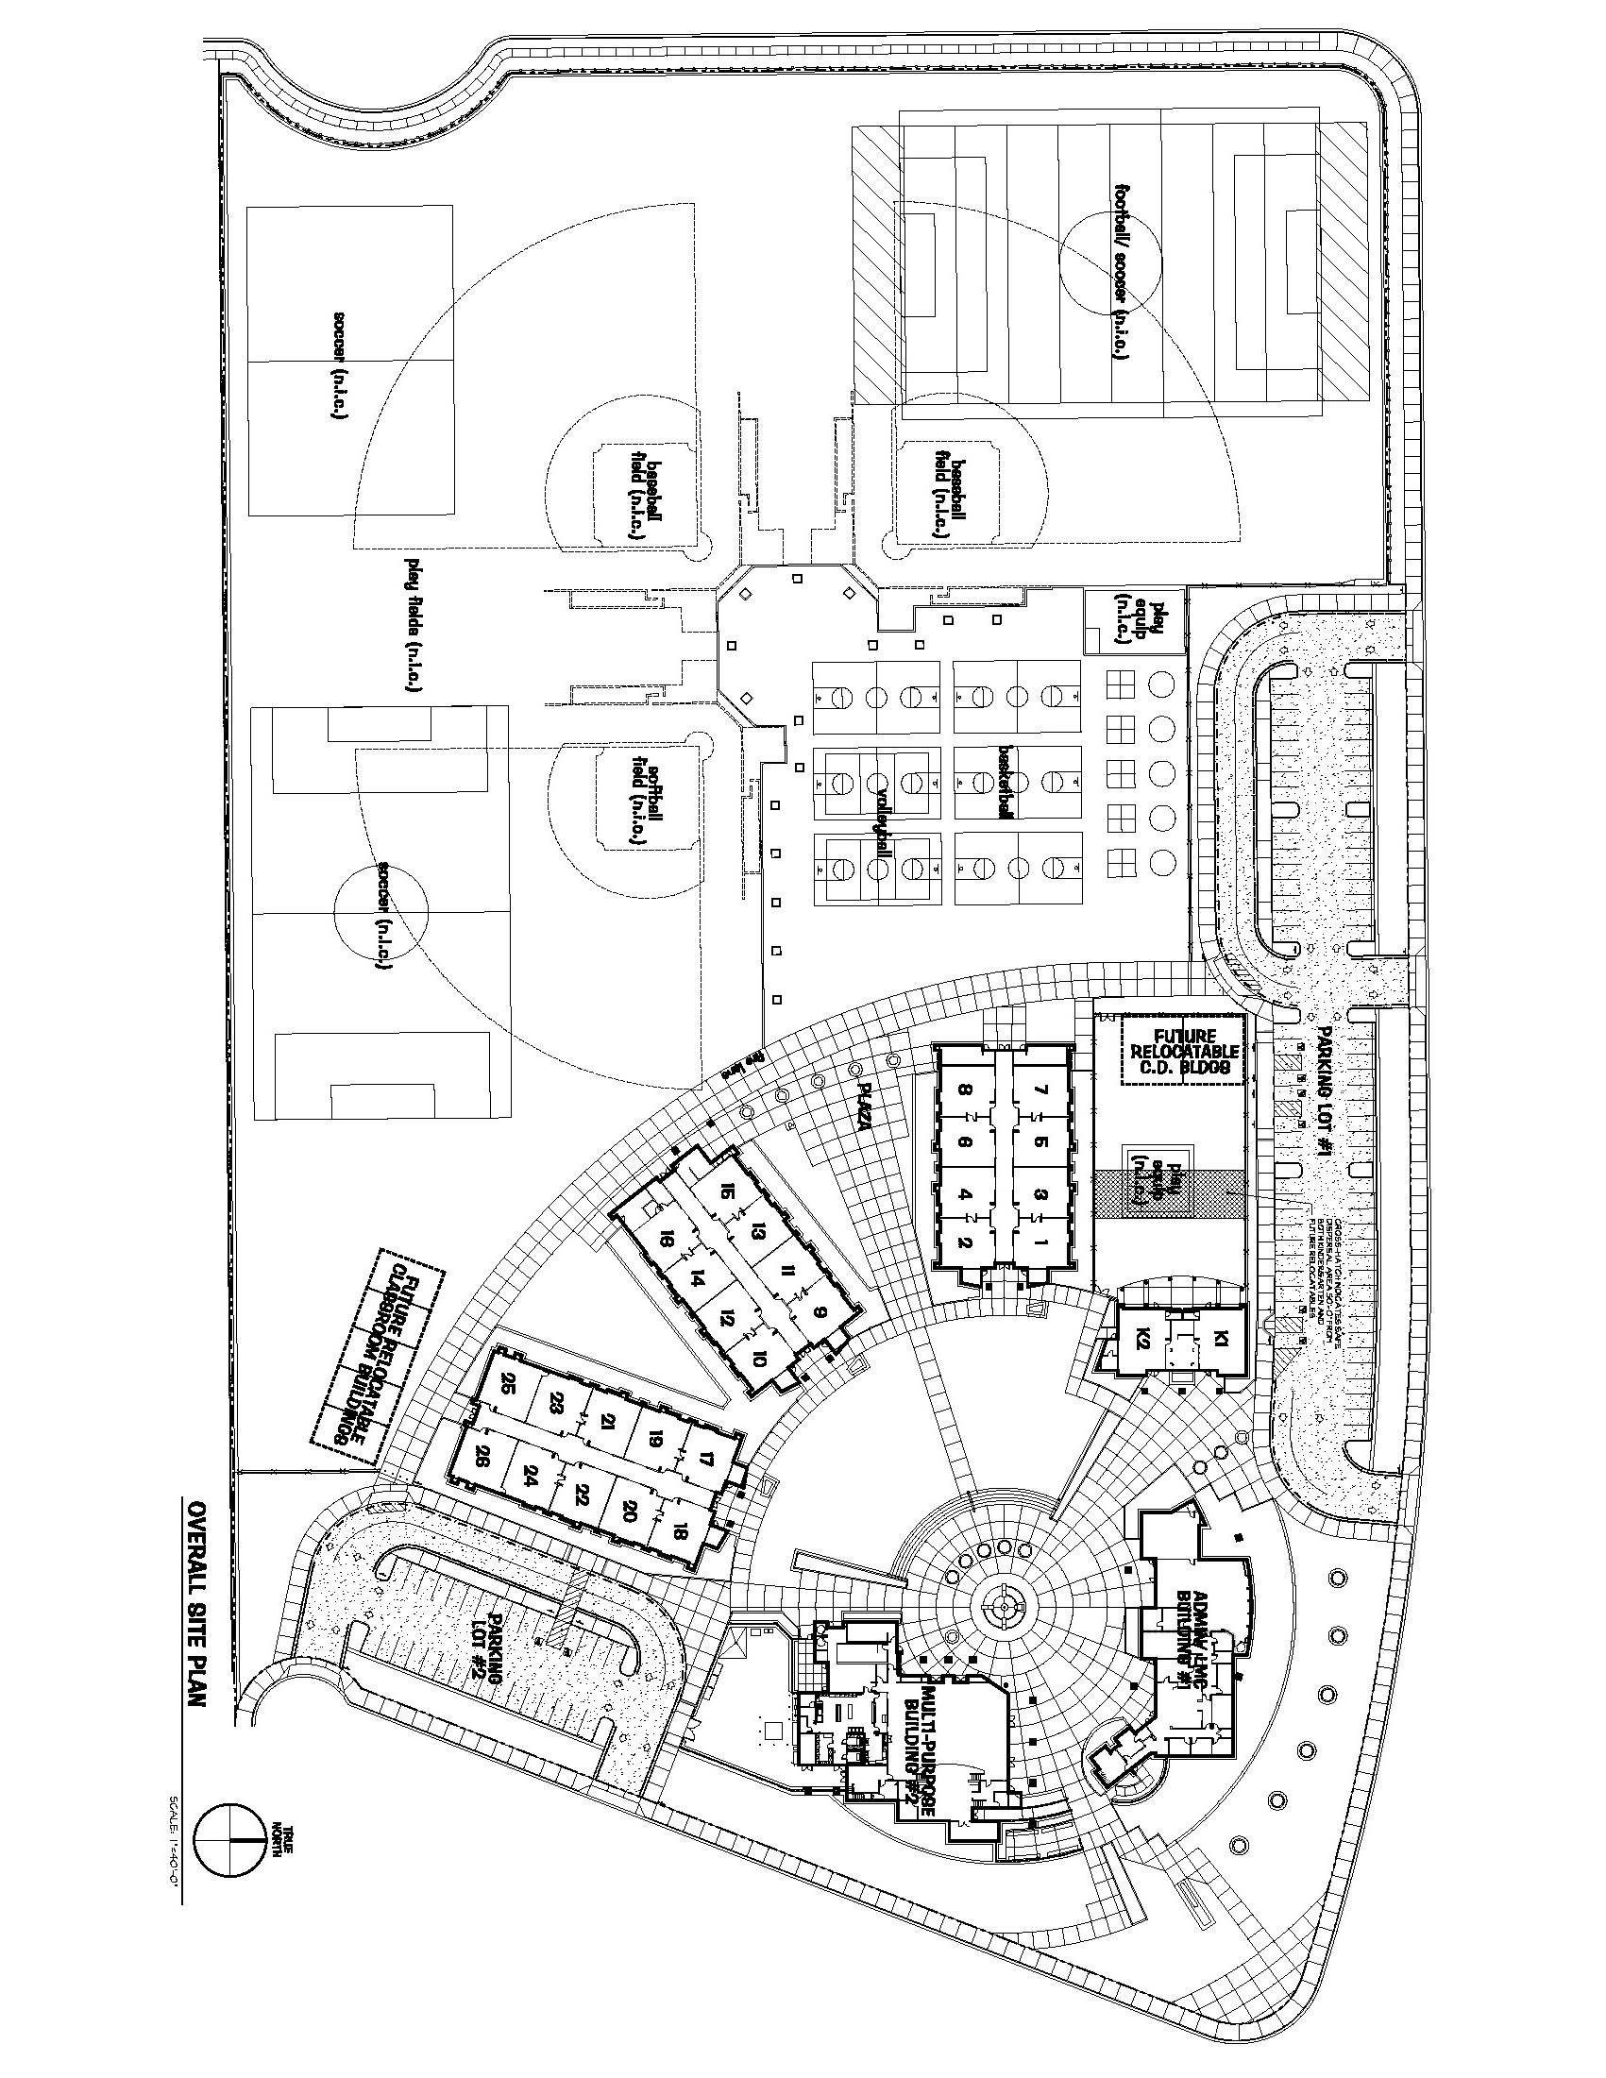
POWERS AVENUE
Administration
31
30

29

28

27

CC1

CC2

LEONARD AVENUE
MPR
LMC

