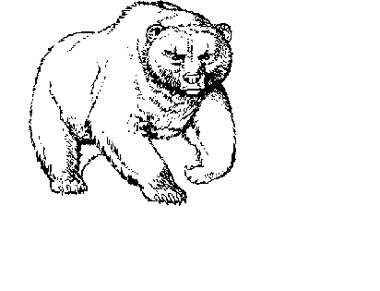
BUCHANAN HIGH SCHOOL

ATHLETIC DEPARTMENT
1560 NORTH MINNEWAWA
CLOVIS, CALIFORNIA 93619
Phone (559) 327-3271 Fax (559) 327-3065

Buchanan High School

Clovis Unified School District

Permit to Release Student to Parent/Legal Guardian

I request that my son/daughter be released to my custody, rather than returning to school on the transportation provided by the school district. I agree that once my son/daughter is released to my custody, I assume full responsibility for his/her health, safety and welfare and that the Clovis Unified School District, its agents and employees are released from any liability, which might be incurred thereby.

DATE: COACH:

Student Parent Signature
Student Parent Signature
Student Parent Signature
Student Parent Signature
Student Parent Signature
Student Parent Signature
Student Parent Signature
Student Parent Signature
Student Parent Signature
Student Parent Signature
Student Parent Signature
Student Parent Signature
Student Parent Signature

