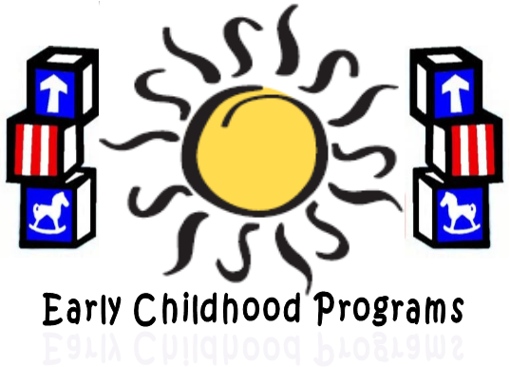

Early Childhood Programs
Substitute Agreement Process

- Parent / Guardian attend Volunteer / Substitute Training.
- Parent / Guardian volunteers in ECP Classrooms.
- Parent / Guardian requests Substitute Agreement Form from Education Specialist.
- Parent / Guardian complete the Parent Section of the form.
- An ECP Teacher signs on the Recommendation line, when she/he feels the person is ready to substitute.
- Form is sent to Education Specialist who presented the Volunteer Training to complete the Early Childhood Programs section.
- Upon verification of completed application, form is sent to ECP Director for approval.
- Parent / Guardian complete the School District On-line application. Make sure all references have an email and upload all certificates. Work history is to be the last Ten (10) years.
- Education Specialist will send letter of next steps to parent / guardian with the pink copy of the Sub Agreement Form.
- White copy will be sent to Human Resources.
- Human Resources will contact parent to schedule fingerprinting and drug testing.
- Canary copy to Confidential Secretary.
- Goldenrod copy to Education Specialist.

