OTISS Authorization Using NCID

1. You will receive an email stating that your request to register as a local government user has been processed.

2. Go to the OTISS website. https://schools.nc.gov/pls/apex/f?p=888:1

3. Enter your NCID user name and password to log in.

4. The following form will appear. Select your user role.

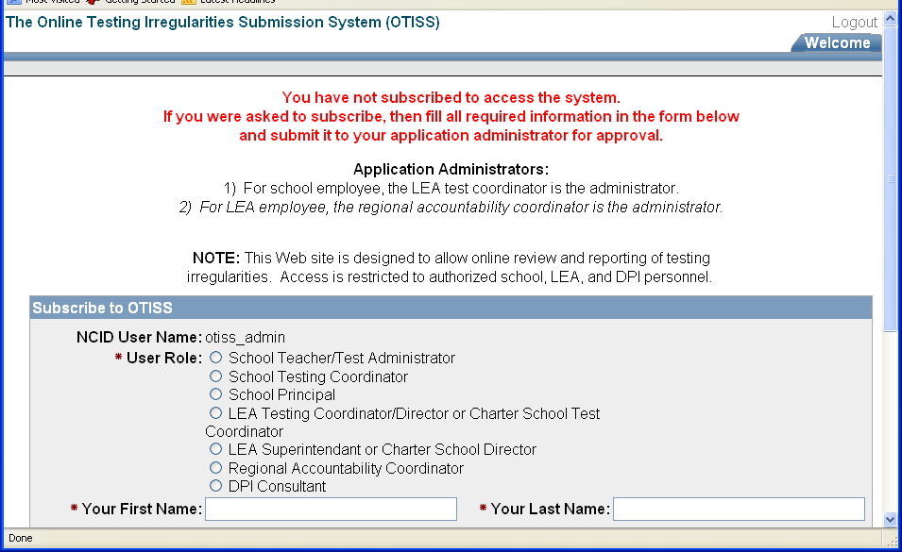

5. Select the required information from the drop down menus that appear.

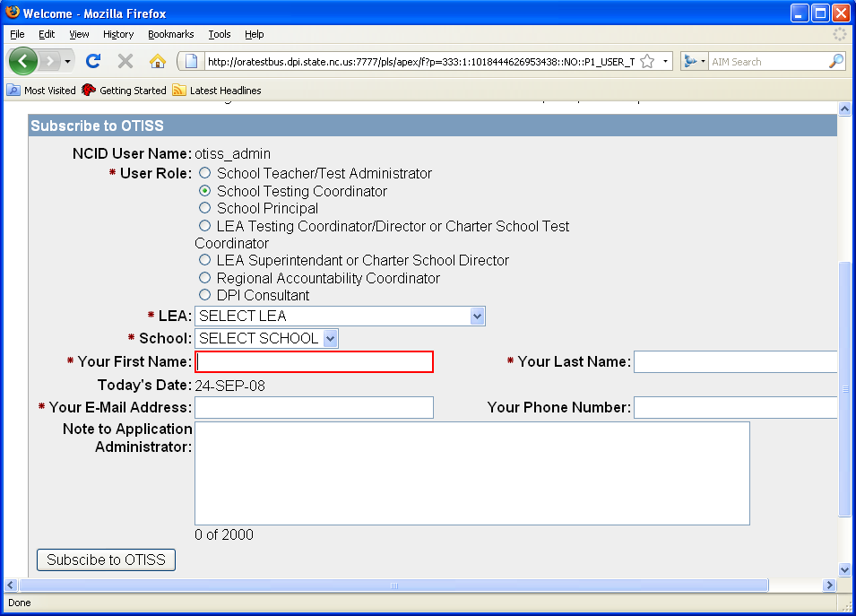
6. Fill out the rest of the required information and click the “Subscribe to OTISS” button.

7. A screen will appear informing you that the application administrator has not approved your account yet. An email will be sent to the address you provided once your account has been approved. You may then log in to the OTISS application using your NCID user name and password.

