Earth Science Notes to Study: the hydrosphere (layer of H2O)!

Fresh Water- ponds, rivers, lakes, streams (does not have salt) 3% of Earth’s H20
(Less than 1% is available for human consumption)

Saltwater- Makes up 97% of Earth’s water, can remove salt through Desalination

Erosion- soil and sediment are moved by rivers, wind, snow, ice, etc
Grand Canyon is a good example

Water Cycle- continuous flow of water
Condensation, precipitation, percolation, runoff, transpiration, and evaporation

Condensation (forms precipitation in clouds, gas-> liquid)
Evaporation (absorbed back to clouds
Liquid to gas)

Precipitation (rain, ice, snow, hail)

Percolation (water moves down in soil) Runoff
(not absorbed->flows in streams over land) Transpiration-moves thru plants

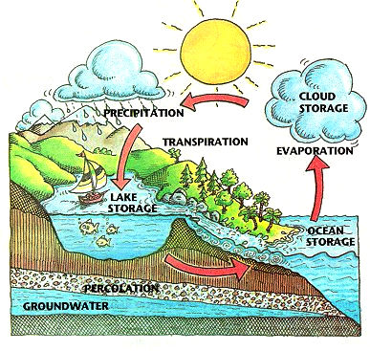

Tributary- water flows into something larger (river, ocean)

Watershed –drainage basin (land where water is drained)

Load- deposits carried by water

Deposition- sediment dropped in river basin or floor

Delta- fan shaped area w/ water

Flood plain- area that easily floods (Louisiana, Collettsville)

Water table -able to measure water levels (rises in wet season, drops in dry season)

Aquifer-rocky layer that holds water underground (Castle Hayne largest in NC)

Porosity- (have pores) ability to hold water (like a sponge)

Permeability-ability to let water move through rocks
Impermeable (rocks that stop the flow)

Artesian spring- water that flows from a crack in a rock

Point-source pollution- comes from a specific place or site (can be controlled or cleaned)

Non-point-source pollution- pollution from many sources (hard to clean up)

pH- amount of acid or base in a liquid (water is around 7, healthy is 6.5-8.5)

Turbidity- amount of particles in water (silt, plankton, waste) ⇑ turbidity, ⇓visibility

