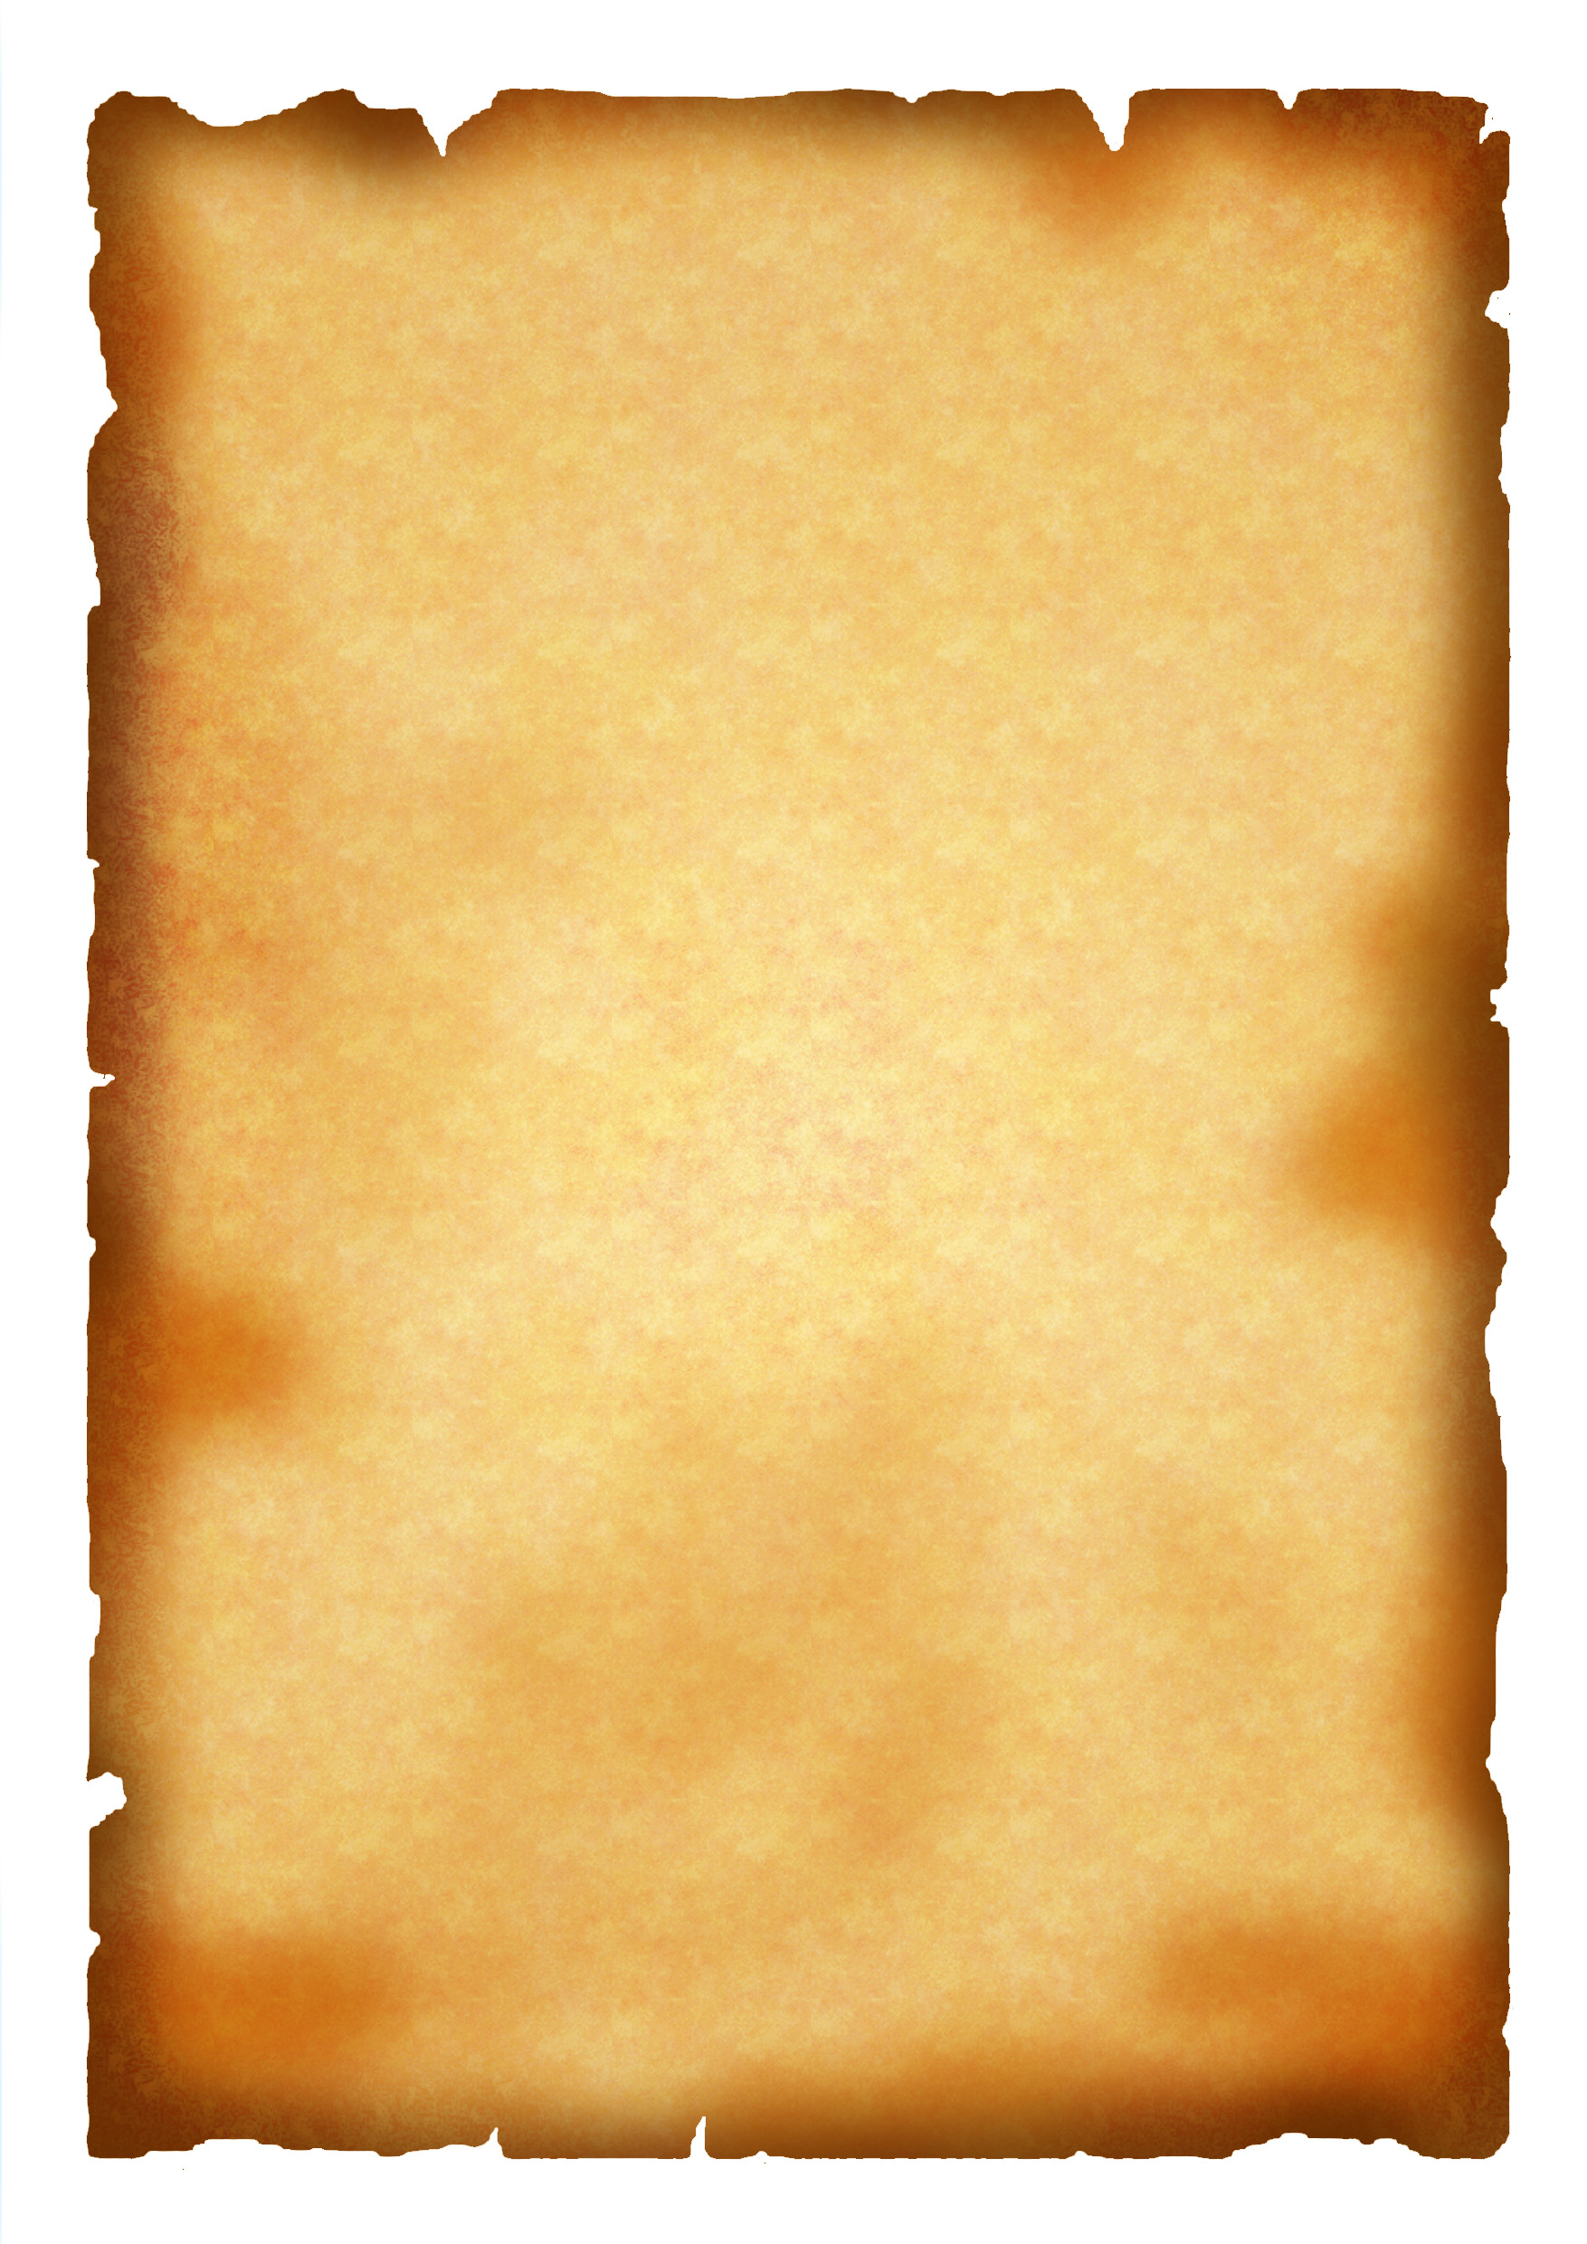
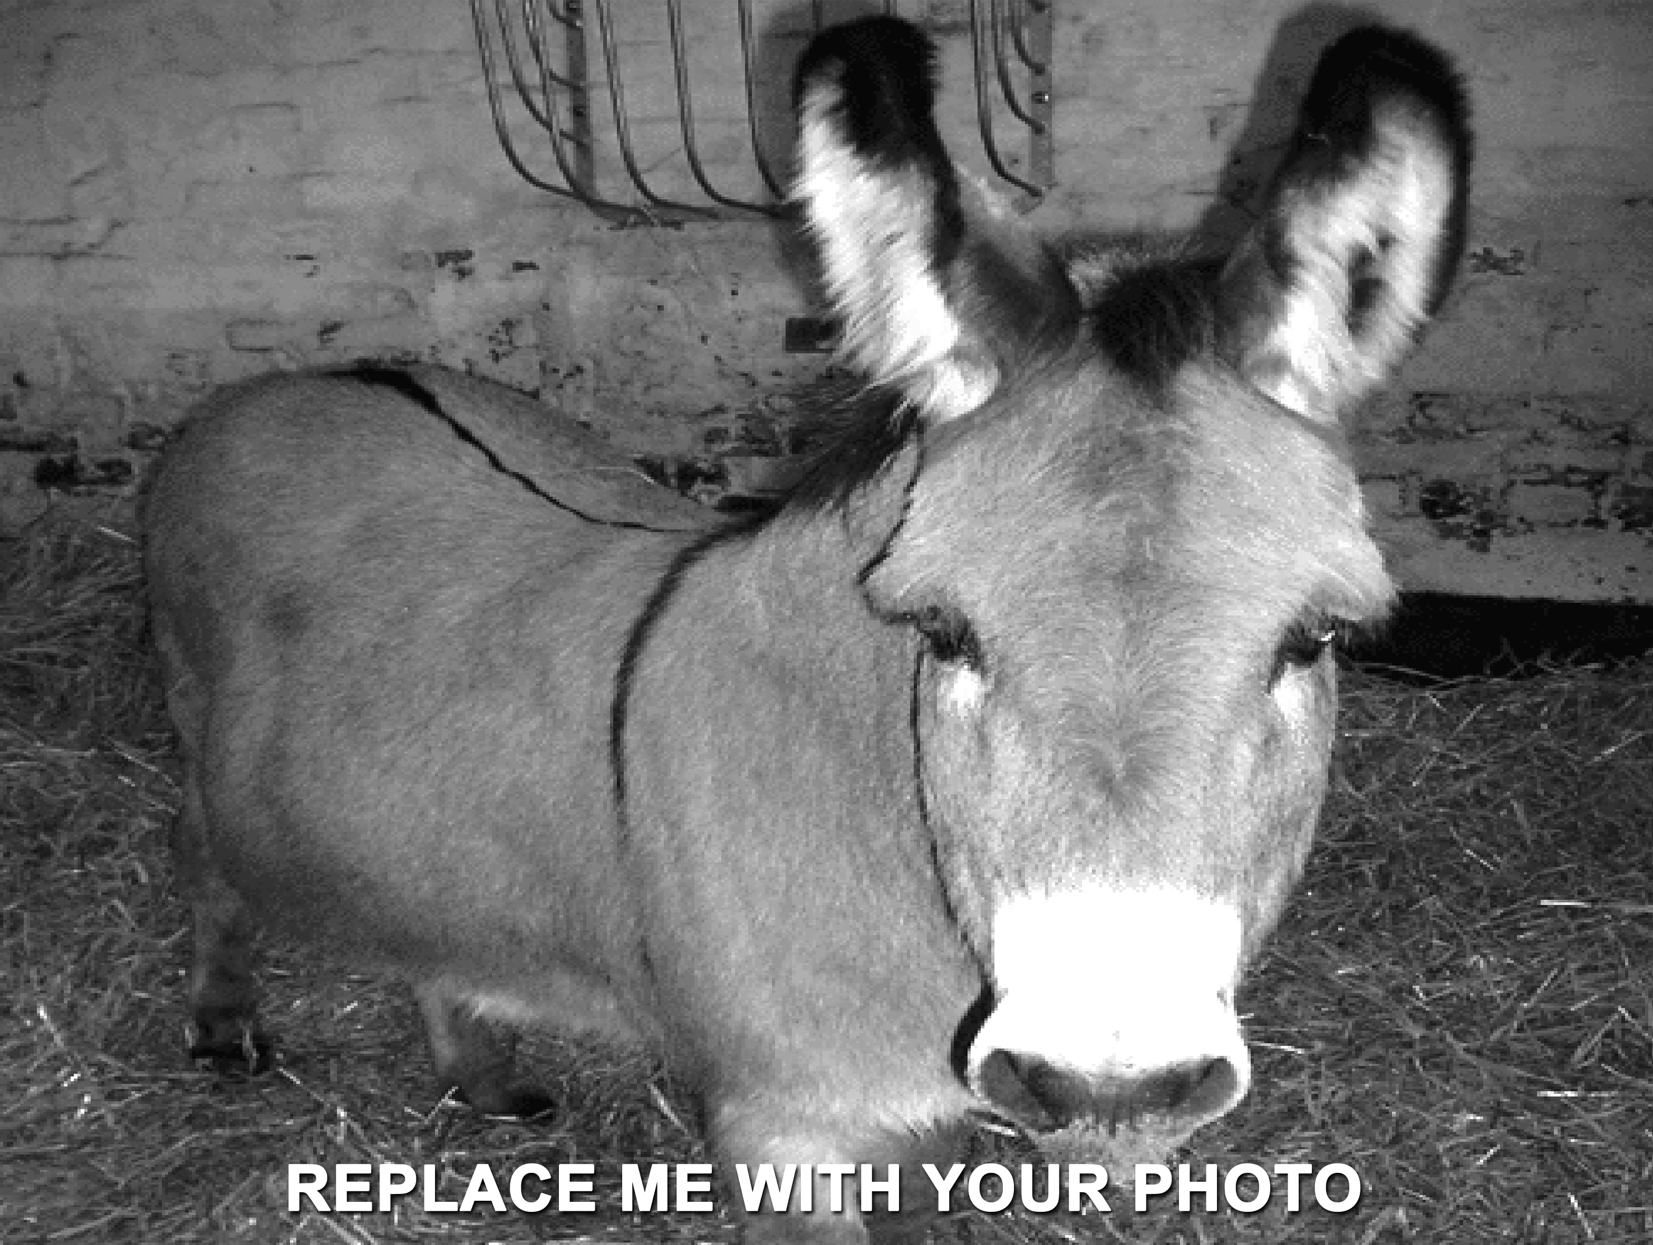

Next President of the United States
Necessary Qualitites
WANTED NAME HERE
Your ideal Qualities here
WANTED!
Type your name here

