Chromebook: A How to Guide for Students

2. Also notice, this is how you access ALEKS (for math), i-Ready (for Encore), Discovery Education (for video assignments), and Mastery Connect (for assessments).
EMAIL and MS TEAMS
How to access your school email and/or MS Teams (which is how you will attend your live class sessions M-Th with each teacher).
Two ways:
1. From MPMS home page, scroll all the way down on the right side until you find “Student Email”and click.
This will open up Office 360 and all the applications available to you. Then click on the “Outlook” icon for email or the “Teams” icon for LIVE classes:
2. OR: Type portal.office.com into a new tab browser (you may be asked to Sign In using your
^{school username and password)}
Whenever asked to sign in, use your CCS email: username@cabarrus.k12.nc.us
Your username is your first initial, last name and last 4
digits of your school ID #.
EX: jdeere1234
Your password is your entire school ID #.
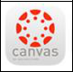

All teachers will be using CANVAS as their LMS (learning management system) to provide your lessons and assignments. You will check EACH teacher’s CANVAS page every day.

Here’s how...

1. From MPMS home page, scroll all the way down until you see this box on the right side

Click on the CANVAS app button:
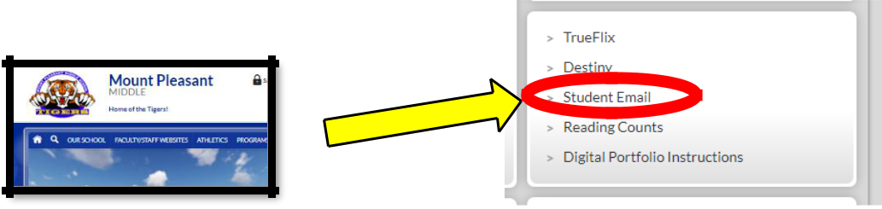

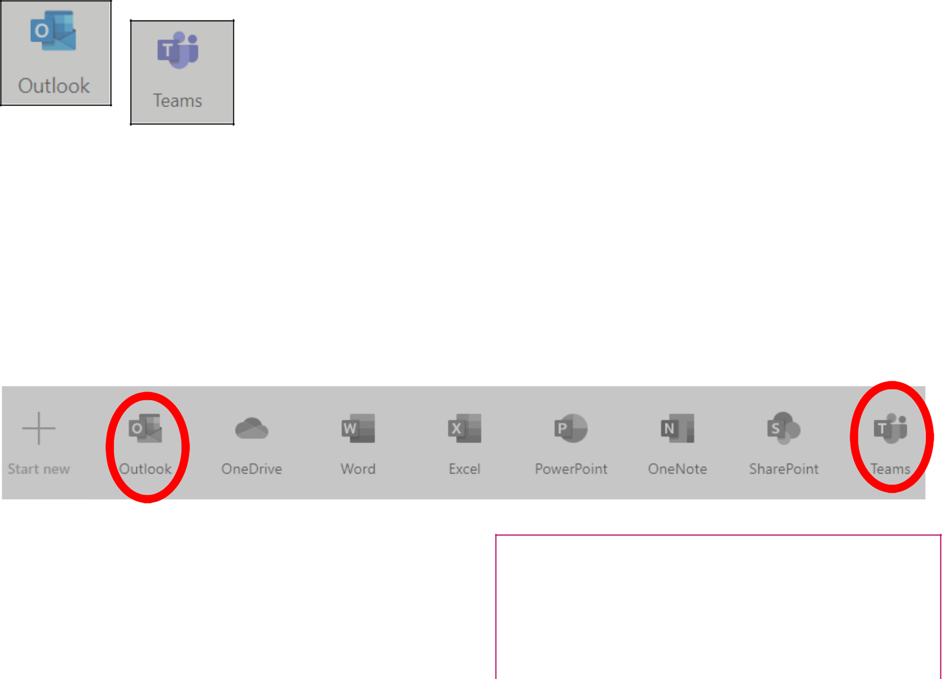
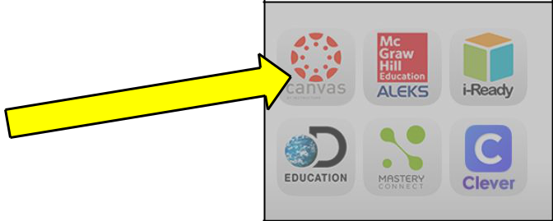
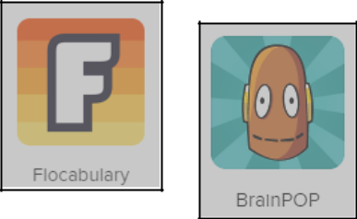
Flocabulary and BrainPOP
(must access through CLEVER!)

- From MPMS home page, scroll all the way down until you see this box on the right side

- Click on Clever, (sign in if prompted), then scroll to find the app you wish to use.
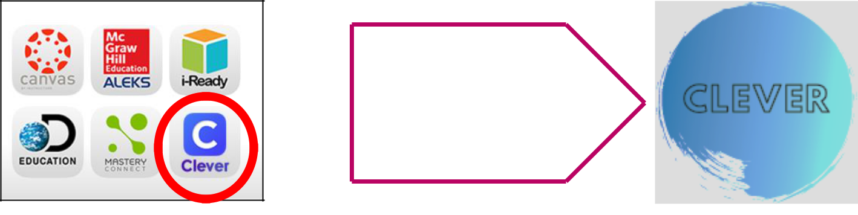

OR
You can click on the
“Clever” button on any
Appalachian teacher’s
CANVAS page.

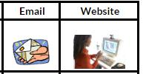

Teachers’ Webpages and Emails

- From MPMS home page, the quickest way to find any teacher is to click on

- Then, “Faculty/Staff Directory” in the drop-down menu.

- From there you can access any staff member individually or click on our “Appalachian Team” to view Harrington, Doss, Stout, Wilson and Ducos from one spot.
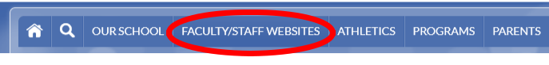


PowerSchool Grade Portal
It is important to check your grades at least once a week.

- Open a new browser tab and type my.ncedcloud.org (a teacher will help you claim your account the first week of school)

- Sign in, click on the grade in the correct quarter/column to open individual courses and see all your graded work.
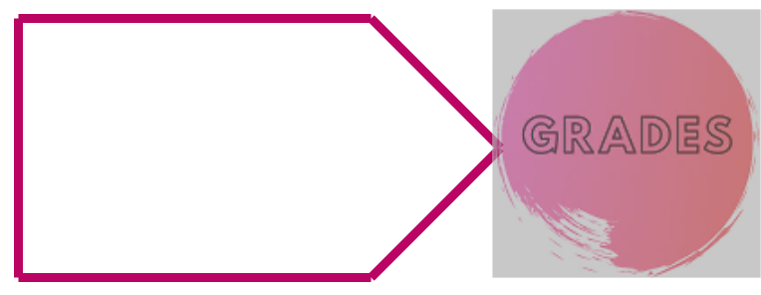

OR

You can click on the
“Grades” button on teacher’s
CANVAS page.

