Cox Mill High School
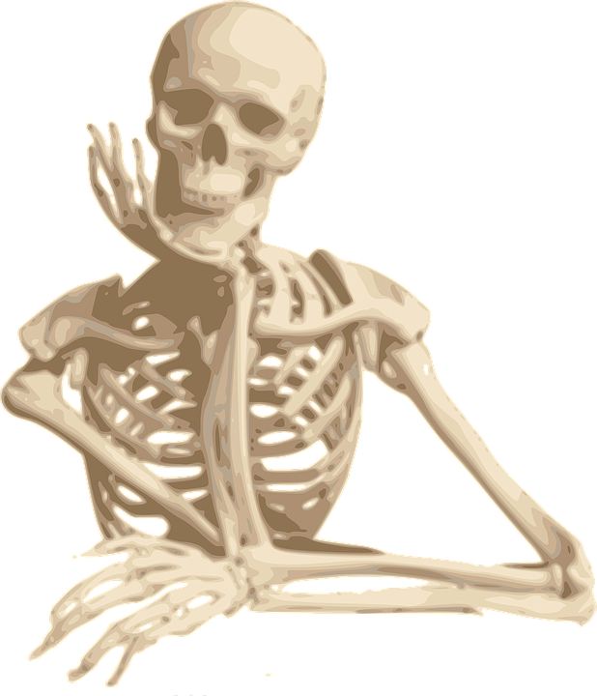
Honors Anatomy and Physiology

Objective: Anatomy is the study of the structures of the human body, while physiology is the study of the functions of these structures.

Materials:  Headphones or earbuds  Notebook paper/graph paper  Pencil/pen/highlighter  Colored pencils, index cards  Stopwatch/calculator |  | Honor Code/ Academic Integrity:  Students are expected to demonstrate honesty and integrity and notify the teacher of those who violate this policy. Work should be completed independently, not copied from another student or other resources. Cheating, plagiarism, forgery, and dishonesty will NOT be tolerated.

Instructor:  Mrs. Austin  melissa.austin@cabarrus.k12.nc.us  School phone (704)260-6600 |  | Absences and Make-up Work:  Daily assignments are posted in canvas and should be completed within five days of an absence to receive full credit. Students are expected to take missed assessments the day they return to class.
Grading:  Tests/Projects: 50%  Classwork/Labs: 30%  Homework: 20%  Late work penalty: 10 points per day |  | Lab Safety:  All students and parents must sign the safety contract (online) before participating in labs. Students are expected to behave appropriately during labs; failure to do so will result in immediate dismissal from the lab. Students are expected to pay to replace broken/damaged lab equipment.
Honors Curriculum:  Students will be challenged to examine anatomy on a higher level, using application and analysis to understand the human body. See complete overview on website. |  | Dissection:  Any student may opt out of dissection and be given an appropriate, equivalent assignment.

Bathroom Policy:
*Students are expected to visit locker, bathroom, and water fountain between classes.
*Only one student will be permitted to leave class at a time.
*Students should request a pass from the teacher during appropriate times.

Classroom Expectations:  Follow all school rules!  - Show respect.  - Be prepared for class.  - No food or drinks.  - Stay seated until bell rings.  - Use technology only as instructed. (no phones) |  | 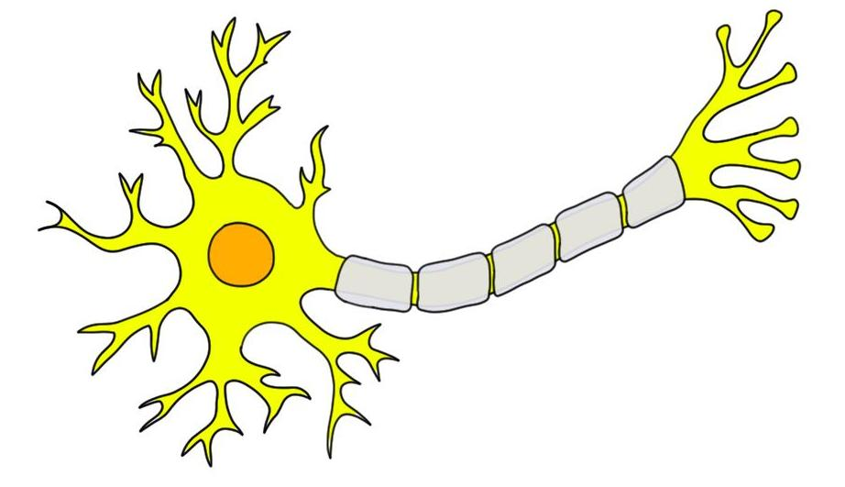

Online Resources:
Class webpage: course syllabus, safety contract, class notes
Canvas: weekly schedule, daily assignments, recorded notes, test dates
Textbook: openstax.org Anatomy and Physiology
(Essentials of Anatomy and Physiology class set for in-person learning)
Review sites:
Purposegames.com
Online.seterra.com
Wisc-online.com
Anatomyzone.com
Free-anatomy-quiz.com

I have read and understand this syllabus.
Student’s signature ___________________________________
Parent’s signature ____________________________________
Parent preferred method of contact (phone # or email address): ____________
**Reminder: Sign lab safety contract on Mrs. Austin’s webpage!

