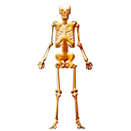

Course Outline

Unit | Chapter | Topic | ~# Instructional Days
1 | 1  2 | Intro to the Human Body  Basic Chemistry | 5  5
2 | 3  4 | Cells and Tissues  Integumentary System | 6  5
3 | 5  6 | Skeletal System  Muscular System | 6  6
4 | 7  8 | Nervous System  Special Senses | 5  4
5 | 9  13 | Endocrine System  Respiratory System | 3  4
6 | 10  11 | Blood  Cardiovascular System | 5  5
7 | 12  14 | Lymphatic/Immune Systems  Digestive System | 6  3
8 | 15  16 | Urinary System  Reproductive System | 5  5

